Background Report
STATUS OF FISHERIES AND AQUACULTURE DEVELOPMENT IN PERU: CASE STUDIES OF PERUVIAN ANCHOVY FISHERY, SHRIMP AQUACULTURE, TROUT AQUACULTURE AND SCALLOP AQUACULTURE

By:
Yvonne Evans,
UCSS Escuela de Post Grado, Universidad Católica Sedes Sapientitae de Lima
and
Sigbjorn Tveteras,
CENTRUM Católica, Pontificia Universidad Católica del Perú

April 2011

1. INTRODUCTION

The purpose of this report is to provide background material on fisheries and aquaculture in Peru. More specifically, this background report is part of a joint NORAD/FAO project that focuses on economic benefits and food security in developing countries related to participation in international fish trade. The objective is to understand the potential benefits of artisanal fishers and producers in participating in international trade through analysis of price and marketing margins in such value chains. As such, this report provides information on four Peruvian fishery and aquaculture sectors that to different degree participates in export oriented activities. These four sectors are Peruvian anchovy fisheries, shrimp aquaculture, trout aquaculture and, finally, scallop aquaculture. This report will then be followed up with analysis of the international marketing chains pertaining to these four sectors. The main interest of the project is on the economic conditions of small scale producers in developing countries and on policies that can enable them to access and benefit international value chains.
In Peru the small-scale sector accounts for a large share of fisheries and aquaculture activities. The main exception is the fishmeal industry, which is dominated by large vertically integrated firms. However, even in this important economic sector of Peruvian fisheries there are many individual vessel owners using more artisanal boats and technology. The Peruvian aquaculture sector is relatively small and young compared to many other countries with aquaculture industries, but because of biological conditions and plentiful access to water resources, fresh and marine, this sector is growing quickly. However, undercapitalisation means that most enterprises in this sector are small-scale. This is evident from the case studies in this study, especially in trout and scallop farming, and to a lesser degree in shrimp farming.
The Peruvian anchovy fishery is strongly associated with the fish meal and fish oil industry. However, there is a small but growing use of anchovies for direct human consumption of which the artisanal fleet is especially involved, because it takes place within the 5-mile limit defined as an artisanal fishing zone. Most of farmed shrimp is destined for export markets, and a large share of scallop production as well, while farmed trout is largely consumed domestically in Peru, with small quantities being exported.
In the next section follows an overview of the fishery and aquaculture sectors in Peru. Then in Sections 3-6 follows information on the four case studies that include Peruvian anchovy fishery, shrimp aquaculture, trout aquaculture and, finally scallop aquaculture. Section 7 contains a brief summary of the report.

2. OVERVIEW OF FISHERIES AND AQUACULTURE IN PERU

Following decades of economic and political instability, Peru has achieved a strong growth during the last decade. This is due to a more stable economic policies focusing on trade liberalization and on attracting foreign capital. Peru's economy is strongly dependent on exports, which has provided hard currency to finance imports and external debt payments during the last decades.
During recent years the reliance on primary industries has presented advantages due to the boom in international commodity prices. Peru is rich on natural resources and foreign trade is dominated by exports of raw materials. In terms of export value, gold and copper are the most important economic export goods followed by fisheries products. Fisheries accounts for 3% of the Peruvian GDP. The conglomerate of all extractive industries accounts 15% to the GDP, but dominates export value and is therefore the most important source of foreign currency revenue.
The strong economic growth during recent years, as evident from Table 1, has created an environment that fosters development in many sectors, including fisheries and aquaculture. Although exports have provided substantial revenue, self-sustained growth and poverty are still major issues because of weak public institutions and a highly skewed income distribution. However, a decade of strong economic growth is giving more and more people opportunities to improve their livelihood.
Table 1. Peru GDP real growth rate (%) 2000-2009..
Year | GDP growth
2000 | 2.4%
2001 | 3.6%
2002 | -0.3%
2003 | 4.8%
2004 | 4.0%
2005 | 4.5%
2006 | 6.4%
2007 | 8.0%
2008 | 9.0%
2009 | 9.8%
Source: CIA World Factbook
2.1 The Fishery Sector
Peru’s fishing industry has always been a key component of the country’s economy, especially because of the economic importance of the anchovy fisheries and the related fish meal and fish oil industry. However, anchovy is not the only commercial species. Peru has 736 known marine fish species, of which a limited number are caught for commercial purposes. Fishing operations are carried out along the Peruvian coast that stretches 1,400 miles. Fishing grounds are more productive in the northern and central part of the coast and, consequently, industry infrastructure is better developed in those regions. The coast has more than 40 fishing ports, which gives some idea of the importance of this sector in terms of employment and economic activity along the Peruvian coast. Paita and Callao (see map in Figure 1 below) are the two most important ports where over 50 different species of fish are landed for commercial purposes.
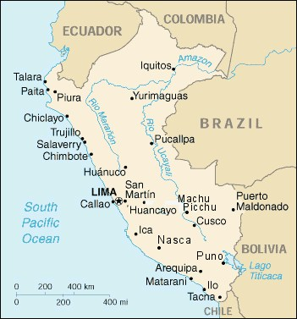
Figure 1. Map of Peru.
In terms of volume landed, Peru is among the largest fishing nations accounting for nearly 10% of the global fish catches. The cold-water Humboldt Current brings nutrient-rich cold waters that create ideal fishing grounds for large pelagic schools. The Peruvian anchovy is the world's largest fishery of a single species measured in landed volume. This species is also the main raw material for the fishmeal and fish oil industry, which is the largest industry within the fishery sector.
The anchovy biomass is located within the productive Humboldt Large Marine Ecosystem (LME). The population fluctuates as a result natural events, mainly climatic, that occur. Every seven to fourteen years occurs the El Niño event, which brings warm surface water to the Peruvian coast that suppresses nutritious cold water with negative effects on the stock of anchovies. Due to the climatic changes these events appear to be more frequent, introducing higher economic risk for the fishery industry.
However, the ecosystems of the Peruvian coasts also supports a number of other species that are commercially important such as mackerel, horse mackerel, tuna fish, flying jumbo squid (?), scallops and many others. Peruvian catches, in Tonnes, officially reported for full year 2009, were as reported in Table 2.
Table 2. Landings by species and volume in 2009. Tonnes.
English | Spanish | 2009
Total | Total | 6,874,412
Of which:
Pelagic | Pelágicos | 6,213,579
Peruvian anchovies | Anchoveta | 5,935,165
Tuna | Atún | 2,520
Striped Bonito | Bonito | 30,648
Mackerel | Caballa | 110,605
Pacific Jack Mackerel | Jurel | 74,694
Yellowtail Amberjack | Perico | 57,153
South American Pilchard | Sardina | 26
Shark | Tiburón | 2,762
Demersal | Demersales | 59,280
Common Peruvian Weakfish | Ayanque | 2,522
Peruvian Rock Seabass | Cabrilla | 2,481
Banded Croaker | Coco | 1,091
Flounder | Lenguado | 234
Peruvian Hake | Merluza | 47,162
Ray | Raya | 1,509
Smooth Hounds | Tollo | 4,281
Coastal | Costeros | 56,568
 | (Pelágicos y Demersales)
Pacific Creolefish | Cabinza | 4,699
Warehou | Cojinova | 453
Corvina Drum | Corvina | 457
Peruvian Grunt | Chita | 154
Flathead Mullet | Liza | 18,595
Lorna Drum | Lorna | 9,204
Pacific Menhaden | Machete | 10,008
Chilean Silverside | Pejerrey | 12,618
Peruvian Morwong | Pintadilla | 380
Other fish | Otros Pescados | 47,842
Cructaceans | Crustáceos | 19,570
Crab | Cangrejo | 1,894
Green Spiny Lobster | Langosta
Penaeus Shrimp | Langostino | 17,519
Other cructaceans | Otros crustáceos | 157
Molluscs | Moluscos | 470,027
Abalone | Abalón | 274
Snail | Caracol | 3,308
Mussels | Choro | 11,072
Scallop | Conchas de Abanico | 26,478
Macha clam | Macha | 31
Clams | Almeja | 326
Squid | Calamar | 13,178
Giant Flying Squid | Pota ^{1/} | 411,805
Octopus | Pulpo | 527
Other Moluscs | Otros moluscos | 3,028
Source: PRODUCE (Ministry of Production in Peru)
From Table 1 it is clear that Peruvian anchovy is by far the largest fishery in Peru, accounting for over 86% of the total volume of landings. Only 15.4% (1.1 Million MT) of the Peruvian catches are destined for direct human consumption while 84.6% (5.8 Million MT) go to the fish meal and fish oil industry, to the so called “indirect human consumption”’. This reflects that the majority of Peruvian anchovy is used for fish meal and fish oil.
Figure 2 shows the evolution of pelagic fisheries from 1991 to 2009. During this period the catch volume of pelagic species, predominantly Peruvian anchovy, has been slightly declining but with fairly strong volatility due to El Niño events. Because the other species groups are relatively small in volume relative to pelagic species, they are shown in a separate Figure 3. Besides of mollusks, the other species groups tend to have relatively stable or stagnating trends. The mollusks group, however, has experienced a strong growh mainly due to increased capture of Giant flying squid, which account for the majority of catch volume in this category. Demersal fish catches peaked in 1996 and has thereafter declined. Similarly, coastal fish catches peaked in 1998 with a declining trend until 2006 and have then increased somewhat until 2009. Finally, crustaceans and other species have fluctuated with periods of strong growth and strong decline. Overall, the trends in the Peruvian fish catches are similar to that of other countries with the majority of large commercial species having reached levels of full or overexploitation, while only the fisheries of few species, such as the Giant flying squid, has been able to increase in the last couple of decades.

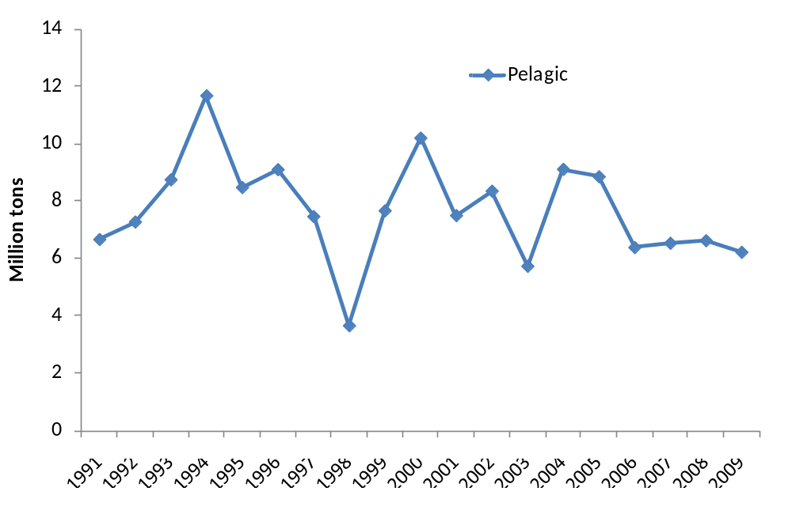
Figure 2. Catch volumen of pelagic fish in Peru from 1991 to 2009 (Ministry of Production in Peru).

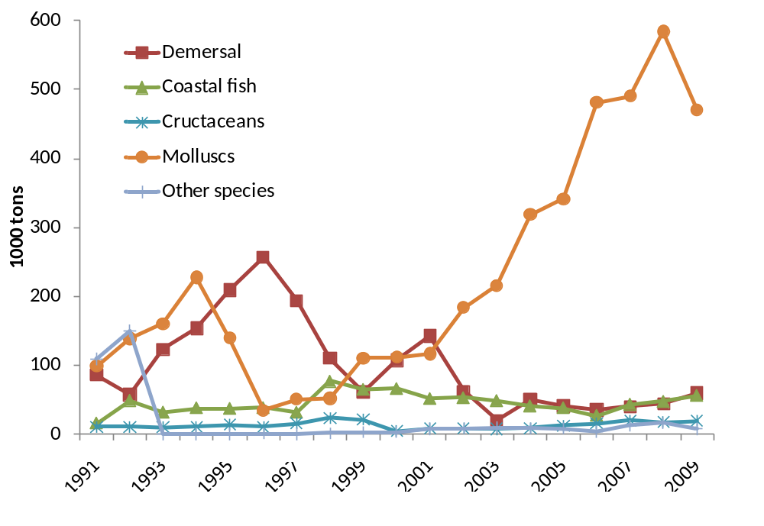Figure 3. Catch volumes of major species groups in Peru from 1991 to 2009 (Ministry of Production in Peru).
2.2 A brief historical recount
Despite a long history of fishing, it is predominantly during the last five to six decades that Peru started to move from artisanal fishing techniques to large-scale modern fisheries operations – and then mainly for a segment pertaining to the fishmeal industry. The first experiments with industrialized fisheries began in the 1930s and were related for to fish canning. This activity remained on a small scale until the early 1940’s.
Then, with the construction of the Frigorífico Nacional one started to experiment with frozen fish production. However, marketing of frozen fish products home and abroad were not successful and led to closure of these operations, which were not resumed until the end of the Second World War (WWII). The outbreak of the WWII in 1939, however, opened up new market opportunities. For instance, the canning industry could expand in response to United States entering the war, since the war boosted demand for cured products. Salted fish was also greatly sought after, and Peru started to export this commodity.
The end of WWII in 1945 also put an end to Peru’s export boom of war-sought fishery products. Foreign sales of salted fish and fish liver and oil ceased completely. Even canned fish exports were threatened because the United States imposed restrictions to protect the domestic industry. Despite of the setback, the Peruvian canning industry managed to continue selling its products without an alarming cutback in production. Inflow of U.S. capital investments in the Peruvian canning operations led to further expansion of the industry from 1947 onwards. At the same time, a small number of freezing plants were installed to produce for the U.S. market.
This is a brief account of the Peruvian fisheries industry before the onset of the “anchovy rush” started. The rise of the anchovy fisheries and the fish meal industry overshadows earlier efforts in fishery sector. In the 1950s, private firms began to specialize in processing anchovy to produce fishmeal and fish oil. Improved fishing technology and increased demand for livestock feed made fishmeal a sought after global commodity. The Peruvian fishing fleet became equipped with sonar equipment to locate fish shoals. Lightweight nylon nets replaced less efficient cotton nets. Anchovy accounted for about half of the world’s fishmeal production.
During less than a decade (1955-1963), the Peruvian industry emerged from obscurity to become world’s largest fish meal producer. The “anchovy wonder” had a great impact on the Peruvian economy. In less than 10 years, the industrial fishing fleet expanded to over 1,700 modern purse seiners, a processing industry consisting of upwards of 150 meal and oil reduction plants, and a number of auxiliary establishments for boat building and repairing, machinery manufacturing and the production of other fishing requisites.
In the 1960s, Peru became the world’s leading fishing nation in terms of volume. The number of fishmeal processing plants peaked at 154. In 1964, Peru harvested 18% of total world fish catches and produced about 40% of total world supply of fishmeal. Fish products account for 25 to 30% of total export earnings, and become leading export sector. Anchovy accounted for 99% of fishmeal production. Signs of overfishing on the northern and central coast appeared in the mid 60s. Fishing fleets begin to explore untapped fishing grounds on the southern coast. Fishing companies try to remain competitive by increasing investment in new, larger fishing boats. Industry was able to process 16 million tons of anchovy annually. As a consequence, the economy registered a sudden upsurge in employment and, by the end of 1962, around 100,000 people were engaged directly or indirectly in the anchovy fishery, more than 20 times the number employed in similar activities 10 years earlier.
From the outset the industrialisation of the fisheries was export driven, with only a small share destined for the domestic market. The industrialization led to a separation of the fishing industry into two distinct sectors, one catering to foreign demand, the other reliant on domestic needs; and unfortunately, advances in technology and general efficiency took place in the former almost in complete isolation of the latter. Thus, the domestic food fish industry that caters to the national market scarcely felt the wave of industrialization. In other words, it has remained artisanal. The artisanal fishing industry is a conglomeration of small vessel enterprises decentralized throughout the country’s coastal zones. In this sector, there are close to 8,500 fishermen fishing in vessels ranging from small boats (“caballeros”) to motor vessels of 22’ to 30’ in length. Except for the widespread substitution of nylon for cotton nets, and the gradual acceptance of outboard and marine engines, there is little evidence of modernization in the industry. Productivity per man hour is low and many species are underexploited.

2.3 Artisanal fisheries
The Peruvian artisanal fishing, also called small-scale fishing or non-industrial fishing, is usually small operations consisting of individual vessels or a small group of medium or small-sized vessels. Artisanal fisheries are commen in the northern coastal zones of Peru. It has special importance for the economic and social development of the country along the coast, not only because it is the largest source of employment and income in the fishing sector but also because of their role as main suppliers for the packing and freezing fish industry.

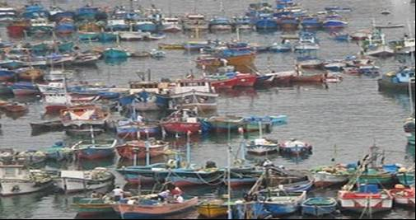
Figure 4. Artisenal fishing vessels in Peru.
The construction of artisanal fishing crafts is a major activity related to fishing. These crafts usually have an average of 12 to 20 meters of length and a hold capacity from 10m³ of to 32.6m³. In the Peruvian artisanal fisheries there are about 30 thousand people that work on approximately 15 hundred vessels. These vessels mainly target fish for direct human consumption.

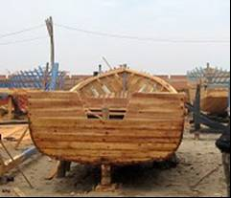
Figure 5. Construction of wooden artisanal fishing boats, also called ‘Vikingos’

The artisanal fisheries have an important role in contributing with food supply and nutrition for the low income population and, moreover, allows to the artisanal fisherman to obtain revenues above subsistence level. Thus, the artisanal fishing contributes to mitigate poverty of low income population, to support food security and to increase or maintain the level of national fisheries exports with an important economic role for the country.
It should be pointed out that there are differences in regulations of artisanal and industrial fisheries. The artisanal fisheries tend to take place within the 5-mile limit where fisheries are mainly directed with the purpose of direct human consumption. This is in particular relevant for the Peruvian anchovy fishery that serves as raw material for two different uses – for fish meal and fish oil, on the one hand, and for conserved products destined for direct human consumption, on the other. This distinction is relevant when we later will discuss in more detail the anchovy fishery.

2.4 The Aquaculture Sector
Since mid-1980s one has recognized the enormous potential for aquaculture development in Peru. The main arguments have been that Peru has a large variety of native species, favorable conditions for marine and freshwater aquaculture along the coast, vast areas of the Peruvian Amazon area and in the highlands for freshwater culture, experience gained by researching the qualities of different native species for aquaculture production, technical staff trained in different fields applied to aquaculture. Moreover, the success of neighboring countries in aquaculture such as shrimp farming in Ecuador and salmon and trout farming in Chile have encouraged Peruvian government to develop policies to promote aquaculture development in Peru.
Thus, in 2000 the Ministry of Fisheries (today a part of the Ministry of Production) defined aquaculture development as a significant objective for 2001-2006. This priority objective was also included in the Law on Promotion and Development of Aquaculture (Law № 27460) and its Regulations (D.S. № 30-2001-PE), which entrusted the General Aquaculture Directorate of the Ministry of Production with the preparation of a National Plan for Aquaculture Development (PNDA).
The PNDA, legally established by Law № 27460 “Law on Promotion and Development of Aquaculture”, has been prepared by the General Aquaculture Directorate of the Deputy Minister’s Office for Fisheries of the Ministry of Production in coordination with different public organizations, regional governments, private sector and other users of aquaculture with support of international organizations and it is a guide for the development of the aquaculture sector in 2010 to 2021 term.
The PNDA defines the vision and mission related to the long-term development of Peruvian aquaculture. Furthermore, it sets forth strategic principles and objectives, which will be the basis for the aquaculture sector development, and offers strategy guidelines and an action plan for its development and application. Finally, the PNDA aims to support and to guide the development of aquaculture, by mobilizing resources from the public sector (central government, regional governments), the private sector and the international cooperation; the development of human resources and improvement in the performance of the institutions in charge of promoting and encouraging aquaculture in Peru.
Establishing goals will aid to measure quantitatively and qualitatively the effectiveness of the Action Plan in the implementation process of the National Plan for Aquaculture Development (Ministerio de Producción del Perú, 2010). In this regard, the following goals for Peruvian aquaculture for 2015 have been established:
- Increase quality, productivity and volume of aquaculture production commercialized at the national and international level
- Volume of aquaculture harvest between 95 to 110 thousand MT
- Volume of aquaculture products commercialized domestically between 16 to 18 thousand MT
- Volume of exports between 25 to 27 thousand MT
- Value of exports between 170 to 186 million USD
- Consumption of aquaculture products between 0,86 to 0,94 kg per capita
- Increasing private investment in aquaculture
  - A 50% Increase of private investment
  - A 100% Increase in credits for aquaculture
- An overall increase of 20% in aquaculture rights (permits and concessions at larger and smaller scale in marine and inland waters)
- A 15% Increase in available areas for the development of aquaculture
- Promoting national production of inputs (seeds and balanced food) for aquaculture
- Promoting the development of education, training and technical assistance services for aquaculture production and commercialization
  - Twelve (12) Regional Governments with training and/or extension programs in aquaculture.
  - Six (06) demonstrative aquaculture farms implemented in the regions (at least 01 demonstrative aquaculture farm for each species such as trout, tilapia and Amazonian fishes and per type of system (cages and ponds)
  - One farming protocol for each aquaculture species which are farmed in Peru
- Promoting the development of health services directed to aquaculture production in farming centers
  - Four (04) health reference centers for aquaculture (one reference center of aquaculture health in the north zone, one in the central zone, one in the south zone and one in the east zone).
- Promoting research, development, adaptation and technological transfer in aquaculture.
- Having a proper organisational structure and human capacities to ensure an effective preparation, implementation and assessment of policy provisions and instruments to promote aquaculture.
These goals reflect the increased focus on aquaculture development in Peru. However, the public resources spent on aquaculture development are still very modest compared e.g. to Chile. It should also be pointed out that Peru is a midget in aquaculture only accounting for 2% of the production in Latin America (Instituto Español de Comercio Exterior, 2010).
Investments initiatives appear to be uncoordinated and based on individual efforts of different firms in different regions and relating to different technologies. In scallop production there are only a handful large firms that have managed to close the production cycle. The scallop sector is dominated by artisanal activities that are purely extractive or a combination of culture and extractive practices. As can be seen from Table 3, scallop is the largest aquaculture activity measured in volume, followed by shrimp. Shrimp is the most developed and capitalized part of aquaculture in Peru, in is located in the Northern region bordering to Ecuador because this region offers good biological and climatic conditions for shrimp farming. Next follows trout farming that takes place in the Andes Mountains. The trout farming industry consists of a large number of small scale producers and only a few large integrated companies that are involved in export activities. Some of the main challenges facing a sector like trout is commercialization, as the small scale farmers with working capital that barely covers the inputs, there is little resources left to devote to sales of their products.
Table 3. Harvest by species and volume in 2009 (Ministry of Production in Peru).
Species (english) | Species (spanish) | Volume (MT)
Freshwater | Continental | 14,836.22
Gamitana | Gamitana | 564.34
Tilapia | Tilapia | 1,260.83
Rainbow trout | Trucha | 12,816.86
Others | Otros | 194.19
Marine | Marino | 29,480.55
Scallops | Concha de abaníco | 16,047.42
Whiteleg Shrimp | Camaron | 13,424.85
Other | Otros | 8.28
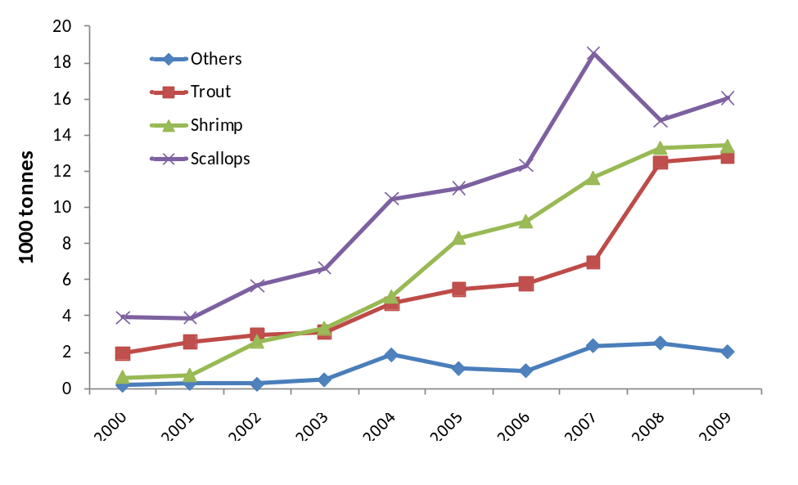
Figure 6. Aquaculture production in Peru from 2000 to 2009 (Ministry of Production)
Figure 6 shows how aquaculture production has evolved over time in Peru. When comparing Figure 2 and 3 with Figure 6, emerges the regular pattern of stagnating fisheries production and growing aquaculture production. In this sense, the development of these sectors in Peru is similar to global trends. Another trend in line with the tendency globally, is that there are few large-volume species that dominates aquaculture production while there are several species produced in small quantities. In figure 6, the small-volume species are aggregated under the label ‘Others’. In this project we focus on the three most important farmed species in terms of economic value, i.e., scallops, shrimp and trout. All of these species have experienced strong growth during the last decade. However, they are still young industries where there are much room for continued development and growth due to lack of technology, know-how and capitalization, and as such are appropriate as case studies for this project.

3. CASE STUDY ONE:

THE PERUVIAN ANCHOVY FISHERY

3.1 Overview
The Peruvian anchovy (Engraulis ringens) is a small pelagic species caught by purse seiner vessels all along the Peruvian coast. The anchovy lives up to 4 years and can reach a length of 20 cm. Recruitment occurs after about 6 months when the fish has reached a length of over 8 cm. Anchovy eats mostly phytoplankton, but its diet also includes small zooplankton and larvae.
It is a marine and coastal species that lives mainly within 80 km of coast, but can occasionally be as far out as 160 km, forming huge schools in surface waters (descending in daytime to up to 50 m, rising at night). The populations depends on the rich plankton of the cold Humboldt current, so availability for catches is reduced when warmer and less saline surface water extends southward over the Peruvian coast (the so-called El Niño phenomenon). Figure 7 shows the variability of the anchovies catches in Peru from 1960 to 2009.

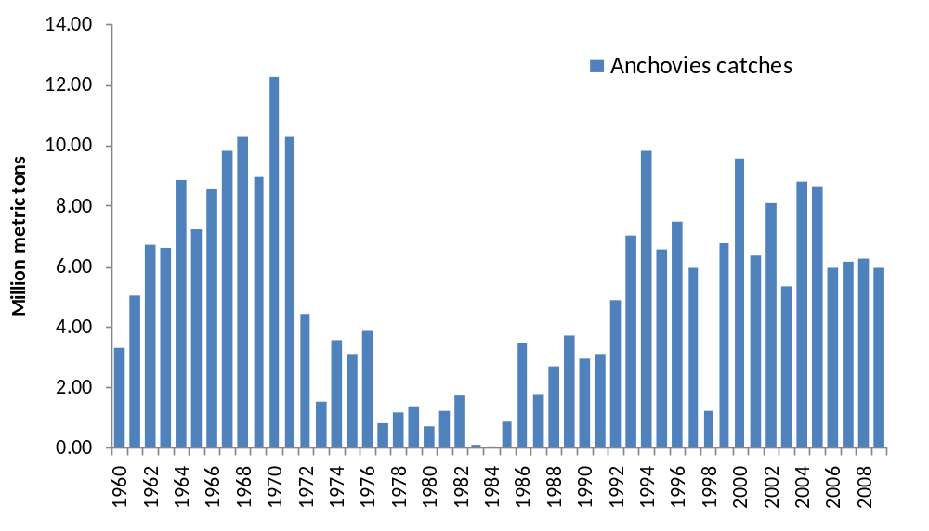
Figure 7. Historical catches of anchovies from 1960 to 2009 (FAO/Ministry of Production in Peru)

Peruvian anchovy is mainly utilized by the fishmeal industry for processing to fishmeal and fish oil. Recently the industry has started to utilize anchovy for products destined directly for human consumption, mainly canned and sometimes fresh, frozen or salted. Less than 1% is destined for human consumption products. However, recently this use was close to zero so 1% utilization of anchovies catches for consumption means that this use has expanded rapidly during the last decade.
The Peruvian anchovy fishery is characterized by very large fluctuations. During the last fifty years catches have varied from a record high of 12.3 million tonnes in 1970 to a record low of 23 thousand tons in 1984 as shown in Figure 1. The El Niño climate event increases the temperature of the sea surface water in the South-East Pacific and suppresses upwelling of cold nutritious water. As a result the anchovy stock tends to diminish drastically when these events occur. Such were the results in 1972, 1982-83 and 1997-98 as can be seen in Figure 1. However, catches have been fairly stable from 2000 to 2009 compared to the historical landings. The average annual catch during this period was 7.1 mmt.
Natural variability is not the only explanation for fluctuating landings. Poor fishery management has exasperated variability in catches of anchovies with especially severe consequences in the 1970s, leading to a prolonged period of 15 years with relatively low catches. At the same time, the fishery management has fostered widespread economic inefficiencies caused by the race for fish (Paredes & Gutierrez, 2008). From 1960 to 2008 the political regime in Peru ranged from a military populist dictatorship in the 1970s with subsequent nationalization of the fishmeal industry, to democratic regimes in the 1980s that led to hyperinflation and economic collapse of the Peruvian economy. Then in the 1990s followed the right-wing government of president Fujimori with privatization of the fishmeal processing industry and liberalization of the economy combined with a high level of corruption. These regime changes neither helped to spur a stable fishery management regime nor to enforce the institutions that regulate and monitor the fisheries.
The General Law of Fisheries (Ley General de Pesca No 25977) introduced in 1992 meant that building of new vessels for fishing anchovies required decommissioning of existing ones (Aranda 2009). However, a recuperated stock of anchovies plus an increasing international demand for fishmeal and fish oil gave the privatized fishmeal industry incentives to expand capacity. A weak regulatory regime thus allowed the number of fishing vessels and processing plants to expand during the 1990s with deteriorating effects on profitability. Financing from banks fuelled the investments that led to overcapacity and, ultimately, brought several companies in this industry to the edge of bankruptcy resulting in exit of some companies (Cayo & Paredes, 2002). Paredes and Gutierrez (2008) estimated that the resulting overcapacity implied an annual rent dissipation of about USD400 million.
The fleet that targets anchovy consists of 1200 purse seiners. The fleet consists of two distinct segments: The large scale fleet and the wooden fleet. The former comprises 608 boats mostly made of steel and larger than 120m3 of fish-hold capacity. The wooden fleet is locally named the ‘Viking’ fleet, so called because of the shape of the hull. This fleet comprises 592 boats that range from 30 to 119m3 of fish-hold capacity. During recent years, concern has arisen with respect to the fishing activities of these boats due to the fact that some of them lack satellite-tracking devices and are thus prone to committing illegal fishing in the first five nautical miles, which is the zone reserved for artisanal fishing (Aranda, 2009). In this zone, fishing for production of fishmeal is forbidden by the General Law of Fisheries.
Paredes and Gutierrez (2008) estimated the overcapacity of the fishing fleet in 2007 to be between 2.5 and 4.6 times its optimal size, and the fishmeal and fish oil processing capacity to be 3 to 5 times its optimal size. One of the most apparent effects of the overcapacity situation on fishing activity was a reduction of the annual number of fishing days. The annual number of fishing days in the Peruvian anchovy fishery decreased from 270 in 1986 to 50 in 2007 (Paredes, 2010). In the same period the number of active fishing vessels increased from 950 to 1250.
During the last decade there has been an ongoing consolidation in the fishmeal industry. In 2009 the seven largest companies accounted for 50% of the fishing fleet and 80% of the fishmeal production (Instituto Español de Comercio Exterior 2010). The fleet of steel vessels is predominantly owned by large vertically integrated companies that process anchovies into fishmeal and fish oil, while the fleet of wooden vessels comprises mostly individual boat owners. When the IVQ system was introduced in June 2008, the government used separate initial quota-allocation mechanism for the two segments of the fishing fleet. Individual vessel quota allocation to steel vessels was based on historical catches (i.e., best year of catches since 2004) and hull capacity, very similar to the initial vessel-quota allocation criteria that was used in Chile almost a decade earlier (Peña-Torres, 2002; Gomez-Lobo, Peña-Torres & Barria 2011). For the wooden fleet, the initial quota allocation was only based on historical landings (Aranda 2009).
The new management system, introduced by legislative decree no. 1084 of June 2008, came into effect in January 2009 and appears to have put an end to the race for anchovies (Tveterås, Paredes & Peña-Torres, 2011). The IVQs also appear to have increased profitability of the fisheries due to the following reasons. First, the individual quotas allow for more efficient usage of fishing effort capacity and even if the IVQs are not directly or ‘per se’ transferable, a company that owns several fishing vessels can nevertheless pool individual quotas into a smaller number of vessels. Also, there is the option to rent IVQs between vessels with different owners for a maximum of three years. These two elements allow for some degree of quota transferability and thus lead to a more cost-efficient use of fleet capacity. Second, the individual quotas allow for more predictable catches. This provides stronger incentives to improve the quality of fish landings, on the one hand, and to invest in value-added production such as premium grade fishmeal (e.g., prime and super prime) and consumer products such as canned anchovies, on the other. The largest integrated fishmeal producer TASA reported that its share of steam dried (i.e., high-quality) fishmeal increased from 51% in 2008 to 76% in 2009, while its share of Fair & Average Quality (FAQ) fishmeal decreased correspondingly from 49% to 24% the same two years (Ferreyros, 2010). This sudden shift in the output mix is most likely due to more efficient use of existing capacity to produce premium grade fishmeal. Also note that average landing prices of anchovies rose 37% from 2008 to 2009 (Galarza, 2010), which reflects that the reform effectively shifted negotiating power from the fishmeal processor to the vessel owner. For the same reason, artisanal vessels that have quota permits to catch anchovies within the 5-mile zone for human consumption are sometimes caught supplying illegally fishmeal processing plants with raw material.

3.1 Fish meal and fish oil processing
Fishmeal is used as a protein input in feeds for farmed fish and animal husbandry, thus this is labeled fish for indirect human consumption since it will eventually be part of edible fish (aquaculture) or meats (chicken and pork). The increased growth factor associated with the use anchovy meal provides in starter feeds for animals is due to its content of essential amino and fatty acids, and is greatly appreciated in the food and feed industry. Fishmeal is also a popular input in pet foods.
Fishmeal and fish oil are produced by a continuous and carefully controlled process which involves cooking, pressing, drying and milling of fresh, raw fish: anchovy. Yields of fishmeal and fish oil can vary between fish species and even from season to season, but typically around 17 – 22% fishmeal and 5 –15% fish oil will be obtained by processing.
Fishmeal and fish oil processing technology currently in Peruvian plants is imported from Norway and some other Scandinavian countries. Purse seiner fishing fleets, some formerly Spanish or Mexican, have been rebuilt into faster and better vessels at Peruvian shipyards with a lot of technical success.
As Peruvian processing sector for fishmeal and fish oil is capital intensive it does not need much labour force; moreover, plants are run by engineers, some assistants and some workers for general maintenance and security. The key personnel are professional technicians and chemists at the different lab tasks.
The fish meal industry has been going through a process of consolidation and currently there are 58 companies that participate in exports of fishmeal and fish oil. The largest companies include TASA, Corporación Pesquera Inca, Pesquera Hayduk, Austral Group Pesquera Industrial El Ángel and Pesquera Diamante. Based on exports volumes, the four-firm concentration ratio is around 50%. In terms of international fishmeal and fish oil prices there is little reason to believe that these companies exert much influence in terms of market power.
Fishmeal and fish oil are exported mainly to China and Europe. Peru is the largest exporting country of fishmeal in the world because of the large Anchovy fisheries. Export prices are available on monthly and yearly basis through several sources to be crosschecked, such as: Aduanet, Sociedad Nacional de Pesqueria, Ministerio de la Produccion (Produce) and international sources include OilWorld and Eurostat.

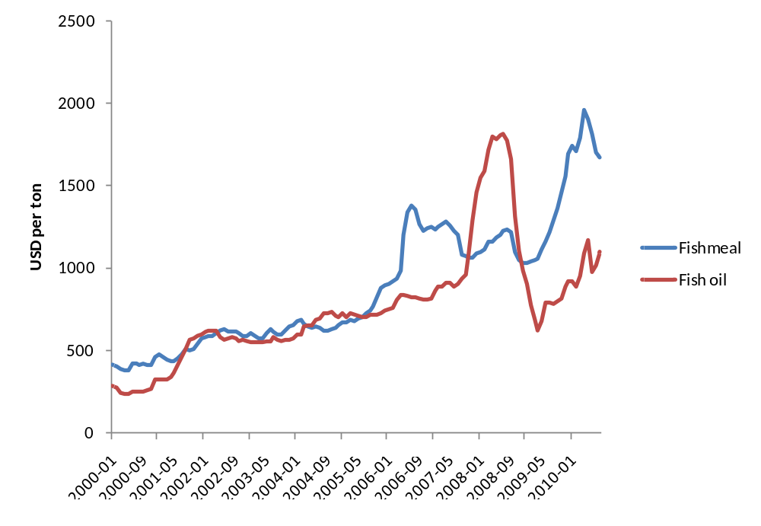
Figure 8. CIF fish meal and fish oil prices from January 2000 to August 2008 (Ista Mielke OilWorld).
The marketing of Anchovy for direct human consumption has been proposed in order to reduce starvation and malnutrition, mainly for low income groups in Peru. However, the predominant use is for canned anchovy marketed in groceries stores and large supermarket chains. The price tag of these products means that the main market is middle class Peruvians. An even larger share is exported to markets that have traditions for eating canned sardines products. The use of anchovy for direct human consumption is important for the artisanal fleet because several of these boats have license for fishing of anchovy within the 5-mile limit.

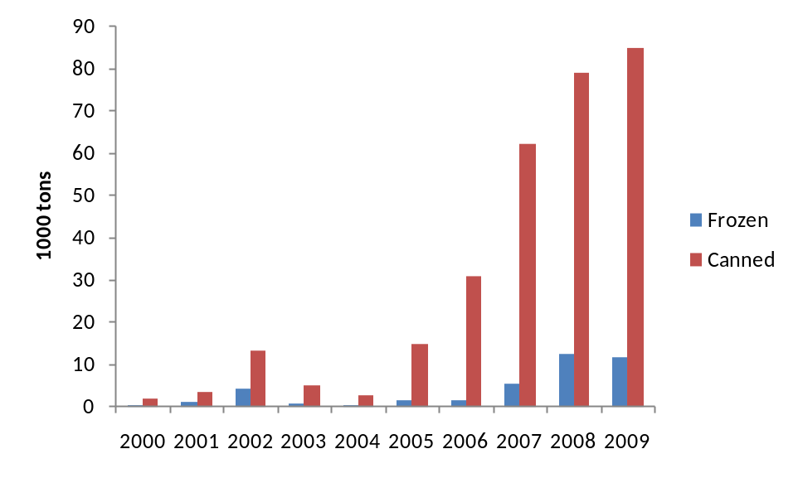
Figure 9. Anchovy in canned and frozen products, 2000-2009 (Ministry of Production)
Figure 9 shows the volumes of anchovy that are destined for direct human consumption in frozen and canned products. Fresh anchovy for human consumption is becoming more frequent to find neighborhood markets, but the volumes are still so small that they are not published in official statistics. Availability of fresh anchovy depends on geographical proximity of markets to landing ports, the so called “terminales pesqueros”. Frozen anchovy is currently processed to become future canned anchovy in order to ensure availability of fish during bans. This presentation has a foreign demand also.
Canned anchovy is nowadays the most common presentation for human consumption, with three well known brands offering this product in oil, tomato sauce and sometimes with olive oil at some delicatessen rare markets. The canned anchovy formerly cheap and thought for popular markets is becoming a medium class product due to local marketing places and its profile of export product. Moreover, the Anchovy only represents approximately 10% of the production costs of the canned product so for this reason cannot be very cheap.
Several of the fishmeal companies mentioned above participate in the market of Anchovy products for human consumption, basically canned products. This is a market that consists of several competing brands based on Anchovy and other anchovies/sardines species. There are also exports of these products to few countries such as Colombia and Brazil.
The volume of anchovy products for direct human consumption is still modest. Wholesale local prices of whole anchovy used for consumption are only available from 2007 at Produce (for Minka wholesale local market). Local production prices of anchovy products for human consumption are unavailable (canned anchovy in oil or tomato sauce). These are confidential data for producing companies.
The availability of time series data on retail prices in Peru needs to be explored further. Local retail prices are not yet published by public agencies. Export price data, on the other hand, can be collected from Peruvian customs agency.
Employment in anchovy fishing involves nearly 40,000 fishermen and additional members of their families. Periodical official fishing bans are imposed by the government in order to preserve a sustainable level of the species biomass. This leads to uneven income flows for fishermen throughout the year, who then have to migrate to other small activities during bans. Peruvian minimum official income is set at USD 160 per month for any labor activity. During the fishing season: this salary rises according to labor demand, fish availability and fishing quotas per vessel. Independent fishermen, i.e. artisanal fishermen, who own their small fishing vessels, could gain revenue about 15% of the current export price of fishmeal, before operational and financial costs have been taken into account. Modern canning plants use women for labelling and packaging.
Fishers’ Associations: Federación de Integración y Unificación de Pescadores Artesanales del Perú (FIUPAP), Asociación Nacional de Empresas Pesqueras Artesanales del Perú (ANEPAP) and Asociación de Pescadores del Perú.
Current Peruvian anchovy catches (quota limit) of 5.8 million tons of raw fish are equivalent to 1.35 million tons of fishmeal and 203 thousand tons of fish oil. Almost the entire volumes are destined for the export market.

3.3 Government regulations and monitoring of fisheries activities
In 2009 Peruvian authorities introduced a new management system for anchovy based on individual vessel quotas. As explained above this system has had a positive impact on the fishery (Tveteras, Paredes & Peña-Torres, 2011). Some of the main regulations and control & monitoring efforts related to this management regime are as follows:
- A formal declaration of holds capacity is compulsory
- Entry of new fishing boats is closed
- Licenses required to fish within the 200 mile limit and to land catches
- Security satellite tracking of all boats operating outside the 5 mile limit 24 hour
- Independent recording of landings at 134 unloading points
- Revoking of licenses is in force for any breach of rules
There are additional controls and information systems - many imposed to protect the landings of fish for direct human consumption. The Ministry of Production publishes every day on its web site the name of the vessels authorized to go out fishing as well as the vessels prohibited to do so.
The processing plants that received landed fish are not authorized to accept fish coming from vessels without valid license or from artisanal vessels. The plants must stop receiving fish if there is any failure in their processing equipment in order to protect the environment.
In order to prevent deterioration of the raw material, fish transportation in bulk in artisanal boats or trucks is prohibited. It is prohibited to land fish from artisanal vessels using systems of pumps and pipes.
There are about 100 operational processing plants with a capacity of 9,000 metric tons of raw material/hour. About 12,000 persons are employed in processing jobs. Fishmeal plants must possess a working license from the Ministry of Production and a health certification from ITP (Instituto Tecnologico Pesquero). Plants must also have HACCP systems in place and many are working towards implementing quality control systems such as FEMAS and some have also an ISO certification.

4. CASE STUDY TWO:

SHRIMP AQUACULTURE

Shrimp aquaculture of Penaeus vannamei takes place along the Northern coastline of Peru using intensive and semi-intensive production systems. The climate in the north is suitable for this shrimp species, which thrives in warm temperature zones. Furthermore land prices have been low, as there have been little competing uses of the land and, as a result, made entry easier.
Shrimp cultivation in Peru in ponds in mangrove areas and near seashore using seawater and can therefore be classified as marine culture. The ponds are usually located close to the sea shore. This lowers the cost of pumping seawater to the ponds. Depending on the capital-intensity of the system, the ponds can be equipped with e.g. plastic-lining, roofing and oxygen-enhancing systems. Relatively few producers in Peru operate own laboratories for egg production, so the industry has to a large degree relied on imports of larvae from Ecuador.
The Peruvian shrimp industry has experienced some turbulent times. First, El Niño in 1998 destroyed much of production facilities and infrastructure due to heavy rain in the north of Peru. In 1999 came the white spot disease and reduced production levels further. Finally, a fall in international prices in the 2000s reduced profitability of the Peruvian industry. First in 2004 production volumes started to recuperate to pre-1998 levels. Thus, all of these factors contributed to a shortage of shrimp for domestic consumption.
As a side note, it can be mentioned that these difficulties led to an intensification of many of the production systems. Infrastructure needed to be rebuilt, and because of the threat of the white spot disease more investments in management and technology was introduced as measures to reduce risk of new disease outbreaks (Berger, Quispe and Talavera, 2004)
Official monthly production (harvesting) data are available since 2003 (Ministerio de la Producción). Domestic sales volumes of shrimp are also available on a monthly basis.
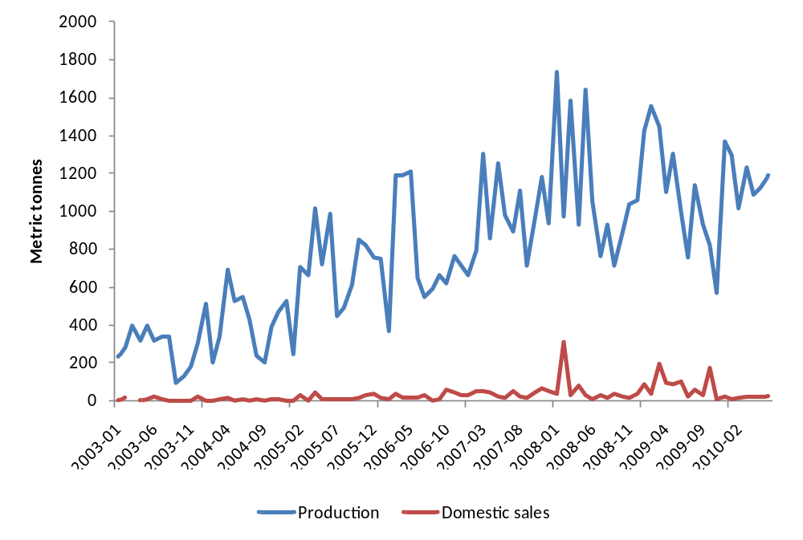
Figure 10. Domestic production and sales of farmed shrimp Jan 2003 – Jun 2010 (Ministry of Production).
Domestic producer prices are unavailable or, at least, difficult to obtain. One reason for this is that most of the production is exported. Small producers that are not able to market their products internationally, often sell to larger producers, which then ship the produce abroad. However, these transactions are not publically registered.
Wholesale shrimp prices from a fish market in Lima, Villa Maria, have only been recorded from 2008. The available wholesale prices from 2008 to 2010 are reported as minimum and maximum prices, so we must use the mean as of these as an estimate of the actual average price. The limited availability of domestic prices is related to events at the end of the 1990s, when the industry experienced several setbacks in production that led to a shortage of shrimp for the domestic market.
Now we look at the availability of export and import prices of Peruvian shrimp. Export prices need to be extracted from official trade data (Aduanet). This is feasible, but laborious because data from individual shipments of shrimp must be identified to construct, say, monthly unit values. Alternatively, the Ministry of Production might be able to provide monthly figures of shrimp trade. This remains to be confirmed.
Monthly US and EU import prices of Peruvian shrimp are available. We have access to import statistics to both of these markets, i.e., value and quantity figures on a product basis.

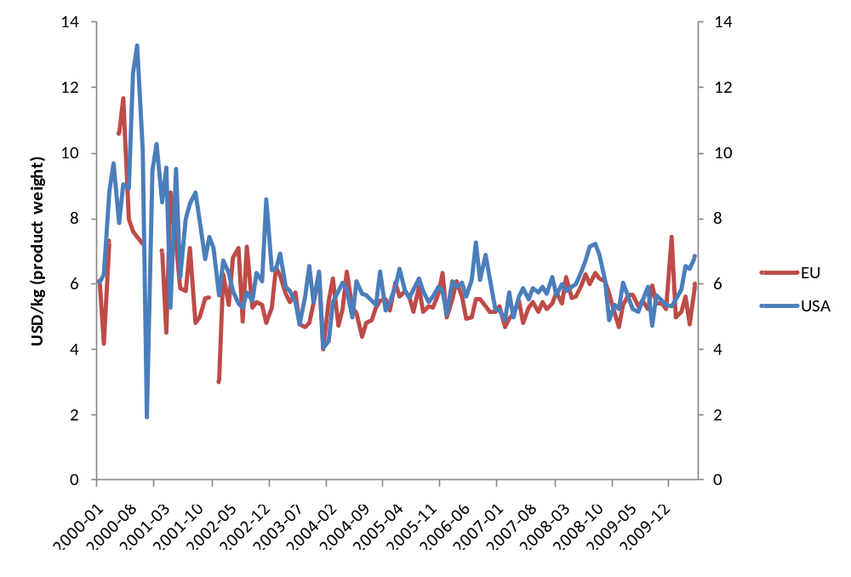
Figure 11. Monthly import prices of Peruvian frozen shrimp to EU and USA from 2000 to 2009 (NMFS and Eurostat).
There are no official statistics on employment and income in the shrimp aquaculture sector. Statistics here must rely on reports and studies. A study by Berger, Quispe and Talavera (2004) suggests employment figures of 5000 persons during the high season. The same study indicates that each hectar of shrimp farms using semi-intensive production systems employ 02.-0.4 workers. If we multiply this number with the current (2010) number of hectars that have been authorized for shrimp production this gives a range of 1130-2260 employees on a permanent basis. Some of these farms are intensive and require 1.5-2 employees per hectar.
Another more recent document, however, suggests that direct employment is 4 500 and indirect employment 12 000. These figures include all activities related to the industry, including processing. We have not found any data sources yet as most effort have been to identify quantity and price statistics that are required for the econometric analysis.
There is a trade association, Acuicultura de Langostinos en el Perú (ALPE). This association represents 18 companies. However, there are many producers outside of this association.
- Products produced (e.g. fresh, salted, dried, canned, refrigerated or frozen)
The majority of shrimp shipped to the EU and USA is peeled or shell-on frozen, which requires freezing facilities and facilities for primary processing. These types of primery processing constitute the largest part of the shrimp production. Very small quantities are further processed. Mostly international shipping that would normally take 15-20 days to reach their destinations in freezer containers with temperatures of minus 35 degrees Celsius.
The Tumbes region in the North of Peru is where most of the shrimp farming is located. In this region the industry employs an approximate 1500 workers for processing plants, the majority of which are woman (Berger, Quispe and Talavera, 2004).
Most of the production is exported, which means that Peruvian shrimp producer competes in the international value chain. The main markest are USA and European countries. Of 13 425 metric tonnes (live weight) produced in 2009, 939 metric tonnes (product weight) was sold domestically. Converted to live weight this can correspond to a figure around 10% of the total production. This shows that a modest but significant part of farmed shrimp in Peru is marketed nationally.

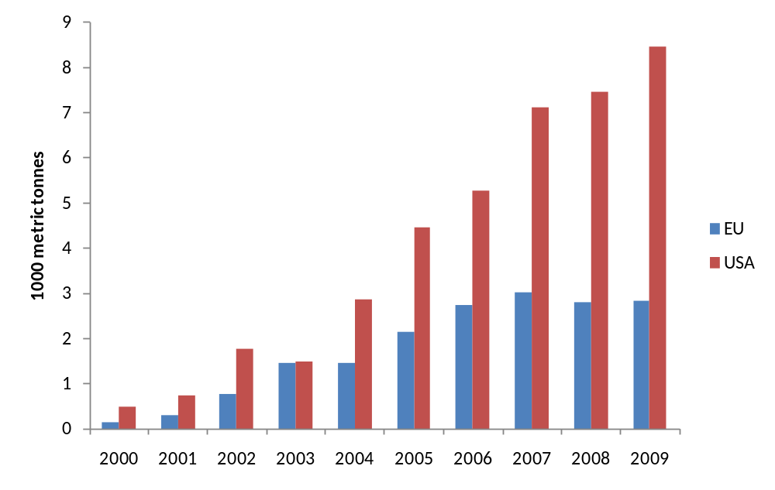
Figure 12. Annual imports of Peruvian frozen shrimp, product weight, to EU and USA from 2000 to 2009 (NMFS and Eurostat).
The main regulation in shrimp aquaculture is relates to the requirements that must be fulfilled to obtain a permit for aquaculture production. The basic requirement for obtaining a permit is conducting an environmental impact study, which must be carried out by a certified consultant.
There is also a domestic market, as farmed shrimp is found in supermarkets and restaurants around the country. Little information is available about which are the companies which supply the local market. As was mentioned above, there is data from 2008 of some quantities of shrimp being sold in wholesale Lima market.
The industry consists of 54 individual producers of where the distribution is approximately 50/50 of which have registered either as small-scale or large-scale producers.

5. CASE STUDY THREE:

TROUT AQUACULTURE IN PERU
Rainbow trout (Oncorhynchus mykiss) is found in freshwaters across Andean Peru but is not a native species. The species was introduced from Canada in the 1920s to supplement the food supply and provide poor Andean communities working in the mining industry with a much needed boost of protein in their diets. Despite not being native, trout have not only survived, but thrived in many places across the country. It seems there that in all Andean lakes and rivers where it was introduced it has remained.
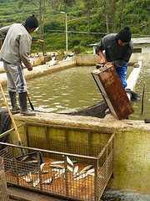
Fish farms exist along the banks of many Andean rivers and lakes, and commercial breeding and farming of trout is increasing. Using the river water to fill and filter various tanks for fish of various stages of development, costs are low and fish yield is high.

Figure 13. A freshwater trout farm in Peruvian highlands.
Peru has advantages in trout production because it has optimal climatic conditions and water bodies for growing commercial-size trout in eight to 10 months, while the normal is 11 to 12 months. Specifically, the Puno region has considerable water resources (Lake Titicaca has 17,400 hectares) suitable for fish farming of which only 4.5% is exploited. These resources have favored the existence of about 400 companies dedicated to trout production in Puno.
Piscifactorias De los Andes, which is the main trout exporting company in Peru, is supplied by its own production and other companies. The company invests in a trout processing plant in Puno and plans, as strategic partner of this project, to provide training and cooperate with local trout producers to develop a sustainable production chain with export quality standards.
According to a report by the Peruvian Association of Aquaculture Professionals (Asoppac), trout production grew the most, with an increase of 19 per cent. This was followed by tilapia (14.5 per cent) and shrimp (7.5 per cent).
According to Asoppac, this increase is due to improved performance of the product prices at international level, the main destinations were Canada, Norway and Germany.
The main destinations for Peruvian trout exports are Europe, United States and Canada, where local production has fallen and imports have increased. In terms of value, these shipments generated USD 3.7 million, a figure which shows an increase of 27.3 per cent compared to last year, as per the Maximixe consultancy. The main destination for Peruvian trout was Germany, where demand increased by 182.3 per cent. Ranked behind was Canada, with a 14.4 per cent increase between January and August 2009, and Norway, with an increase of 4.9 per cent. Maximixe confirmed that during the analyzed period, Peruvian trout was also exported to France and Russia, although the shipments were still relatively small.
Peru mainly exported frozen trout fillets (60 per cent), frozen trout (35 per cent), fresh or chilled trout (4.8 per cent) and the remainder was used for other preparations and canning. During the first eight months of the year, the leading exporter of trout was Piscifactorías de Los Andes S.A., with 95 per cent of the total export value, whilst the remaining 4.9 per cent came from the Peruvian Aquaculture Company.
A multilateral development bank (BID?) signed Memorandum of Understanding with Swisscontact, a NGO, with support of Piscifactorias De los Andes.
In a first stage the project has benefit 30 companies and later another 400 dedicated to small-scale trout breeding on the banks of lakes Titicaca and Lagunillas.
Some 30 microenterprises benefited from the "Model for trout competitiveness in the Puno region" project through which the Andean Development Corporation (CAF) and Swisscontact will offer technical support and institutional strengthening to small-scale breeders of this species in the localities of Pomata and Santa Lucía on lakes Titicaca and Lagunillas, respectively.
CAF was aiming to consolidate, coordinate and strengthen a network of trout breeders through actions to develop their breeding techniques, implement quality management systems in their operations, and commercial linkage.
With the alliance formed with the Piscifactorias De los Andes company, the project reinforces the work of training, quality guidelines and linkage to the trout producer market in the Puno region, in a scheme in which all the chain gains competitiveness. This private initiative is also part of the priorities of the public sector, for example, the Sierra Exporter Program - as well as the Technical Standards Program for export of aquatic species which Promperu is promoting.
Puno is the main trout producer, so there will be a broad demonstrative and replication effect in the sector, particularly taking into account that the technicians who give the training are local so they will be able to offer advice to more companies in the area in the future.
The direct impact of the project will be on 30 small-scale trout breeders, there is clear potential to scale up the impact of linkage to the target group of the 400 trout breeders that operate in Puno.
The chain will also be strengthened by the value added which the project will receive from linkage with a processing plant to be set up by Piscifactorias De los Andes, the largest export company in the market.
Achieving a standardized production will permit participants in the chain to access developed markets and improve profitability levels. The increased competitiveness of fish farming will favor the region, and improve the socioeconomic situation of the population of the Puno districts of Pomata and Santa Lucia.
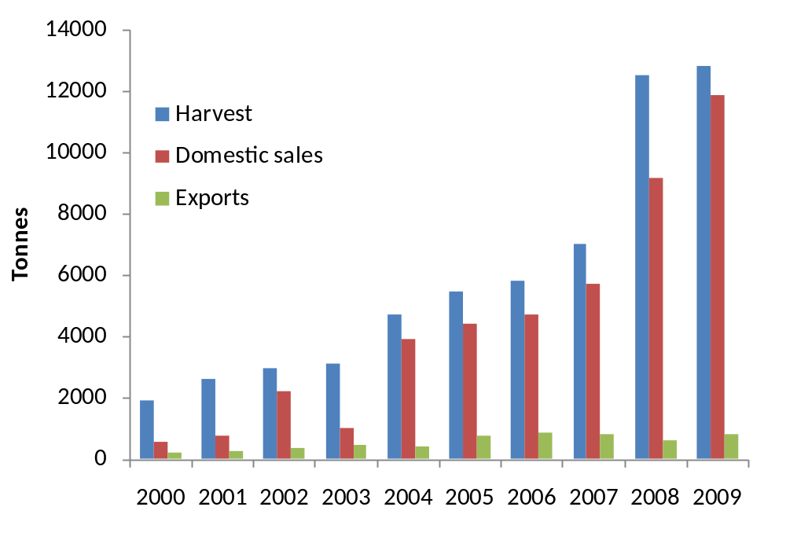
Figure 14. Domestic production, sales and export of trout in volume 2000-2009 (Ministry of Production)

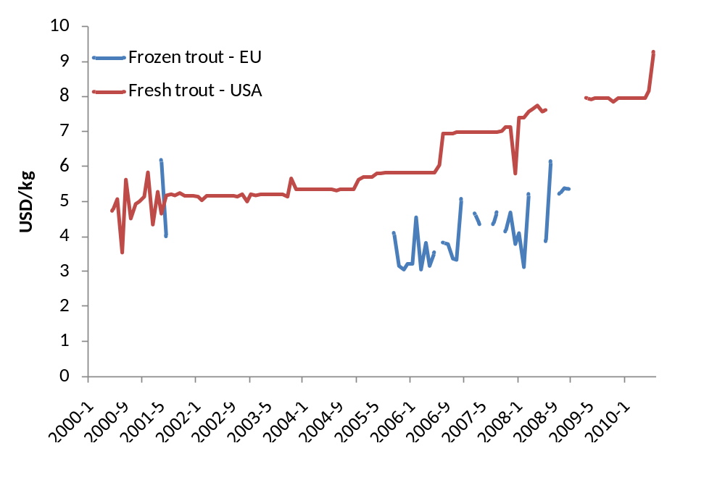
Figure 15. Import prices of Peruvian frozen trout to EU and fresh trout to USA (Eurostat and NMFS)
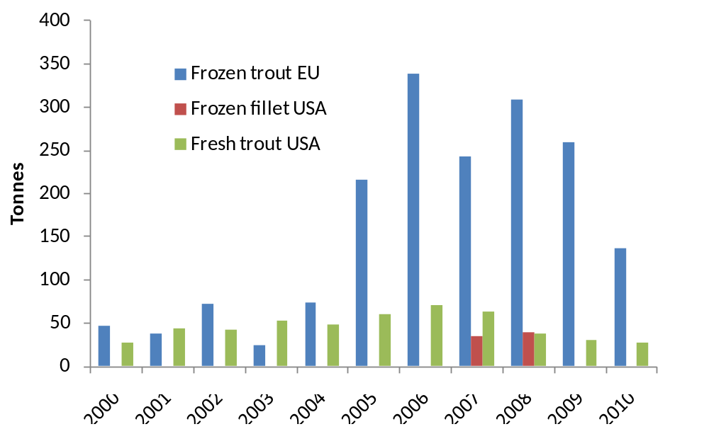
Figure 16. Import volumes from Peru of principal trout products to EU USA, product weight (Eurostat and NMFS).
Piscifactorias De Los Andes people consider that trout breeding at industrial level is an emerging activity in Peru which has grown 25% annually in the last five years with a total production of 5,800 tons which positions the country as 11th world producer.

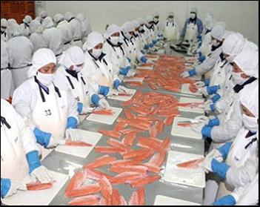
Figure 17. Trout processing.

6. CASE STUDY FOUR:

SCALLOP AQUACULTURE IN PERU
Scallops (Argopecten Purpuratus), which is a marine bivalve mollusk of the Pectinadae family is found all along the Peruvian coast where it is more widely known as “conchas de abanico”. Scallops live along coastal zones of south America from Panama down to Coquimbo (Chile), at 5 to 30 meters deep in the ocean and temperatures from 13º y 28º C. Under these conditions they spawn all year long, with specially high productivity during El Nino events as this leads to higher water temperatures.
In Peru, the production zones are at the coastal part in the region of Ancash, mainly in Samanco and Guaynuma; while in Lima, there is an important zone at Pucusana. There are also huge natural scallop schools at Pisco (Ica), Paracas, Sechura (Piura), Lobos de Tierra (Lambayeque), Bahía de Independencia and Isla San Lorenzo (Lima).
The production of scallops in Peru includes both wild harvest and aquaculture. Wild harvest is mostly artisanal small-scale activity while in aquaculture there are producers that have closed to production cycle and produce at relatively large volumes. The wild harvest is subject to Peruvian fisheries laws and is regulated through harvesting bans and restrictions based in scientific evidence and socioeconomic factors.
Aquaculture of scallops, on the other hand, is subject to the Law of Promotion and Development of Aquaculture, which gives authorizations for marine areas in order to develop this activity in its diverse forms and allows establishment production facilities (laboratories) for the production of larvae for reproduction purposes. The scallop aquaculture is rapidly increasing as an export-oriented industry where most of the scallops are shipped as frozen products; whereas the wild harvest go mainly to the local market (fresh and frozen).
In addition to preservation of the seafood resource, marine culture offers enormous advantages by allowing the control of the natural processes of scallop’s development, without altering them, but extracting of them the biggest possible profit, thus obtaining both biological and economical excellent results.
As per estimations of the Peruvian Society of Fisheries (SNP), the private industry association, every 100 hectares of farming of scallops require an investment of two millions dollars and it produces next to 140 MT per year, generating direct employments for more than 200 people. However, the permanent supply of larvae is the critical point in marine culture. This activity needs a huge support to guarantee this kind of supply. This problem remains the same for farmed scallops, which larvae can be obtained using the following systems: Natural reception of post-larvae made by placing collectors, plastic mesh bags, in the natural banks. Reproduction of larvae in laboratories or hatcheries.
The extraction of scallops under 65 mm is banned. Maximum volumes of daily extraction by vessel are subordinated to periods of plenty (or scarcity) of the species.
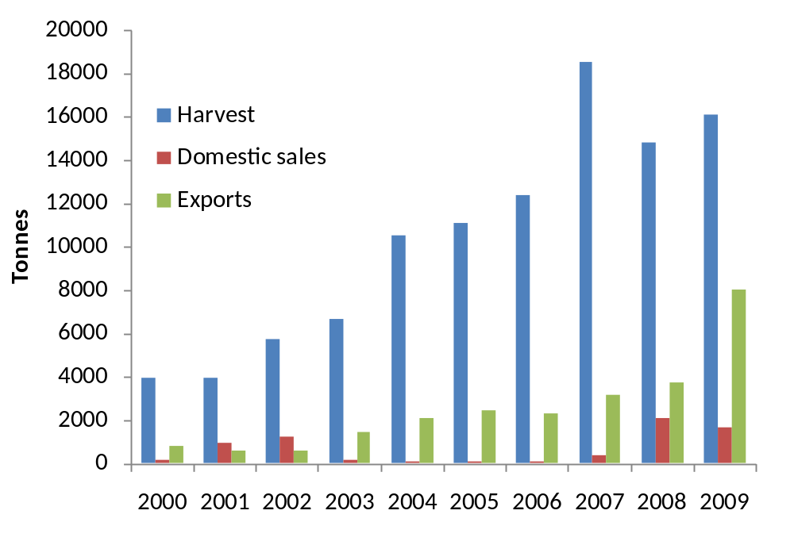
Figure 18. Harvest, domestic sales and export volumes of scallops, 2000-2009 (Ministry of Production).

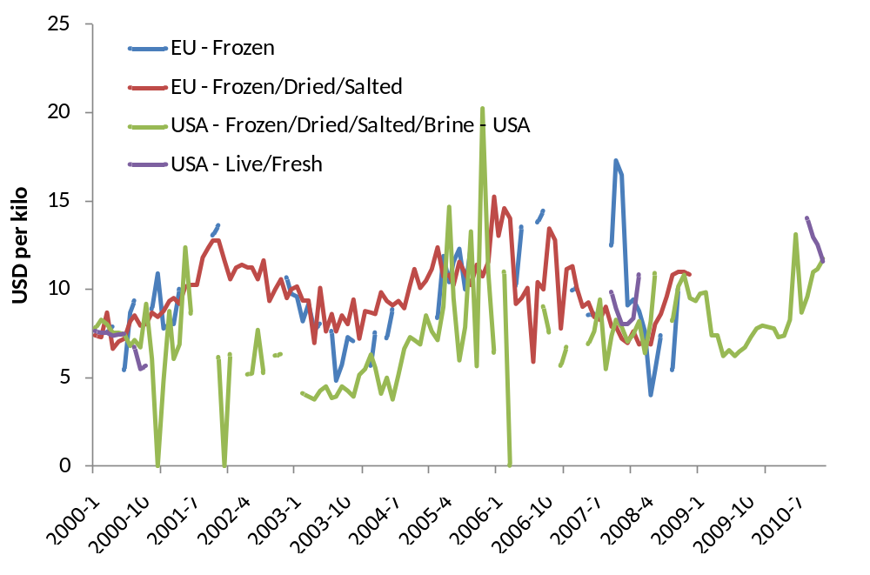
Figure 19. Import prices for scallop products to EU and USA, 2000-2010 (Eurostat and NMFS)

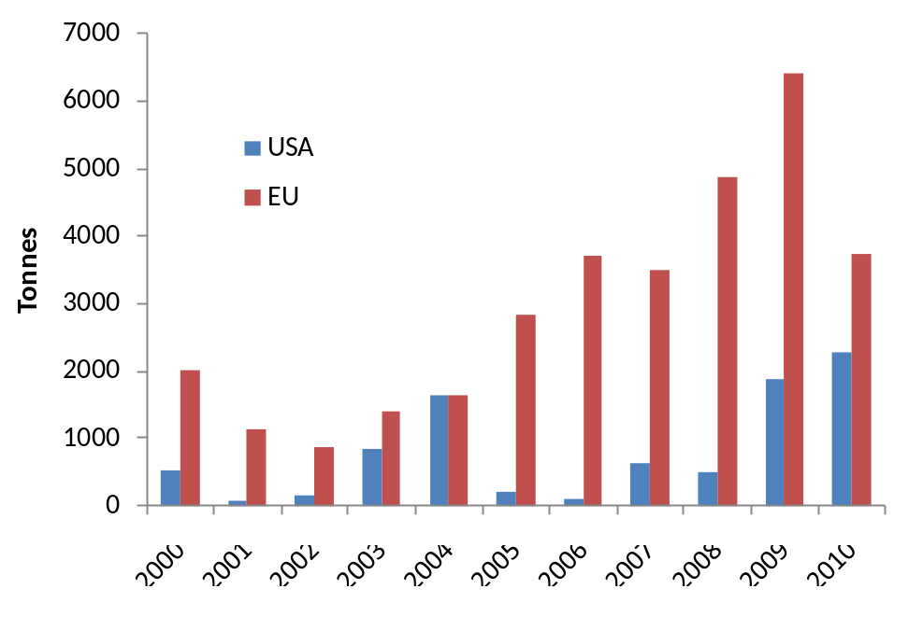
Figure 20. Export volumes of scallops to EU and USA, 2000-2010 (Eurostat and NMFS)
There are no restrictions for the farming of scallops. The commercialization is free at any stages of the species. Thus, securing the production of scallop larvae out of the authorized farming area by means of the installation of collectors’ installation.
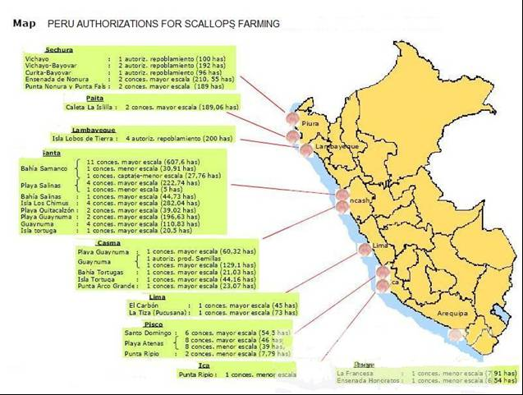
Figure 21. Authorization of scallop farming (Ministry of Production).
Scallops are a popular type of shellfish in both Eastern and Western cooking. They are characterized by having two types of meat in one shell: the adductor muscle, called "scallop" which is white and meaty, and the roe, called "coral", which is red or white and soft.
In European cuisine, scallops are commonly “sautéed” in butter, or else breaded and deep fried. Scallops are commonly paired with light semi-dry white wines. When a scallop is prepared, the byssus, also called the beard, which tends to be tough, is usually discarded or used later on for stock. Sometimes, markets sell scallops already prepared in the shell, with only the adductor muscle intact. Outside the U.S. the scallop is often sold whole.
World demand of scallops is concentrated in frozen. Imports of scallops, on a global scale, are growing in volumes with a small contraction in prices average of imports. According to lines of products, the “canned” products represent about two thirds of the demand on a global scale.
World production led by species comes from marine culture. World production of scallops is about 2 million MT. China is one of the main producers of marine scallops, as well as Japan. The production of scallops in the northern Americas is covered completely by aquaculture. Canada is also a main exporter of scallops. Peru contributes as one the top ten top in the ranking of world production of scallops.
There are excellent conditions in Peru for the aquaculture of scallops: wide experience in aqua farming, favorable climate in the coastal areas, availability of cheap labor, good positioning as a fishing country, less costs compared to other aquaculture species since feeding is not costly, high natural productiveness reflected in the rapid growth of scallops and periodic presence of El Nino accelerating the natural process of the species. As fishing catches are limited due to bans and restrictions, the market waits to be covered by aquaculture products. Thus, there is a great demand of scallops on the international market and Peru is a strategic geographic place to access the North American market, where demand is increasing, and to reach the European markets.
On the other hand, some weaknesses have been found in Peruvian aquaculture of scallops: specific farming zones, high informality in the productive chain, concentration of exports in few companies, lack of enough laboratories to control production, conflicts between the economic agents (artisanal workers – established aquaculture companies - the government) standing behind a lack of national agreements for production, conflicts in the development of the activity and programs of natural conservation, depredation of natural banks, insufficient cold chain, limited technical assistance and little management capacity as well as lack of a control system of the reproduction in captivity, lack of a sanitary alert system.

7. SUMMARY
Fishery and aquaculture are important industries and important employers along the coast and in certain regions of the Andes Mountains. However, as in many other developing countries, there are substantial parts of the economic activity in these sectors that can be characterized as artisanal. Seafood is one of the most traded food products and as such there are potential benefits for producers to participate in international value chains. First of all is the prospect of receiving higher prices for ones products and second is to obtain more stable incomes. While there are Peruvian exports of all of four species presented in the case studies above, there many small-scale producers in Peru have are unable to access international markets. This is amongst other because they are unable to meet certification requirements needed. However, a more general problem is lack of know-how and capital.
Given that the benefits of participating in international fish trade are considerable there are policy measurements that can be implemented to increase the share of the fishery and aquaculture sector participating in export-oriented activities. As a next step, we will analyze trade data on to obtain a better understanding of the international value chains where Peruvian seafood exports participate and how benefits are distributed throughout the chain.

References

Aranda, M. (2009). Developments on fisheries management in Peru: The new individual vessel quota system for the anchoveta fishery. Fisheries Research , 96, 308-312.
Berger, C., Quispe, M. and Talavera, V. (2004). Programa Nacional para la competitivdad de la acuicultura langostinera en el Perú 2005-2014. Asociación langostinera Peruana (ALPE).
Cayo, J. M. and C. H. Paredes. 2002. La Superación de la Crisis Financiera. (Overcoming the financial crisis.) in Libro de Oro de la Pesquería Peruana - 50 Años, Lima, Peru: Sociedad Nacional de Pesquería, 209-234.
Galarza, Elsa (ex-Vise-minister of fisheries). 2010. Individual Quotas for Anchoveta Fishery in Perú. Results of the first year of implementation, presentation at the seminar Économie des services écosystémiques et gestion de la Biodiversité, L´École de Ponts ParisTech, University of Paris, París, 24 September 2010. http://cermics.enpc.fr/~delara/EcoBiodiv2010/talk_Galarza.pdf (last accessed 18 March, 2011).
Gomez-Lobo, Andres, Julio Peña-Torres and Patricio Barria (2011). “ITQs in Chile: Measuring the Economic Benefits of Reform", Environmental and Resource Economics, 48(4), 651-678.
Instituto Español de Comercio Exterior. El sector de la Pesca y Acuicultura en el Perú. Lima: Oficina Económica y Comercial de la Embajada de España en Lima, 2010.
Ministerio de la Producción. Plan Nacional de Desarrollo Acuícola, December 2009.
Paredes, C. E. (2010). Reformando el Sector de la Anchoveta Peruana: Progreso Reciente y Desafíos Futuros. Universidad de San Martín de Porres. Lima: Instituto del Perú.
Paredes, C. E., & Gutierrez, M. (2008). The Peruvian Anchovy Sector: Costs ans Benefits. An analysis of recent. IIFET Conference Proceedings 2008. Portsmouth.
Peña-Torres, J. 2002. Debates sobre Cuotas Individuales Transferibles: ¿‘Privatizando’ el Mar? ¿Subsidios? o ¿Muerte Anunciada de la Pesca Extractiva en Chile?, Estudios Públicos 86 (Mayo): 183- 222
Ministerio de Producción del Perú (2010). Plan Nacional de Desarrollo Acuícola. Dirección General de Acuicultura, Despacho Viceministerial de Pesquería, Peru.
NMFS. National Marine Fisheries Service, USA
Eurostat, EU
Ferreyros, G. 2010. Presentation at International Fishmeal and Fish Oil Organization conference in Miami, 12-14 April 2010.
Froese, Rainer, and Daniel Pauly, eds. (2006). "Oncorhynchus mykiss" in FishBase. February 2006 version.
"Oncorhynchus mykiss". Integrated Taxonomic Information System. Retrieved 30 January 2006.
Scott and Crossman. (1985) Freshwater Fishes of Canada. Bulletin 184. Fisheries Research Board of Canada.
Tveteras, S., Paredes C.E. & Peña-Torres, J. (2011). IVQs in Peru: Stopping the Race for Anchovies. Forthcoming in Marine Resource Economics.

Appendix

Price and quantity data: European import data

Table A1. Volume and unit value of imported Peruvian anchovy products to Europe (Eurostat)
 | Anchovy, engraulis, frozen |  | Anchovy, salted |  | Anchovy, prepared/conserved, whole/pieces
Date | USD/kg | Mt | USD/kg | Mt | USD/kg | Mt
1996M01
1996M02
1996M03 | $1.85 | 13 | $0.94 | 53
1996M04 |  |  | $1.00 | 91
1996M05 |  |  | $0.96 | 83 | $3.64 | 22
1996M06 |  |  | $1.08 | 78
1996M07 |  |  | $0.86 | 300
1996M08 |  |  | $0.95 | 81
1996M09 |  |  | $1.00 | 42 | $6.09 | 11
1996M10 | $1.75 | 16 | $1.40 | 15
1996M11
1996M12 |  |  | $0.99 | 127
1997M01
1997M02 |  |  | $0.96 | 192
1997M03 |  |  | $0.99 | 152
1997M04 |  |  | $1.00 | 209
1997M05 |  |  | $1.08 | 185
1997M06 |  |  | $1.02 | 86
1997M07 |  |  | $0.93 | 359 | $3.40 | 5
1997M08 |  |  | $0.98 | 209
1997M09 |  |  | $1.07 | 125
1997M10 |  |  | $1.12 | 132
1997M11 |  |  | $1.19 | 48
1997M12 |  |  | $1.13 | 195
1998M01 |  |  | $1.15 | 136
1998M02 |  |  | $0.86 | 69
1998M03 |  |  | $1.21 | 91
1998M04
1998M05
1998M06 |  |  | $1.38 | 13
1998M07
1998M08 |  |  | $1.23 | 97
1998M09
1998M10
1998M11
1998M12 |  |  | $1.20 | 15
1999M01
1999M02
1999M03 |  |  | $0.88 | 41
1999M04
1999M05
1999M06 |  |  | $1.02 | 64
1999M07 |  |  | $1.00 | 12 | $3.72 | 39
1999M08 |  |  | $1.01 | 70 | $3.81 | 26
1999M09 |  |  |  |  | $3.81 | 26
1999M10 | $0.96 | 23 | $0.89 | 19 | $3.74 | 53
1999M11 |  |  | $0.78 | 64 | $3.62 | 26
1999M12
2000M01 |  |  | $1.13 | 23 | $3.81 | 26
2000M02 |  |  | $0.77 | 22 | $3.65 | 26
2000M03 |  |  | $0.86 | 49 | $2.40 | 10
2000M04 |  |  | $0.88 | 25 | $3.21 | 76
2000M05 |  |  |  |  | $2.96 | 26
2000M06 |  |  | $0.90 | 109 | $3.00 | 26
2000M07
2000M08 | $1.50 | 2 | $0.98 | 42 | $2.38 | 29
2000M09 |  |  | $0.94 | 109
2000M10 |  |  | $0.95 | 43 | $2.96 | 26
2000M11 | $1.08 | 13 | $0.98 | 46 | $2.93 | 27
2000M12 |  |  | $0.91 | 43 | $3.13 | 52
2001M01 |  |  |  |  | $3.00 | 49
2001M02 |  |  | $0.88 | 41 | $3.89 | 18
2001M03 |  |  | $0.73 | 79 | $2.92 | 64
2001M04 |  |  | $0.88 | 43 | $3.37 | 63
2001M05 |  |  | $0.91 | 200 | $3.37 | 67
2001M06 |  |  | $0.98 | 56 | $2.13 | 8
2001M07 |  |  | $0.90 | 67 | $3.00 | 26
2001M08 |  |  | $1.03 | 40 | $4.00 | 4
2001M09 |  |  | $1.34 | 89 | $2.98 | 50
2001M10 |  |  | $0.83 | 63 | $4.53 | 15
2001M11 |  |  | $1.00 | 44 | $2.88 | 56
2001M12 |  |  | $0.91 | 22 | $2.98 | 52
2002M01 |  |  | $0.88 | 24 | $2.95 | 40
2002M02 |  |  | $0.98 | 44 | $2.98 | 40
2002M03 |  |  | $0.82 | 22 | $2.88 | 26
2002M04 |  |  | $0.55 | 22
2002M05 |  |  | $1.01 | 91 | $2.96 | 26
2002M06 |  |  |  |  | $3.09 | 64
2002M07 |  |  | $1.04 | 23
2002M08 |  |  |  |  | $3.31 | 13
2002M09
2002M10 |  |  | $0.86 | 22 | $3.15 | 39
2002M11 |  |  | $0.86 | 7 | $3.06 | 34
2002M12 |  |  |  |  | $3.06 | 18
2003M01 |  |  | $0.68 | 22 | $3.56 | 18
2003M02
2003M03 |  |  | $0.68 | 22 | $3.26 | 35
2003M04 |  |  |  |  | $3.38 | 66
2003M05 |  |  | $1.05 | 22 | $3.31 | 39
2003M06 |  |  |  |  | $3.26 | 87
2003M07 | $0.64 | 11 |  |  | $2.81 | 26
2003M08 | $0.67 | 48 |  |  | $3.72 | 36
2003M09 | $0.75 | 44 |  |  | $2.92 | 26
2003M10 | $0.71 | 48 |  |  | $2.98 | 52
2003M11 |  |  |  |  | $3.89 | 18
2003M12 |  |  |  |  | $3.32 | 65
2004M01 |  |  | $4.11 | 18
2004M02 |  |  |  |  | $2.88 | 26
2004M03 |  |  |  |  | $3.00 | 71
2004M04 | $1.00 | 1 | $2.08 | 62 | $2.97 | 29
2004M05 |  |  |  |  | $2.88 | 52
2004M06 | $0.75 | 8
2004M07 |  |  |  |  | $3.62 | 39
2004M08 | $0.67 | 3 |  |  | $2.88 | 26
2004M09 |  |  | $1.43 | 14 | $4.29 | 76
2004M10 | $0.85 | 13 | $1.24 | 33 | $3.01 | 78
2004M11 | $0.86 | 14 |  |  | $3.73 | 78
2004M12 |  |  |  |  | $3.00 | 26
2005M01 |  |  |  |  | $2.86 | 78
2005M02 |  |  |  |  | $4.40 | 63
2005M03 |  |  |  |  | $2.96 | 78
2005M04 |  |  |  |  | $2.88 | 78
2005M05 |  |  | $1.05 | 22 | $3.58 | 78
2005M06 |  |  |  |  | $3.89 | 63
2005M07
2005M08 | $0.67 | 3 |  |  | $3.56 | 41
2005M09 |  |  | $4.58 | 24
2005M10 |  |  |  |  | $3.67 | 42
2005M11 |  |  |  |  | $2.92 | 52
2005M12 |  |  |  |  | $4.01 | 78
2006M01 |  |  | $1.09 | 23 | $5.74 | 73
2006M02 |  |  |  |  | $4.76 | 49
2006M03 |  |  |  |  | $2.91 | 78
2006M04 |  |  |  |  | $6.68 | 37
2006M05 | $1.00 | 6 |  |  | $4.78 | 63
2006M06 |  |  |  |  | $5.68 | 31
2006M07 |  |  |  |  | $3.26 | 91
2006M08 | $0.75 | 8 |  |  | $5.59 | 99
2006M09 | $0.73 | 15 |  |  | $6.00 | 70
2006M10 | $0.71 | 7 |  |  | $5.03 | 97
2006M11 |  |  | $1.07 | 54 | $4.37 | 63
2006M12 | $1.43 | 40 |  |  | $3.61 | 88
2007M01 |  |  | $1.57 | 23 | $5.32 | 122
2007M02 |  |  |  |  | $5.34 | 67
2007M03 | $1.00 | 6 |  |  | $5.09 | 76
2007M04 | $1.83 | 6 |  |  | $5.02 | 96
2007M05 |  |  |  |  | $4.86 | 125
2007M06 |  |  | $1.16 | 75 | $3.86 | 71
2007M07 |  |  | $0.95 | 19 | $4.85 | 59
2007M08 | $1.40 | 35 | $1.33 | 36 | $4.04 | 25
2007M09 | $1.88 | 8 |  |  | $5.37 | 60
2007M10 |  |  |  |  | $4.67 | 18
2007M11 |  |  | $1.00 | 6 | $6.07 | 54
2007M12 | $0.69 | 51 | $9.08 | 13 | $4.60 | 117
2008M01 | $0.96 | 46 |  |  | $5.71 | 113
2008M02 | $0.71 | 77 | $2.95 | 38 | $5.82 | 50
2008M03 | $0.00 | 1 |  |  | $7.10 | 51
2008M04 | $0.75 | 4 | $2.08 | 61 | $6.36 | 84
2008M05 | $1.86 | 7 |  |  | $6.29 | 51
2008M06 | $0.74 | 23 |  |  | $8.81 | 21
2008M07 | $0.73 | 26 | $3.15 | 48 | $6.42 | 72
2008M08 |  |  | $6.08 | 13 | $9.08 | 12
2008M09 | $0.92 | 93 | $1.22 | 18 | $7.03 | 58
2008M10 | $0.94 | 237 | $5.60 | 20 | $5.82 | 57
2008M11 | $1.02 | 121 | $5.42 | 12 | $7.28 | 72
2008M12 | $0.89 | 153 | $6.07 | 14 | $5.30 | 70
2009M01 | $1.57 | 7 |  |  | $5.81 | 27
2009M02 | $1.03 | 32 |  |  | $5.27 | 70
2009M03 | $1.11 | 163 | $5.73 | 15 | $5.69 | 42
2009M04 | $1.57 | 21 | $5.38 | 40 | $5.10 | 77
2009M05 | $1.67 | 6 | $5.74 | 38 | $5.64 | 44
2009M06 | $1.64 | 39 | $5.50 | 26 | $7.41 | 68
2009M07 | $1.17 | 111 | $5.15 | 20 | $4.19 | 26
2009M08 | $0.72 | 218 | $5.38 | 13 | $5.36 | 85
2009M09 | $1.73 | 11 |  |  | $4.23 | 22
2009M10 | $2.05 | 19 | $5.19 | 16 | $6.72 | 82
2009M11 | $1.88 | 40 | $6.09 | 32 | $8.06 | 53
2009M12 | $1.38 | 72 |  |  | $6.84 | 58
2010M01 | $1.91 | 32 | $5.21 | 14 | $5.46 | 125
2010M02 | $1.70 | 20 |  |  | $11.69 | 16
2010M03 |  |  | $6.00 | 35 | $5.28 | 93
2010M04 |  |  | $9.67 | 3 | $8.08 | 49
2010M05 |  |  | $2.09 | 69 | $5.54 | 156
2010M06 | $2.00 | 6 | $3.70 | 27 | $5.17 | 47
2010M07 | $1.85 | 20 |  |  | $6.25 | 60
2010M08 | $2.33 | 6 | $0.86 | 22 | $4.27 | 95
2010M09 | $1.75 | 20 | $6.06 | 17 | $6.07 | 87
2010M10 | $2.00 | 20 |  |  | $5.00 | 110
2010M11 | $1.38 | 29 |  |  | $4.88 | 89
2010M12 | $0.98 | 84 | $4.71 | 7 | $5.19 | 149
2011M01 | $2.00 | 20 |  |  | $4.29 | 155

Table A2. Volume and unit value of imported Peruvian shrimp to Europe (Eurostat)
 | Shrimp, other, frozen |  | Shrimp, penaeus, frozen
Date | USD/kg | Mt | USD/kg | Mt
1996M01 | $6.10 | 59
1996M02 | $6.75 | 219
1996M03 | $6.40 | 245
1996M04 | $6.07 | 257
1996M05 | $6.41 | 251
1996M06 | $6.24 | 147
1996M07 | $3.48 | 333
1996M08 | $6.97 | 116
1996M09 | $6.79 | 96
1996M10 | $6.65 | 192
1996M11 | $7.00 | 244
1996M12 | $6.64 | 277
1997M01 |  |  | $6.42 | 122
1997M02 | $5.38 | 13 | $6.64 | 99
1997M03 | $6.85 | 20 | $7.17 | 178
1997M04 | $7.26 | 42 | $7.17 | 152
1997M05 |  |  | $7.31 | 134
1997M06 |  |  | $6.28 | 135
1997M07 |  |  | $7.18 | 92
1997M08 | $5.76 | 21 | $6.87 | 128
1997M09 |  |  | $7.62 | 69
1997M10 |  |  | $6.96 | 96
1997M11 | $10.00 | 1 | $6.80 | 98
1997M12 | $17.14 | 7 | $6.24 | 202
1998M01 |  |  | $6.08 | 127
1998M02 |  |  | $7.07 | 88
1998M03 | $5.91 | 22 | $6.43 | 54
1998M04 | $7.31 | 13 | $8.09 | 101
1998M05 |  |  | $8.21 | 151
1998M06 | $15.20 | 5 | $7.51 | 158
1998M07 | $6.61 | 38 | $6.58 | 199
1998M08 | $4.82 | 51 | $7.65 | 201
1998M09 | $6.16 | 31 | $7.57 | 275
1998M10 |  |  | $6.80 | 142
1998M11 | $6.45 | 11 | $7.44 | 298
1998M12 | $5.06 | 47 | $6.27 | 227
1999M01 | $5.80 | 20 | $5.89 | 66
1999M02 |  |  | $5.89 | 84
1999M03 | $4.00 | 1 | $5.48 | 81
1999M04 |  |  | $6.21 | 67
1999M05 | $7.11 | 9 | $6.07 | 27
1999M06 |  |  | $6.08 | 98
1999M07 |  |  | $7.12 | 236
1999M08 | $5.00 | 2 | $6.15 | 98
1999M09 |  |  | $6.55 | 22
1999M10 |  |  | $8.27 | 85
1999M11 | $3.83 | 6 | $6.14 | 123
1999M12 | $4.67 | 3 | $6.31 | 101
2000M01 |  |  | $6.09 | 11
2000M02 | $4.15 | 13
2000M03 |  |  | $7.32 | 22
2000M04
2000M05 |  |  | $10.58 | 12
2000M06 |  |  | $11.67 | 3
2000M07 |  |  | $8.00 | 1
2000M08 | $6.25 | 4 | $7.83 | 24
2000M09 | $6.83 | 6 | $7.88 | 8
2000M10 | $8.33 | 6 | $6.81 | 16
2000M11
2000M12 |  |  | $5.88 | 8
2001M01
2001M02 |  |  | $7.00 | 2
2001M03 | $4.38 | 8 |  | 0
2001M04 | $8.93 | 15 | $8.25 | 4
2001M05 | $8.22 | 9 | $6.97 | 34
2001M06 |  |  | $5.86 | 37
2001M07 |  |  | $5.76 | 34
2001M08 |  |  | $7.10 | 10
2001M09 |  |  | $4.80 | 10
2001M10 |  |  | $5.00 | 52
2001M11 |  |  | $5.59 | 46
2001M12 |  |  | $5.57 | 44
2002M01
2002M02 |  |  | $3.00 | 1
2002M03 |  |  | $6.29 | 7
2002M04 |  |  | $5.38 | 53
2002M05 |  |  | $6.82 | 28
2002M06 |  |  | $7.09 | 23
2002M07 | $3.24 | 25 | $5.05 | 185
2002M08 | $6.73 | 22 | $7.69 | 16
2002M09 | $4.14 | 21 | $5.64 | 69
2002M10 |  |  | $5.45 | 55
2002M11 | $3.89 | 44 | $5.86 | 131
2002M12 | $3.86 | 44 | $5.62 | 50
2003M01 | $4.50 | 20 | $7.83 | 6
2003M02 | $10.57 | 7 | $5.33 | 24
2003M03 | $12.00 | 8 | $5.73 | 91
2003M04 | $10.10 | 10 | $5.44 | 173
2003M05 | $5.39 | 33 | $5.47 | 120
2003M06 | $14.00 | 1 | $5.67 | 145
2003M07 |  |  | $4.78 | 197
2003M08 | $4.80 | 20 | $4.68 | 212
2003M09 | $16.00 | 1 | $4.71 | 135
2003M10 | $6.70 | 30 | $4.85 | 73
2003M11 | $6.90 | 49 | $5.64 | 44
2003M12 |  |  | $3.98 | 59
2004M01 |  |  | $5.49 | 80
2004M02 | $6.90 | 29 | $5.58 | 38
2004M03 | $5.50 | 12 | $4.61 | 71
2004M04 | $6.17 | 53 | $4.79 | 113
2004M05 | $8.00 | 9 | $6.04 | 46
2004M06 | $5.80 | 15 | $5.19 | 85
2004M07 | $5.06 | 34 | $5.20 | 10
2004M08 |  |  | $4.39 | 221
2004M09 | $7.75 | 8 | $4.69 | 177
2004M10 | $5.00 | 22 | $4.85 | 112
2004M11 |  |  | $5.29 | 284
2004M12 |  |  | $5.48 | 54
2005M01 | $4.60 | 20 | $6.09 | 35
2005M02 | $3.67 | 6 | $5.30 | 87
2005M03 | $5.00 | 1 | $6.03 | 90
2005M04 | $5.00 | 1 | $5.60 | 143
2005M05 | $13.00 | 1 | $5.74 | 121
2005M06 |  |  | $5.63 | 151
2005M07 |  |  | $5.15 | 103
2005M08 |  |  | $5.92 | 138
2005M09 | $6.50 | 2 | $5.14 | 229
2005M10 |  |  | $5.31 | 338
2005M11 |  |  | $5.27 | 449
2005M12 |  |  | $5.69 | 237
2006M01 |  |  | $6.32 | 81
2006M02 | $8.75 | 4 | $4.75 | 60
2006M03 |  |  | $5.54 | 107
2006M04 | $7.33 | 3 | $6.06 | 180
2006M05 | $10.00 | 1 | $5.60 | 242
2006M06 | $4.18 | 22 | $4.97 | 478
2006M07 |  |  | $5.00 | 208
2006M08 | $4.50 | 2 | $5.52 | 157
2006M09 |  |  | $5.51 | 227
2006M10 |  |  | $5.31 | 254
2006M11 | $4.70 | 20 | $5.21 | 258
2006M12 |  |  | $5.16 | 425
2007M01 |  |  | $5.34 | 226
2007M02 |  | 0 | $4.67 | 251
2007M03 | $17.00 | 1 | $4.90 | 252
2007M04 | $4.38 | 21 | $5.18 | 175
2007M05 | $8.25 | 8 | $5.36 | 210
2007M06 | $6.00 | 2 | $4.81 | 153
2007M07 |  |  | $5.27 | 325
2007M08 |  |  | $5.44 | 346
2007M09 |  |  | $5.15 | 274
2007M10 | $11.00 | 1 | $5.41 | 304
2007M11 | $4.46 | 24 | $5.29 | 320
2007M12 | $8.00 | 2 | $5.38 | 130
2008M01 |  |  | $5.76 | 149
2008M02 | $11.00 | 5 | $5.28 | 271
2008M03 | $7.50 | 8 | $6.17 | 217
2008M04 | $5.70 | 40 | $5.56 | 140
2008M05 | $5.41 | 61 | $5.68 | 239
2008M06 | $9.52 | 25 | $5.51 | 191
2008M07 |  |  | $6.28 | 307
2008M08 |  |  | $5.99 | 384
2008M09 |  |  | $6.34 | 200
2008M10 |  |  | $6.17 | 237
2008M11 | $5.67 | 27 | $6.18 | 123
2008M12 | $6.57 | 21 | $5.58 | 161
2009M01 | $5.46 | 13 | $5.06 | 78
2009M02 | $4.35 | 20 | $4.71 | 212
2009M03 | $4.12 | 17 | $5.42 | 252
2009M04 | $5.50 | 6 | $5.69 | 134
2009M05 | $4.80 | 85 | $6.79 | 66
2009M06 | $7.50 | 2 | $5.30 | 322
2009M07 | $6.10 | 10 | $5.49 | 276
2009M08 | $5.68 | 34 | $5.22 | 402
2009M09 | $8.25 | 4 | $5.94 | 297
2009M10 |  |  | $5.42 | 287
2009M11 | $7.20 | 5 | $5.37 | 172
2009M12 |  |  | $5.23 | 140
2010M01 | $11.00 | 1 | $7.37 | 68
2010M02 | $4.38 | 21 | $5.09 | 131
2010M03 |  |  | $5.15 | 186
2010M04 | $11.00 | 1 | $5.61 | 401
2010M05 |  |  | $4.78 | 167
2010M06 | $6.50 | 2 | $6.01 | 286
2010M07 |  |  | $5.95 | 413
2010M08 |  |  | $6.25 | 274
2010M09 |  |  | $5.59 | 135
2010M10 | $6.59 | 22 | $6.29 | 203
2010M11 |  |  | $5.95 | 472
2010M12 |  |  | $5.87 | 430
2011M01 |  |  | $6.52 | 151

Table A3. Volume and unit value of imported Peruvian trout to Europe (Eurostat)
 | Trout, frozen |  | Trout, frozen fillet |  | Trout, frozen fillet < = 400 g |  | Trout, frozen < = 1kg
Date | USD/kg | Mt | USD/kg | Mt | USD/kg | Mt | USD/kg | Mt
1996M01
1996M02 | $3.67 | 6 | $6.70 | 10
1996M03
1996M04
1996M05 | $6.75 | 8 | $3.63 | 8
1996M06
1996M07
1996M08 | $3.56 | 18
1996M09
1996M10
1996M11
1996M12 | $4.33 | 3
1997M01 | $3.20 | 5 | $5.88 | 8
1997M02
1997M03 | $2.67 | 3
1997M04 | $3.14 | 7 | $6.00 | 8
1997M05 | $3.77 | 13 | $6.63 | 8
1997M06 | $3.25 | 4
1997M07 | $4.25 | 4
1997M08 | $3.60 | 10 | $6.00 | 3
1997M09 | $4.40 | 5 | $6.38 | 8
1997M10
1997M11 | $3.33 | 12 | $6.33 | 6
1997M12
1998M01 | $3.74 | 19 | $6.20 | 10
1998M02
1998M03
1998M04 | $3.40 | 5 | $6.70 | 10
1998M05
1998M06 | $3.20 | 10 | $6.00 | 12
1998M07
1998M08 | $3.53 | 15 | $5.90 | 10
1998M09
1998M10
1998M11 | $3.33 | 15 | $6.25 | 8
1998M12
1999M01
1999M02
1999M03 | $3.36 | 14 | $5.75 | 8
1999M04
1999M05
1999M06 | $2.62 | 21
1999M07
1999M08 | $3.53 | 15 | $6.33 | 9
1999M09
1999M10
1999M11
1999M12 | $3.23 | 13 | $6.18 | 11
2000M01
2000M02
2000M03 | $3.43 | 7 | $6.40 | 15
2000M04
2000M05
2000M06
2000M07
2000M08
2000M09
2000M10
2000M11 | $3.45 | 11 | $5.93 | 14
2000M12
2001M01
2001M02
2001M03
2001M04
2001M05 |  |  | $6.17 | 12
2001M06 |  |  | $4.00 | 1
2001M07
2001M08
2001M09
2001M10 | $3.44 | 9 | $6.27 | 15
2001M11
2001M12
2002M01
2002M02 | $2.38 | 24
2002M03
2002M04 | $3.47 | 17 | $6.14 | 7
2002M05
2002M06
2002M07
2002M08
2002M09
2002M10
2002M11 | $3.54 | 13 | $6.36 | 11
2002M12
2003M01
2003M02
2003M03
2003M04
2003M05
2003M06 |  |  |  |  | $6.33 | 9 | $3.40 | 15
2003M07
2003M08
2003M09
2003M10
2003M11
2003M12
2004M01
2004M02
2004M03 |  |  |  |  | $5.89 | 9 | $3.19 | 16
2004M04
2004M05
2004M06
2004M07
2004M08
2004M09 |  |  |  |  | $6.40 | 5 | $3.47 | 19
2004M10
2004M11 |  |  |  |  | $6.33 | 3 | $3.86 | 21
2004M12
2005M01
2005M02
2005M03
2005M04 |  |  |  |  |  |  | $3.63 | 24
2005M05
2005M06
2005M07
2005M08
2005M09 |  |  |  |  | $6.36 | 14 | $3.32 | 41
2005M10 |  |  |  |  |  |  | $3.16 | 80
2005M11 |  |  |  |  |  |  | $3.04 | 28
2005M12 |  |  |  |  |  |  | $3.21 | 28
2006M01 |  |  |  |  |  |  | $3.21 | 28
2006M02 |  |  |  |  | $6.22 | 9 | $3.65 | 17
2006M03 |  |  |  |  |  |  | $3.04 | 28
2006M04 |  |  |  |  | $6.62 | 13 | $3.28 | 69
2006M05 |  |  |  |  |  |  | $3.14 | 28
2006M06 |  |  |  |  | $6.67 | 3 | $3.21 | 28
2006M07
2006M08 |  |  |  |  |  |  | $3.82 | 44
2006M09 |  |  |  |  |  |  | $3.77 | 22
2006M10 |  |  |  |  |  |  | $3.36 | 22
2006M11 |  |  |  |  | $3.33 | 3
2006M12 |  |  |  |  | $7.00 | 7 | $4.33 | 18
2007M01
2007M02
2007M03 |  |  |  |  | $7.67 | 9 | $3.89 | 35
2007M04 |  |  |  |  |  |  | $4.33 | 21
2007M05
2007M06
2007M07 |  |  |  |  |  |  | $4.33 | 21
2007M08 |  |  |  |  | $8.00 | 2 | $4.39 | 23
2007M09
2007M10 |  |  |  |  |  |  | $4.12 | 41
2007M11 |  |  |  |  | $7.60 | 10 | $4.17 | 58
2007M12 |  |  |  |  | $3.77 | 22
2008M01 |  |  |  |  |  |  | $4.08 | 39
2008M02 |  |  |  |  |  |  | $3.11 | 18
2008M03 |  |  |  |  | $8.38 | 13 | $4.43 | 53
2008M04
2008M05 |  |  |  |  |  |  | $3.42 | 19
2008M06
2008M07 |  |  |  |  |  |  | $3.84 | 19
2008M08 |  |  |  |  | $8.00 | 9 | $4.50 | 10
2008M09
2008M10 |  |  |  |  | $7.14 | 21 | $4.16 | 38
2008M11 |  |  |  |  | $9.33 | 3 | $4.63 | 16
2008M12 |  |  |  |  | $5.38 | 32 | $5.21 | 19
2009M01 |  |  |  |  |  |  | $4.33 | 18
2009M02 |  |  |  |  | $8.50 | 6 | $4.05 | 60
2009M03
2009M04
2009M05
2009M06
2009M07
2009M08 |  |  |  |  | $7.93 | 14 | $4.45 | 11
2009M09 |  |  |  |  |  |  | $3.67 | 42
2009M10 |  |  |  |  |  | 0 | $3.43 | 44
2009M11 |  |  |  |  |  |  | $3.41 | 22
2009M12 |  |  |  |  | $4.36 | 22 | $3.45 | 20
2010M01 |  |  |  |  |  |  | $3.92 | 24
2010M02 |  |  |  |  | $9.25 | 12 | $5.41 | 29
2010M03
2010M04 |  |  |  |  |  |  | $3.76 | 17
2010M05 |  |  |  |  |  |  | $4.23 | 40
2010M06 |  |  |  |  | $8.67 | 6 | $5.33 | 9
2010M07 |  |  |  |  |  |  | $4.70 | 20
2010M08
2010M09 |  |  |  |  |  |  | $6.00 | 26
2010M10 |  |  |  |  |  |  | $4.15 | 40
2010M11 |  |  |  |  | $4.40 | 5 | $4.09 | 35
2010M12 |  |  |  |  | $9.21 | 24 | $4.38 | 32
2011M01 |  |  |  |  | $5.33 | 3 | $4.14 | 76

Table A4. Volume and unit value of imported Peruvian scallop to Europe (Eurostat)
 | Scallop, other, frozen/dried/salted |  | Scallop, pecten maximus, frozen |  | Scallop, live/fresh
Date | USD/kg | Mt | USD/kg | Mt | USD/kg | Mt
1996M01 | $6.73 | 100 | $10.80 | 10 | $13.00 | 2
1996M02 | $8.47 | 49 | $11.12 | 67
1996M03 | $7.04 | 28 | $8.72 | 32
1996M04 | $8.58 | 33 |  |  |  | 0
1996M05 | $7.78 | 41 |  |  |  | 0
1996M06 | $8.72 | 61 | $10.71 | 17
1996M07 | $10.19 | 32 | $6.56 | 27
1996M08 | $8.49 | 39 | $6.43 | 7
1996M09 | $10.55 | 47 | $6.29 | 7
1996M10 | $10.97 | 37 | $2.60 | 5
1996M11 | $11.12 | 17
1996M12 | $5.00 | 1 |  | 0 | $15.50 | 6
1997M01 | $10.26 | 27
1997M02 | $10.36 | 25 | $8.17 | 6
1997M03 | $10.60 | 10
1997M04
1997M05
1997M06 | $11.05 | 22 | $10.53 | 17
1997M07 | $7.19 | 31 | $3.00 | 1
1997M08 | $8.55 | 47 | $4.50 | 2
1997M09 | $9.70 | 27
1997M10 | $7.31 | 29
1997M11 | $8.47 | 85
1997M12 | $9.85 | 130 |  |  | $11.00 | 1
1998M01 | $11.03 | 106 | $9.93 | 14
1998M02 | $10.76 | 133 | $8.18 | 11 | $7.79 | 19
1998M03 | $9.03 | 117 | $10.63 | 24
1998M04 | $9.48 | 112 | $9.25 | 32
1998M05 | $8.68 | 76
1998M06 | $9.38 | 181 | $9.17 | 18
1998M07 | $9.36 | 226 | $7.65 | 17 | $9.38 | 34
1998M08 | $9.34 | 328 | $9.71 | 17 | $7.86 | 36
1998M09 | $9.41 | 188
1998M10 | $9.83 | 315 | $8.94 | 35
1998M11 | $9.18 | 903 | $8.60 | 75
1998M12 | $8.93 | 468 | $7.89 | 37
1999M01 | $8.16 | 394
1999M02 | $7.35 | 362
1999M03 | $7.90 | 403 | $8.89 | 38
1999M04 | $8.16 | 362
1999M05 | $8.98 | 96
1999M06 | $7.63 | 267 | $9.14 | 21
1999M07 | $8.28 | 183
1999M08 | $7.47 | 228 | $7.46 | 41
1999M09 | $8.51 | 85 | $7.00 | 2
1999M10 | $8.13 | 174 | $6.40 | 30 | $10.00 | 1
1999M11 | $7.66 | 238 | $8.45 | 11
1999M12 | $8.26 | 267 | $7.94 | 34
2000M01 | $7.40 | 276
2000M02 | $7.32 | 120
2000M03 | $8.68 | 148 | $7.56 | 25
2000M04 | $6.67 | 106 | $7.87 | 30
2000M05 | $7.08 | 226
2000M06 | $7.26 | 144 | $5.40 | 10
2000M07 | $8.18 | 79 | $8.66 | 44
2000M08 | $8.56 | 97 | $9.34 | 58
2000M09 | $7.94 | 17
2000M10 | $8.00 | 34
2000M11 | $8.66 | 302 | $8.85 | 40
2000M12 | $8.46 | 221 | $10.93 | 30
2001M01 | $8.80 | 277 | $7.75 | 20
2001M02 | $9.31 | 123 | $8.00 | 30
2001M03 | $9.50 | 103 | $8.00 | 1
2001M04 | $9.22 | 101 | $10.00 | 20
2001M05
2001M06 | $10.16 | 37
2001M07 | $10.23 | 31
2001M08 | $10.28 | 43 | $12.82 | 11
2001M09 | $11.84 | 50
2001M10 | $12.35 | 40
2001M11 | $12.77 | 133 | $13.04 | 27
2001M12 | $12.80 | 66 | $13.60 | 10
2002M01 | $11.66 | 100
2002M02 | $10.58 | 67
2002M03 | $11.23 | 31 | $11.85 | 20
2002M04 | $11.41 | 61
2002M05 | $11.21 | 38
2002M06 | $11.26 | 31
2002M07 | $10.61 | 80 | $4.00 | 6
2002M08 | $11.68 | 40
2002M09 | $9.32 | 41
2002M10 | $9.98 | 82
2002M11 | $10.55 | 101
2002M12 | $9.52 | 124 | $10.63 | 30
2003M01 | $9.99 | 77 | $9.75 | 20
2003M02 | $10.14 | 90 | $9.58 | 19
2003M03 | $9.39 | 62 | $8.16 | 25
2003M04 | $9.37 | 91 | $9.17 | 18
2003M05 | $6.93 | 41 | $7.68 | 22
2003M06 | $10.05 | 41 | $8.00 | 20
2003M07 | $7.63 | 75
2003M08 | $8.59 | 95 | $7.65 | 20
2003M09 | $7.59 | 66 | $4.85 | 13
2003M10 | $8.53 | 81 | $5.75 | 36
2003M11 | $8.04 | 151 | $7.31 | 42
2003M12 | $9.42 | 252 | $7.06 | 32
2004M01 | $7.21 | 82
2004M02 | $8.81 | 37
2004M03 | $8.68 | 50 | $5.68 | 19
2004M04 | $8.60 | 10 | $7.55 | 20
2004M05 | $9.80 | 20
2004M06 | $9.38 | 112 | $7.24 | 33
2004M07 | $9.13 | 121 | $8.85 | 20
2004M08 | $9.34 | 124
2004M09 | $8.94 | 153 | $9.13 | 8
2004M10 | $10.25 | 208
2004M11 | $11.11 | 412
2004M12 | $10.05 | 184 | $9.79 | 19
2005M01 | $10.50 | 193
2005M02 | $11.15 | 96
2005M03 | $12.34 | 333 | $8.37 | 35
2005M04 | $10.74 | 91 | $11.88 | 32
2005M05 | $10.85 | 88 | $10.43 | 40
2005M06 | $10.28 | 142 | $11.55 | 20
2005M07 | $11.59 | 68 | $12.33 | 40 |  | 0
2005M08 | $10.91 | 208 | $10.00 | 14
2005M09 | $10.25 | 170 | $12.45 | 49
2005M10 | $11.40 | 98
2005M11 | $10.78 | 596 | $13.11 | 18
2005M12 | $11.55 | 502 |  | 0
2006M01 | $15.23 | 185
2006M02 | $13.07 | 208
2006M03 | $14.62 | 279
2006M04 | $14.06 | 276
2006M05 | $9.16 | 216 | $10.20 | 20
2006M06 | $9.54 | 285 | $13.50 | 4
2006M07 | $10.12 | 133
2006M08 | $5.94 | 374
2006M09 | $10.45 | 398 | $13.80 | 25
2006M10 | $10.01 | 354 | $14.45 | 33
2006M11 | $13.47 | 512
2006M12 | $12.83 | 379 | $11.14 | 29
2007M01 | $7.76 | 318
2007M02 | $11.16 | 80
2007M03 | $11.30 | 83 | $9.90 | 21
2007M04 | $10.07 | 169 | $10.13 | 24
2007M05 | $8.99 | 116
2007M06 | $9.29 | 181 | $8.50 | 6
2007M07 | $8.43 | 111 | $8.62 | 13
2007M08 | $8.32 | 309
2007M09 | $9.06 | 321
2007M10 | $7.84 | 290 | $12.47 | 15
2007M11 | $7.84 | 976 | $17.33 | 6
2007M12 | $7.20 | 444 | $16.50 | 6
2008M01 | $6.97 | 466 | $9.08 | 13
2008M02 | $7.62 | 372 | $9.42 | 19
2008M03 | $6.86 | 638 | $8.78 | 27
2008M04 | $7.08 | 396 | $7.64 | 11 | $8.63 | 8
2008M05 | $6.89 | 270 | $4.00 | 2
2008M06 | $8.03 | 205 | $5.42 | 12
2008M07 | $8.58 | 346 | $7.38 | 21
2008M08 | $9.61 | 214
2008M09 | $10.80 | 259 | $5.43 | 23
2008M10 | $11.03 | 398 | $10.03 | 29
2008M11 | $11.01 | 561
2008M12 | $10.81 | 536 | $8.64 | 55
2009M01 | $8.98 | 406
2009M02 | $7.78 | 267
2009M03 | $7.58 | 551 | $7.53 | 91
2009M04 | $7.21 | 459 | $7.40 | 10
2009M05 | $7.36 | 289
2009M06 | $6.48 | 406 | $5.55 | 47
2009M07 | $6.72 | 663 | $7.00 | 55
2009M08 | $6.34 | 417 | $5.70 | 20
2009M09 | $6.47 | 420 | $7.78 | 37
2009M10 | $6.97 | 462 | $6.72 | 43
2009M11 | $6.90 | 736 | $6.88 | 42
2009M12 | $7.09 | 992 | $4.00 | 3
2010M01 | $7.61 | 729 | $6.47 | 19
2010M02 | $7.31 | 451
2010M03 | $7.69 | 845
2010M04 | $8.30 | 520 | $5.14 | 7
2010M05 | $8.61 | 603 | $5.57 | 35
2010M06 | $9.08 | 505 | $9.11 | 18
2010M07 | $9.61 | 697 | $6.80 | 5
2010M08 | $9.60 | 528 | $8.70 | 44
2010M09 | $10.14 | 846 | $6.37 | 19
2010M10 | $10.56 | 707 | $8.58 | 57
2010M11 | $10.12 | 1545 | $8.65 | 40
2010M12 | $10.34 | 979 | $9.06 | 48 | $10.10 | 10
2011M01 | $10.81 | 696 | $11.67 | 15 | $12.20 | 10

Price and quantity data: US import data
…

