Healthy Vanuatu School Food Guidelines
Guidelines on the types of foods that should be sold or eaten at school
WHY DO WE NEED SCHOOL FOOD GUIDELINES?
Children eat about one-third of their day’s food at school, so it is very important that the foods they buy or bring to school are healthy and nutritious. Healthy eating and good nutrition helps school students to:
- Develop and grow properly, physically and mentally.
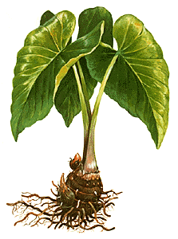
- Keep healthy and strong.
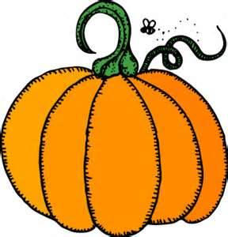
- Stop sickness and help recovery from sickness
- Keep active at all times.
- Learn well at school.
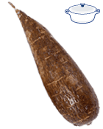
WHAT IS HEALTHY EATING?
Healthy eating is about:
- Eating a variety of foods.
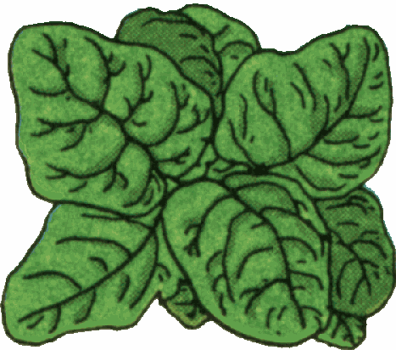
- Eating lots of locally produced fruits and vegetables.
- Drinking lots of water.
- Eating less sugar, salt and unhealthy fats.
- Eating less ‘rubbish’ food and soft drinks and avoiding over-eating.
HEALTHY SCHOOL FOOD GUIDELINES
The Ministry of Health and Ministry of Education have developed these school food guidelines, which all schools must follow.
- The table on the next page splits food into three groups: Energy Foods, Protective Foods, Body Building Food. All meals served at school must contain food from each group.
- The table shows foods that children and students should eat plenty, eat some or not eat at school.
- Eat Plenty Foods- These foods should be the main foods sold or served at school.
- Eat Some Foods- These foods can be sold or served at school, but in moderate amounts
- Do Not Eat at School- These foods must not be sold at school and students should be discouraged from bringing these foods into school.
- Always provide healthy drinks for students, such as juice made from local fruits, coconut water, milk or plain water. Cordials and fizzy drinks should not be sold.
- Always use iodised salt. Iodine is important for children’s brains, but only use small pinches of salt.
- Cooks should only use small amounts of oil, butter, salt and sugar in cooking.
- Food must be prepared in a clean and hygienic environment and all cooks must hold a current Food Safety Certificate. Under the Food Control Act it is the law that anyone who makes food to be sold or served to the public must have a Food Safety Certificate.
- Schools are not to make profits from selling food at the expense of students’ health and well-being. Schools should allocate funding from their annual Student Grants towards the running of the canteen and kitchen (e.g. gas, firewood, electricity) and any profits from food sales should be put back into the canteen to purchase healthy food for the children.
- Schools are encouraged to involve students in food preparation. This will teach them about healthy cooking and assist cooks to prepare meals more quickly.
SUITABLE AND UNSUITABLE FOODS FOR CHILDREN AND STUDENTS
 | Energy foods | Protective foods | Body-building foods
Eat plenty  These are healthy foods with the right amounts of vitamins, minerals, starchy carbohydrates and healthy fats. | Manioc, yam, taro, kumala, plantain banana, breadfruit, sweet potato, potato, avocado, coconut slices | All fresh fruits and vegetables  Herbs and spices – eg, onion, ginger, garlic, chilli  Frozen fruits and vegetables  Green coconut juice | Local fish and seafood  Meat – e.g., chicken, pork, beef (fat and skin cut off)  Milk, yoghurt, nuts (unsalted), egg, dry beans, lentils
Eat some  These foods are still good, but do not have as many vitamins and/or have some added sugar, unhealthy fats or salt. | Bread, rice, pasta, macaroni, pancake, cracker, sandwich, popcorn (unsalted), roti, coconut milk (watered down) | Tinned fruit (drained)  Tinned vegetables (drained)  local fruit juice or juice with water added | Tinned meat or fish (oil drained)  Meat with small skin or fat  Evaporated milk  Baked beans  Peanut butter, cheese
Do not eat at school  These are high in added sugar, unhealthy fats, or salt and lower in vitamins and minerals | Chinese noodles, pizza, fried potatoes, chips, bongos, gato, ice-cream, ice-block, sweet biscuit, cake, strong coconut milk, lollies, twisty, fizzy drink, cordial, doughnut, Jams, Omai, green peas, | Fruits tinned (not drained)  Tinned vegetables (not drained) fried vegetables, juice, | Tin meat or fish (not drained), sausages, bacon, condensed milk, fried fish or chicken

HEALTHY SNACK IDEAS
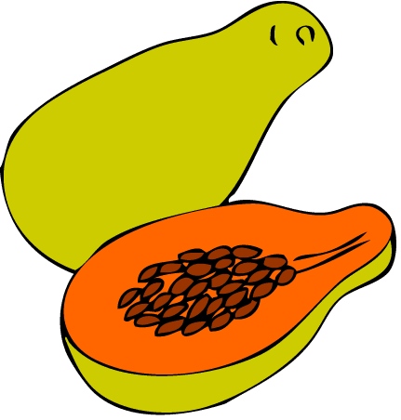
Here are some ideas for healthy snack foods and drinks, schools are encouraged to make other snacks from local foods:
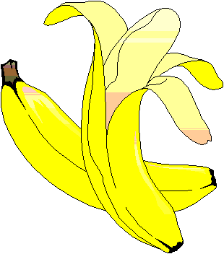
- Peanuts and other local nuts (unsalted)
- Popcorn (unsalted)
- Pancakes cooked in a little oil
- Boiled eggs
- Chopped fruit, vegetables and coconut wedges
- Local fruit juices, milk or coconut water.
- Bread with toppings such as egg, avocado, tomato, cucumber, peanut butter or banana
- Local foods such as simboro or boiled or baked root crops

