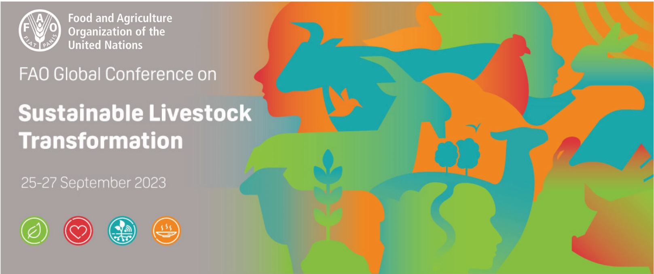
FAO Global Conference on Sustainable Livestock Transformation

CALL FOR PROPOSALS
Exhibition on Sustainable Livestock Transformation
Better production, better nutrition, better environment, better life
25-29 September 2023, FAO Headquarters, Rome, Italy

BACKGROUND
The Food and Agriculture Organization of the United Nations (FAO) is organizing from 25 to 27 September 2023 at its Headquarters in Rome, Italy, a Global Conference on Sustainable Livestock Transformation with the theme “Better production, better nutrition, better environment, better life”. The conference will provide a forum for FAO Members, producers, scientists, development agencies, policy makers, civil society, opinion leaders and the private sector to engage in dialogues on innovations and pathways to efficiently produce more nutritious, safe and accessible animal source foods with a reduced environmental footprint, and contribute to vibrant local and diversified livestock systems that are more resilient to shocks and disruptions.

OBJECTIVES
The general objective of the exhibition is to showcase success stories from different stakeholders, including FAO and Members, where they have used innovative solutions and approaches to transform their livestock production systems to make them more sustainable. At the same time, key facts, data and messages will be provided to underline the importance of livestock, the challenges of the sector and possible solutions for building a more sustainable, efficient, inclusive and resilient livestock sector for all.
The specific objectives are to:
- Promote the four betters (see above) and illustrate how the livestock sector can contribute to each of them;
- Raise awareness of the sustainable development of the livestock sector in the face of the challenges it faces; and
- Inform visitors about key facts, data and messages regarding sustainable livestock production, as well as, innovative solutions and approaches for sustainable livestock transformation.

CALL FOR PROPOSALS
Based on their wide experience and knowledge in different fields of expertise and regions, FAO Members, FAO staff, producers, scientists, development agencies, policy makers, civil society, and the private sector are invited to propose success stories where they have used innovative solutions and approaches to transform livestock systems to make them more sustainable.
Please use the form below to propose success stories of sustainable transformation of livestock systems. Please fill out, in English, one form for each proposal, providing in a concise way as much information as you can. All boxes with an asterisk will have to be duly filled in for the proposal to be considered. Send them to Livestock-Conference@fao.org by Friday 16 June 2023.
Only a limited number of proposals will be chosen for the exhibition. An FAO Task Force has been established to screen and select the success stories, based on pre-established criteria which include geographic, stakeholder and livestock systems balance. For those that are selected, a representative of the proposing entity will be invited to FAO Headquarters to provide further information on the success story during the exhibition.

SUCCESS STORY PROPOSAL FORM
(Deadline for submission of proposals: 16 June 2023)
Please send forms to Livestock-Conference@fao.org

Form to propose success stories, to transform livestock systems. Please fill out in English, one form for each proposal, providing in a concise way as much information as you can. All boxes with an asterisk will have to be duly filled in for the proposal to be considered.

Thematic area involved in the proposal
(tick the relevant box or boxes.)
- Better production
- Better health
- Better environment
- Better life

Title (max 15 words)*
Include the title of your success story.

Time and place (50 words max)*
Indicate time and place of your success story
About (200 words max)*
Describe in short your success story

Impact (200 words max)*
Describe its concrete impact and beneficiaries

Metrics (100 words max)
Add key facts and data to help measure the impact of your achievement

Partners
List key contributors, e.g. resource partners, governments, research institutes, private companies, producer associations, etc. involved

Links
List and provide a link to any key resources relevant to the success story (e.g. publication, e-learning course, video, website, etc.)

Leads*
Indicate the primary responsible entity and key contact person who could present this experience during the exhibition. Please note that the presenter should have been directly involved in the success story and be able to speak in one of the following languages: English, French, Spanish, Arabic, Chinese or Russian.

Name of the proposing entity:

Contact person
- Name:
- Role:
- Email:
- Gender:

- Language spoken:
- English
- French
- Spanish
- Chinese
- Russian
- Arabic

- Under 35 years of age?
- Yes
- No

- Over 65 years of age?
- Yes
- No

