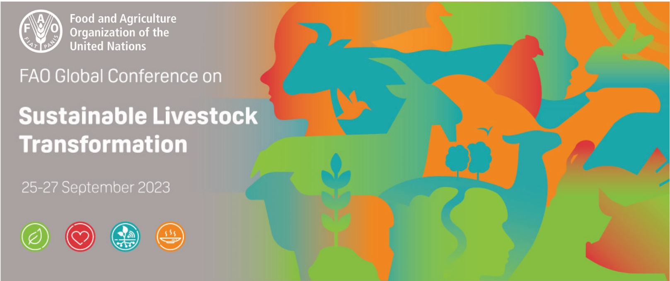
CALL FOR PROPOSALS
Side events on Sustainable Livestock Transformation

BACKGROUND
The Food and Agriculture Organization of the United Nations (FAO) is organizing from 25 to 27 September 2023 at its headquarters in Rome, Italy, a Global Conference on Sustainable Livestock Transformation with the theme “Better production, better nutrition, better environment, better life”. The global event will provide a forum for FAO Members, producers, scientists, development agencies, policy makers, civil society, opinion leaders and the private sector to engage in dialogues on innovations and pathways to efficiently produce more nutritious, safe and accessible animal source foods with a smaller environmental footprint and contribute to vibrant local and diversified livestock systems that are more resilient.

SIDE EVENTS
In addition to the main programme, the meeting will include four 1-hour side events related to the sustainable transformation of livestock systems.
The conference secretariat has chosen four main themes for the side events:
- International Year of Camelids
- Partnerships for investments in the livestock sector
- Science and innovation in the livestock sector
- One Health, One Welfare.

CALL FOR PROPOSALS
FAO Members, intergovernmental organizations, producer organizations, universities and research institutes, development agencies, policy makers, civil society, and the private sector are invited to submit side event proposals by using the form below to Livestock-Conference@fao.org by Friday 30 June 2023.

An FAO task force has been established to screen and select the final side-event presenters based on pre-established criteria, which include a balance of geographic areas, stakeholder types and livestock systems. Priority will be given to proposals involving multiple organizations and different types of stakeholders. The speakers/panelists of the selected side events will be invited to the Global Conference on Sustainable Livestock Transformation, although they will be responsible for their own travel and accommodation costs.
SIDE EVENT PROPOSAL FORMª
FAO Global Conference on Sustainable Livestock Transformation
Deadline for receiving proposals for side events: 30 June 2023
Please send completed form to Livestock-Conference@fao.org
Theme  Select one | ☐ International Year of Camelids  ☐ Partnerships for investments in the livestock sector  ☐ Science and innovation in the livestock sector  ☐ One Health, One Welfare
Proposed title of the side event

Coordination
Organization name; Contact person(s);
Contact email(s)
Collaborating organizations
Organization name(s); name(s) and email address(es) of persons to be copied on communications, if any

Brief description of the event
Background and rationale, proposed format (max. 150 words)

Proposed chair / co-chair / facilitator
(name, title/position, organization/country)

Proposed speakers/panelists
(name, title/position, organization/country, title and length of presentation)

Preferred date/time:  (Final decision is at the discretion of FAO) | ☐ Monday, 25 September – 12:45-13:45^{b}  ☐ Monday, 25 September – 17:15-18:15  ☐ Tuesday, 26 September - 12:45-13:45  ☐ Wednesday, 27 September – 12:45-13:45
Options  (Any costs are to be covered by the proposing organization) | ☐ Interpretation  ☐ Video conferencing/hybrid modality  ☐ Web casting  ☐ Food/snack and beverage
ªThe cells of the table may be expanded, if necessary
^{b}All times CEST (UTC+2)

Please note:
- The side events will take place in the Sheik Zayed Centre.
- The room will be equipped with a computer with Internet connection.

