NOTE
LEARNING AND EDUCATION AS CAPACITY FOR FOOD SECURITY
Please note that this PDF version does not have the interactive features
offered through the courseware such as exercises with feedback, pop-ups,
animations etc.
We recommend that you take the lesson using the interactive courseware
environment, and use the PDF version for printing the lesson and to use as a
reference after you have completed the course.
© FAO, 2012, Cesare Maramici
LESSON 1. WHAT IS CAPACITY? WHAT IS CAPACITY DEVELOPMENT

LESSON 2. WHAT IS LEARNING?

LESSON 3. FOOD SECURITY, LEARNING and EDUCATION

OBJECTIVES

At the end of this lesson you will be able to:  • define Capacity and Capacity Development;  • understand the relationship between Learning;Education and Capacity Development AND Food Security  • understand how rural people learn. | 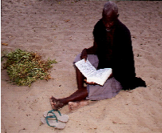

INTRODUCTION

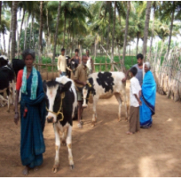 | This course is intended as a tool for all those who are seeking ways to strengthen the links between Education, Training and wider individual and societal objectives related to Capacity Development and Food Security. It discusses the relationships between learning, education and capacity and underlines the concept of FAO Capacity Development and Food Scurity  The concept of capacity is used as a lens for an analysis of the links between education and wider objectives related to food security. The concept of capacity is used as an analytical tool.  The different dimensions and meanings of Capacity and FAO Capacity Development are illustrated.

LESSON 1. WHAT IS CAPACITY?

DEFINITION OF CAPACITY

HOW WOULD YOU DEFINE CAPACITY? 

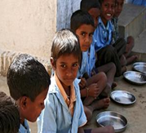 | The etymology of the concept of Capacity stems from French Capacite´ (latin capacitas) and it has two meanings.  - The first has to do with space i.e. what can be contained in a room, a ship or a container. It is also used in relation to the human body i.a. the capacity of the heart or the capacity of the lungs of a person.  - The other meaning has to do with action. Capacity is what individuals, organisations or countries are able to do. In the words of a recent definition by the DAC, capacity is “the ability of people, organisations and society to manage their affairs successfully.”

DEFINITION OF CAPACITY

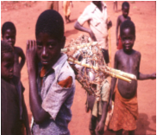 | Capacity exists when there are capable people, efficient organisations and a normative and policy environment that is conducive to change.  Capacity can only be measured in a meaningful way when it has been translated into action.  In the case of the FAO, these capacities are relate to individuals and organisations that act on objectives related to Food Security.  It is only when agricultural production has increased that it is meaningful to conclude that the capacity for agricultural production has been increased.  The policy environment is also important. It may open up or close possibilities for individuals and organisations to act.  Capacity is also related to normative issues.
DEFINITION OF CAPACITY and CAPACITY DEVELOPMENT

CD Portal : http://www.fao.org/capacitydevelopment/en/
“UNTIL RECENTLY, CAPACITY DEVELOPMENT WAS VIEWED MAINLY AS A
TECHNICAL PROCESS, INVOLVING THE SIMPLE TRANSFER OF KNOWLEDGE
OR ORGANIZATIONAL MODELS FROM NORTH TO SOUTH.”
OECD, 2006
(pag 9 of “Enhancing FAO’s practices for supporting capacity development
of member countries”)

A widely accepted definition of capacity is “the ability of people, organizations, and society as a whole  to manage their affairs successfully.”2 This includes the ability to create, understand, analyse, develop,  plan, achieve set targets, reflect on outcomes of actions, move towards a vision, change and transform.  The definition of Capacity Development (CD) adopted in the FAO Corporate Strategy on Capacity Development3 is “the process whereby individuals, organizations and society as a whole unleash, strengthen, create, adapt and maintain capacity over time.”  CD is primarily an endogenous process led by national actors and agencies, which is only supported by FAO. Most importantly, it involves social and political aspects and not only technical ones. | The linkages between the three dimensions (individual, organization, policy environment or Enabling Environment) of the concept of Capacity Development have been illustrated in Figure 1 below.  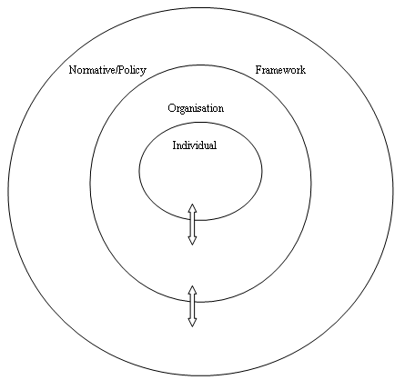  Figure 1 of ”Education as a way to strengthen the capacity of rural people to improve food security; Towards a tool for analysis. by Ingemar Gustafsson

DEFINITION OF CAPACITY and PEOPLE

WHAT WE NEED TO DEVELOP IS PEOPLE, NOT THINGS,
AND PEOPLE CAN ONLY DEVELOP THEMSELVES...
ARUSHA DECLARATION 1967
There is a shifting role of FAO, which is increasingly called upon to play  a facilitative role, connecting sources of knowledge among governments,  non-governmental organizations, farmers and the private sector.  Thr objective should be to transform what are now isolated good CD practices into an institutionalized corporate set of practices.  Since the beginning of the millennium, FAO has been harmonizing its practices with the UN system.  FAO focuses on developing national capacities. | There is an increased demand for FAO’s support in functional areas, such as strengthening the capacity of Member Countries to:  > put in place relevant policies, strategies, legislation and regulatory frameworks  > access, use and share information  > relate externally, network, advocate for the interests of the country/the institution  in regional and global fora and attract resources and investments  > plan and implement developmental processes through modern  management techniques including CD processes and  > learn continuously, adapt to and be resilient to unexpected crises.
CAPACITY DEVELOPMENT(CD) Guiding Principles

- Country ownership and leadership – Countries own and manage their development processes.

- Alignment with national needs and priorities – National needs and priorities, rather than agency priorities, should guide CD interventions

- Use of national systems and local expertise –Use of country systems – at whatever stage of development they are – is itself a contribution to strengthening Member
Countries’ capacities.

- Contextual factors at country, regional and local levels (including historical pathways and evolution, governance, politics and social texture among others) have been found to have clear operational implications on CD interventions.

- Multiple-level approach – CD implies an endogenous strengthening of existing capacities and assets, which takes place across three overlapping and interdependent levels: individual, organizational and enabling environment.

- Mutual accountability – Both donors and national governments are accountable to the ultimate beneficiaries for development results. Transparency is the foremost instrument of public accountability.

- Harmonization of action and partnership – Many development actors from the UN, middle-income countries, global funds, the private sector and civil society organizations have been increasing their contributions and bringing valuable experience to CD. More effective harmonization and inclusive partnerships are desirable so that efforts have greater impact on reducing poverty.

(pag 16 of “Enhancing FAO’s practices for supporting capacity development
of member countries”)

CAPACITY DEVELOPMENT – Some modalities to support national capacity development preocesses

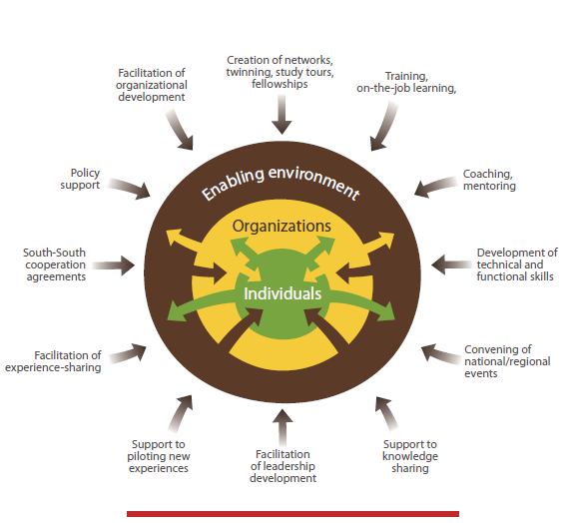

(pag 21 of “Enhancing FAO’s practices for supporting capacity development
of member countries”)

DEFINITION OF CAPACITY DEVELOPMENT (CD)
KEY POINTS

> CD is a long-term process that builds gradually and incrementally across dimensions,
and that requires continued follow-up and well-crafted external support.

> Member Countries own and manage their development processes.

> The design and sequencing of CD activities must fit country circumstances and national development plans/strategies.

> There is an ample choice of modalities to support CD targeting one or multiple entry points simultaneously. Training is only one modality and should be used in conjunction with other CD modalities for more sustainable impact.

(pag 21 of “Enhancing FAO’s practices for supporting capacity development
of member countries”)

CAPACITY DEVELOPMENT (CD) – Some modalities to support national capacity development preocesses

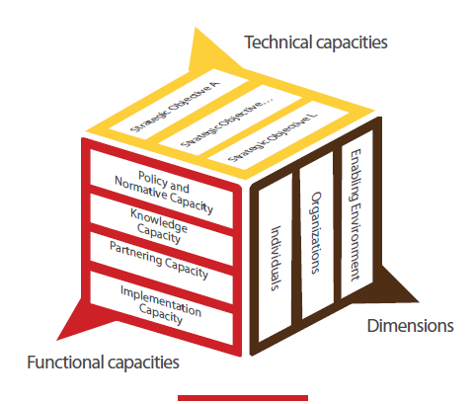

(pag 24 of “Enhancing FAO’s practices for supporting capacity development of member countries”)

TECHNICAL and FUNCTIONAL CAPACITIES

Technical capacities refer to capacities that Member Countries need to achieve the
Millennium Development Goals.

FAO is gradually shifting its focus from being the direct provider of assistance on technical aspects to playing a more facilitating role – connecting sources having the required specialized knowledge with governments, non-governmental organizations (NGOs), farmers and the private sector at field level.

Functional capacities refer to capacities that Member Countries need to uptake and sustain changes in the ARD (Agriculture and Rural Development) sector. In general, these include capacities relevant to individual and organizational effectiveness, such as management, leadership, budgeting, marketing, information and communication technology and strategic planning, in addition to soft skills such as communication and advocacy. These skills are perceived to be a necessary complement to technical CD interventions as they empower the actors to effectively apply the new knowledge/skills and upscale the results of the intervention.

(pag. 25-26 of “Enhancing FAO’s practices for supporting capacity development
of member countries”)

THREE DIMENSIONS OF CAPACITY DEVELOPMENT

A fundamental condition for a country to reach its developmental goals lies in its capacities at individual and organizational levels, and in the enabling environment.
Each of these three dimensions – individual, organizational and enabling environment – works interdependently with the others and influences the overall impact of a CD intervention.

Capacities are developed at the individual dimension to lead to changes in skills, behaviours and attitudes among a wide range of actors in the ARD sector (such as farmers, producers, traders, food inspectors, policy makers, administrations and staff of organizations). Measures may include the strengthening of knowledge, skills, motivation and values. Training is only one modality.

Competent individuals are not sufficient to make a capable organization.
Organizations are defined as “groups of individuals bound by some common purpose to achieve objectives”. Organizational capacity refers to the collective capability of members to achieve their organization’s goals.

The enabling environment is the context in which individuals and organizations put their
capabilities into action, and where capacity development processes take place. It includes
the institutional set-up of a country, its implicit and explicit rules, its power structures and
the policy and legal environment in which individuals and organizations function.

(pag 27 of “Enhancing FAO’s practices for supporting capacity development
of member countries”)

CAPACITY DEVELOPMENT (CD)

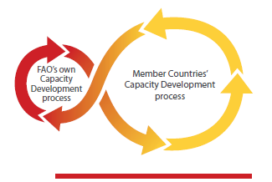

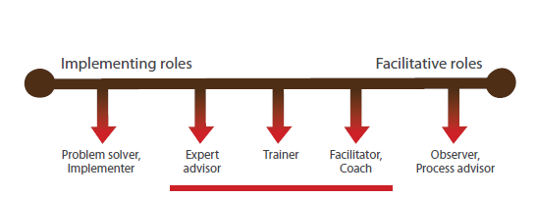
(pag 40-41 of “Enhancing FAO’s practices for supporting capacity development
of member countries”)

CAPACITY DEVELOPMENT - KEY POINTS

> To make its CD approach more systematic and sustainable, FAO adopted a conceptual
framework consisting of two capacities – technical and functional – working across
the three dimensions – individuals, organizations and enabling environment.

> Functional capacities are a necessary complement to technical capacities as they empower national actors to effectively apply the new knowledge/skills and upscale the results of the intervention.

> Each of the three dimensions – individual, organizational and enabling environment – works interdependently with the others and influences the overall impact of a CD intervention.

(pag 31 of “Enhancing FAO’s practices for supporting capacity development
of member countries”)

CAPACITY DEVELOPMENT IN PRACTICE

Are the capacities of Countries increased?

Experiences are mixed – success is intermingled with frustration in the stories recounted. In some cases there was a problem at the receiving end: corruption, lack of real commitment by national actors. More frequently, however, the problem was found to be in the way CD interventions were programmed: poor assessment of needs, insufficient attention to context, short timeframes, activities not built into existing institutions – to mention few of the major obstacles.

Some key points of the programming process:

> Using Participatory and collaborative methods

> A context analysis and risk assessment must be carried out early in the project.

> Careful identification of local partners to implement the project

> Defining roles and responsibilities in the context.

> Attitudes made the whole difference in the project. FAO did not perceive its role as problem-solver in the project; instead the Organization was well aware of its facilitative role to catalyse learning and changes with local partners, being ready to learn in turn from them.
(pag 35 of “Enhancing FAO’s practices for supporting capacity development
of member countries”)

CAPACITY DEVELOPMENT - KEY POINTS

For more impact and sustainability, five key steps should be systematically
incorporated in CD programming:
> Engaging in sustained dialogue; understanding the context, including assessing existing capacities;
> Engaging in CD-focused design;
> Using a participatory and adaptive implementation approach; and reflecting on outcomes and learning;
> Pursuing long-term engagement is not always easy, but is necessary to ensure
the sustainability of CD interventions. Adeguate funding modalities, iterative
approaches and promotion of partnership arrangements can help with this;
> Moving from an implementer to a facilitator role.

(pag 36 of “Enhancing FAO’s practices for supporting capacity development
of member countries”)

LESSON 2. WHAT IS LEARNING?

DEFINITION OF LEARNING

HOW WOULD YOU DEFINE LEARNING?

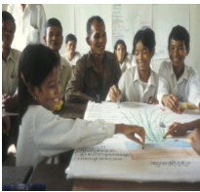 | Learning as the interplay between inner mental processes and contacts with the environment. (Jarvis, 2007).  According to Jarvis, there is often a disjuncture between what the individual carries with him or her and what he or she experiences in the environment.  The more rapid the changes are, the more likely it is that a disjuncture arises. It is precisely at this disjuncture that learning takes place.  “Learning is always personal but some of the opportunities to learn are provided by social institutions, such as State and employers.” (Jarvis, 2007).

LEARNING AND EDUCATION

When this learning takes place in an organized way, (within organisations that have been set up for this purpose) this will called education.  Education is the way in which the process of learning is organized.  Formal education  In all countries today education consists of complex national systems with professional teachers, instructors, planners and managers.  Learning and structured forms of training also takes place in the myriad of other organisations that are modern society.  When organisations for learning are brought together into a coherent system, this will be called a system of Life-Long Education.  These organisations work in an equally complex policy environment which may or may not be conducive to individual learning.  Informal education  Also today, a lot of learning takes place outside the organisation of a school or a university, perhaps increasingly so. This learning is usually less structured and well organised. | 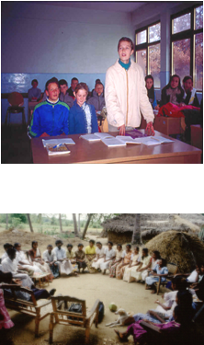  The individual learning is determined  by organizations and normative (policy framework)

DEFINITION OF LEARNING
Comments

The reality for rural people is far from this vision of Life-Long Education. The more typical picture is that Education for Rural People is taking place within many different structures within and outside the State. Also, rural people learn outside these organised structures set up for the purpose of learning.

It is important to recall what was observed by Coombs and Ahmed already in 1974: “Non-formal education, contrary to impressions withstanding, does not constitute a distinct and separate education system, parallel to the formal education system. It is any organized, systematic educational activity, carried out outside the framework of the formal system, to provide selected types of learning to particular subgroups in the population, adults as well as children. Thus defined, non-formal education includes, for example, agricultural extension and farmer training programmes, adult literacy programmes, occupational skill training given outside the formal system, youth clubs with substantial educational purposes, and various community programs of instruction in health, nutrition, family planning, cooperatives, and the like.”(Coombs and Ahmed, 1974:8).

Pag 11 of ”Education as a way to strengthen the capacity of rural people to improve food security; Towards a tool for analysis. by Ingemar Gustafsson

INTERNATIONAL POLICY FRAMEWORKS

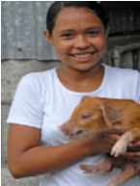 | The most important rights frameworks pertaining to education are:  - The Universal Declaration of Human Rights of 1948. “Everybody has the right to education”; “Elementary education shall be compulsory.”  - The Declaration of the Rights of the Child.  In this Convention, the right to education is linked to the principle of non-  discrimination.  - The Jomtien Declaration on Education for All -1990  - The World Education Forum, 2000, Dakar

WHAT SHOULD BE THE POURPOSE OF LEARNING?

According to the Delor Commision Report (1996), there ought to be four objectives. They are:

(1) Learning to know,
(2) Learning to do,
(3) Learning to live together,
(4) Learning to be.

WHERE and HOW DO RURAL PEOPLE LEARN?

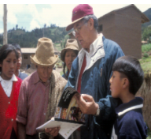 | Sometime formal education is not accessible for rural people, due to long distances to schools or high user fees.  Rural people walk in and out of organisations for learning during their life-span. Many never get in contact with a primary school, a secondary school or a university.  As observed in a study by the International Fund for Agricultural Development: “Most farmers learned more by looking over the fence and copying techniques from other farmers” (than through extension or other organised forms of learning, our comment). (IFAD, 2005, p.4).  Farmers have always had their networks and they have learnt from each other.  The trend is towards diversification of activities and sources of income. In this new reality, farmers need to get together and organise themselves.  In the words of the FAO strategy for Capacity Development, farmers will need both functional and technical capacities. (FAO, 2009).  Furthermore the new Information Technology, ICT has made possible to organise production process in a less hierarchical way than has traditionally been the case.  This means that vertical and hierarchical structures are replaced or supplemented by more decentralised and horizontal networks. (Castells, 1996, 1998).  Pag 13-21 of ”Education as a way to strengthen the capacity of rural people to improve food security; Towards a tool for analysis. by Ingemar Gustafsson

A NEW RURALITY IS EMERGING

Rural societies and economies are no longer so distinct, increasingly interacting on a regular basis with urban society-something made possible also by mobile telephony-and depending on it. Migration is a visible embodiment of this inter-connectedness, and remittances drive rural economies in many contexts.

Rural people are no longer so distinct from their urban peers in terms of occupations-many have diversified from agriculture. A recent study from India which is considered to be typical of a world wide trend underlined that less than one of five households entirely sourced their income from agriculture.

LESSON 3. FOOD SECURITY, LEARNING and EDUCATION

DEFINITION OF FOOD SECURITY
HOW WOULD YOU DEFINE FOOD SECURITY?

Food security is a multi-dimensional concept, we usually specialize in addressing one aspect of the larger food security problem.
Agricultural production, trade, income, food quality, clean water, sanitation, governance and political stability are all factors influencing one’s food security status.
The current FAO definition of Food Security reads as follows: “Food Security exists when all people, at all times, have physical social and economic access to sufficient safe and nutritious food that meets their dietary needs and food preferences for an active and healthy life. Household food security is the application of this concept to the family level, with individuals within the household as the focus of concern.” (FAO, 2009, p. 8).

“Food insecurity exists when people do not have adequate physical, social or economic access to food as defined above. (ibid, p. 9).

Right to adequate food is a human right, inherent in all people, «to have regular, permanent and unrestricted access, either directly or by means of financial purchases, to quantitatively and qualitatively adequate and sufficient food corresponding to the cultural traditions of people to which the consumer belongs, and which ensures a physical and mental, individual and collective fulfilling and dignified life free of fear.»
http://www.fao.org/righttofood/principles_en.htm

There are approximately 1000 million people in the world in 2010 for whom the right to adequate food is not a reality. The great majority, or 70 per cent are living in rural areas.

The FAO has and continues to put special emphasis on the capacity or capabilities of small farmers to produce food. It is important to increase the productivity of poor farmers with the goal to have access to food of good quality on a sustained basis.

Production of food should be organised with respect for the environment and in a sustainable way. (World Summit on Sustainable Development in 2002).

In later years, issues of climate change have come into the picture. Research, new technologies, innovation, Institutions and States have also an important role to play.

LESSON 3. FOOD SECURITY, LEARNING and EDUCATION

DEFINITION OF FOOD SECURITY
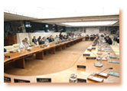HOW WOULD YOU DEFINE FOOD SECURITY?

The concept of food security has evolved significantly over time. The definition of food security used in this course is the one adopted at the 1996 World Food Summit held in Rome.
This definition, which has been formally endorsed at the global level, reads as follows: Food security exists when all people, at all times, have physical and economic access to sufficient safe and nutritious food that meets their dietary needs and food preferences for an active and healthy life.
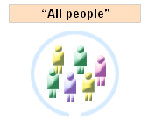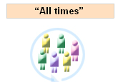
This definition introduces four main dimensions of food security:

Food availability addresses the “supply side” of food security and is determined by the level of food production, stock levels and net trade.
Concerns about insufficient food access have resulted in a greater policy focus on incomes and expenditure in achieving food security objectives.
A third dimension – food utilization – has become increasingly prominent in food security discussions since the 1990s. Utilization is commonly understood as the way the body makes the most of various nutrients in the food. This food security dimension is determined primarily by people’s health status.
The phrase “at all times” refers to the stability dimension of food security. It emphasizes the importance of having to reduce the risk of adverse effects on the other three dimensions: food availability, access to food or food utilization.

(pag 4 of The FAO e-learning course “What is Food security?” : http://www.foodsec.org/DL/course/shortcourseFC/EN/lesson.asp?lessoncode=0411)

LINKS BETWEEN FOOD SECURITY AND EDUCATION

Capactiy can be only measured looking at its different dimensions and the linkages between them.  It is wrong looking at capacity only as concrete actions that result from individual learning and the way learning process is organised.  Studies that have looked at knowledge and skills that are related to family life have generally found a strong relationship between learning, education on the one hand and improved nutrition, hygiene and health status of families on the other.  There is a strong relationship between nutrition (access to adequate food) and the ability to learn. | Educational responses to  different dimensions of Food Security  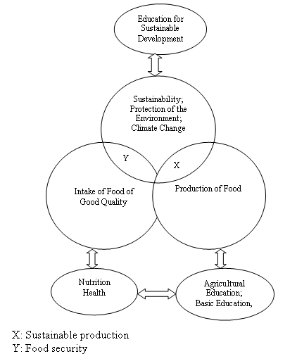  Figure 2 of ”Education as a way to strengthen the capacity of rural people to improve food security; Towards a tool for analysis. by Ingemar Gustafsson

LINKS BETWEN FOOD SECURITY AND EDUCATION

CAPACITY  Three dimensions | EDUCATION | FOOD SECURITY
INDIVIDUAL | Learning throughout life | Rural People
ORGANIZATIONAL | Schools, Universities,  Extension,  Literacy etc.  Formal, Non formal | Ministries  NGOs  Farmers,  Associations
ENABLING ENVIRONMENT  Or  NORMATIVE/POLICY | Right to Education  International Action Plans | Right to Food  International Action Plans

EDUCATION, LEARNING AND FOOD SECURITY

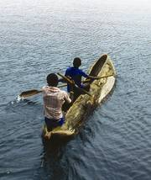 | Education for rural people, the main group directly involved in food production, processing and commercialization, is a key factor in fighting food insecurity in low-income countries. We propose a broader approach to Food Security than the increase of agricultural production. It also includes issues such as “processing and commercialisation.”  There is a strong relationship between literacy and issues that have to do with pride, self-esteem and possibilities to make your voice heard.  Learning is at the heart of capacity development at the individual level. If and when this learning is the result of national programmes of basic education, for children and adults, it can be argued that there is a strong relationship between learning and the capacity to act.

EDUCATION, LEARNING AND FOOD SECURITY
Comments

It is important to note, however, that these effects of adult education and literacy are not automatic, but result only when literate individuals are able to exercise their literacy, which requires that broader development and rights policies are in effect and implemented. Indeed, literacy per se is not the sole solution to social ills such as poverty, malnutrition, and unemployment, though it is one factor in helping to overcome them.

“Education, training, literacy and numeracy depend for their full effects on supportive environments-social, political, institutional, infrastructural. They need to be part of a total development effort.”(Oxenhan, 2009, p. 98).

LINKAGES AT THE NORMATIVE/POLICY (ENABLING ENVIRONMENT) FRAMEWORKS LEVEL AND AT ORGANISATIONAL LEVEL

The building of bridges at the normative level is a precondition for a closer connection between all those organisations that seek to link education and training to higher order objectives related to Food Security.

From the point of education as organised learning, there are two kinds of organisations; there are organisations whose main purpose is organised learning and there are organisations which have other mandates but put organised learning high on their agenda. This latter aspect is usually referred to learning within organisations. It applies to schools and universities, to Ministries of Agriculture and to Non-Governmental Organisations.

FAO and UNESCO are the main organisations that have sought to establish and maintain linkages at the international level. There is fragmentation as well as alliances and networks, in a complex web, typical of the international community of today.
Improvements of the capacity of organisations related to Education and Food Security is a question of identifying and strengthening linkages both within and between organisations.

THE EDUCATION FOR RURAL PEOPLE AS A BRIDGE

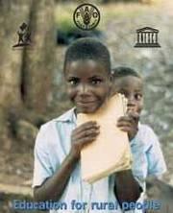 | Education for rural people initiative (ERP) is a bridge between organisations, international normative and policy frameworks pertaining to Food Security and to education.  It is also a network for learning in its own right.  The ERP can be seen as one of many international networks, typical of the modern Knowledge Society. It has generated a lot of knowledge and it has served as a network for learning.  In a perspective of Capacity Development, ERP has been a way to develop the capacity of the individuals who have participated in the network through mutual learning. In some cases it has also done so through different forms of organised learning.

CONCLUDING Comments

This module has identified linkages between learning, education and three dimensions of the concept of Food Security. It has used the concepts of Capacity and Capacity Development as a lens.

When learning and education is implemented in a national perspective, education (including both formal and non-formal education) is an important pillar of a wider strategy that aims at improving of national capacities for Food Security.

There are strong linkages between international normative and policy frameworks. Human Rights Frameworks reinforce each other and so do international action plans in the fields of Food Security and Education.

It becomes even clearer that the improvements of capacity through education and training are strongly related to changes at the organisational level where the main problem lies. The problems are not primarily at the normative/policy level. Nor do they have to do with rural people. They improve their capacity through learning whenever they can. Some of their learning will take place “over the fence.”

The rural people strategies are marked by diversification of their sources of income and the means by which this income is generated. That diversification is a way to mitigate risk but also to seize the opportunities that may arise. Diversification is also driven by increasing contacts and exchanges between rural and urban areas.

The emergence of a world wide Knowledge Society is closely linked to modern Information and Communication Technologies. If this kind of analysis is used, it will impact on the linkages between Learning, Education and Food Security. The results can be seen among rural people today in their use of mobile phones but the implications for the understanding of these new trends are much wider. One question is how the emerging society will enhance the possibilities for rural people to access information and to learn.

There is a strong connection between the emerging Knowledge Societies and the need for flexible and yet integrated systems of Life-Long Education where linkages between formal and non-formal education need to be strengthen.

IF YOU WANT KNOW MORE............

Online resources

CD Portal : http://www.fao.org/capacitydevelopment/en/
“Enhancing FAO’s practices for supporting capacity development
of member countries” by FAO http://www.fao.org/docrep/013/i1998e/i1998e00.htm

“What is Food security?” by FAO http://www.foodsec.org/DL/course/shortcourseFC/EN/lesson.asp?lessoncode=0411
”Education as a way to strengthen the capacity of rural people to improve food security; Towards a tool for analysis.
by Ingemar Gustafsson
http://typo3.fao.org/fileadmin/templates/ERP/docs2010/EducationasawayFebr2011.pdf

Additional reading

Assessing Impact of Development Programmes on Food Security: http://www.fao.org/spfs/learning-from-results/e-learning/en/

Development Assistance Committee of the Organisation for Economic Cooperation and Development

