16th World Milk Day
1 June 2016

The 1st World Milk Day was celebrated in June 2001 and has since become an annual event in many countries throughout the world. The Day provides an opportunity to focus attention on milk and to publicise activities connected with milk and the milk industry. The fact that many countries choose to do this on the same day lends additional importance to individual national celebrations and shows that milk is a global food. For more information, see: World Milk Day
In 2016, World Milk Day was celebrated by over 40 countries. Activities included holding marathons and family runs, milking demonstrations and farm visits, school-based activities, concerts, conferences and seminars, competitions and a range of events focussing on promoting the value of milk and illustrating the important role played by the dairy industry in the national economy.
Here is a selection of activities from a range of countries which submitted reports.
Country | Description
Afghanistan | Milk promotion and distribution | 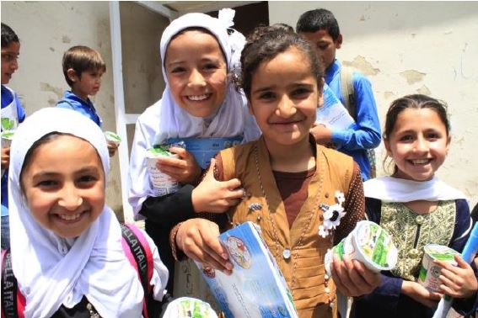
Argentina | Information day | 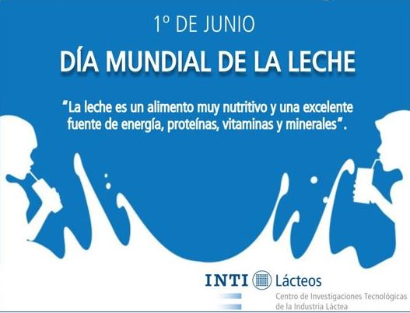
Bangladesh | Seminars, processions, rally | Bangladesh: more info
Bolivia | Information day on the nutritional value of milk and consumption | Bolivia: more info
Bosnia and Herzegovina | A range of events, including distribution of milk | 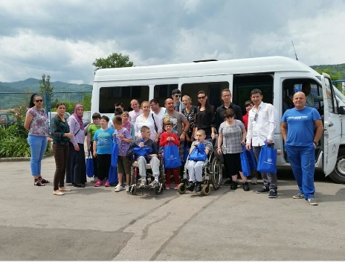
Brazil | Conference | Bosnia and Herzegovina: more info  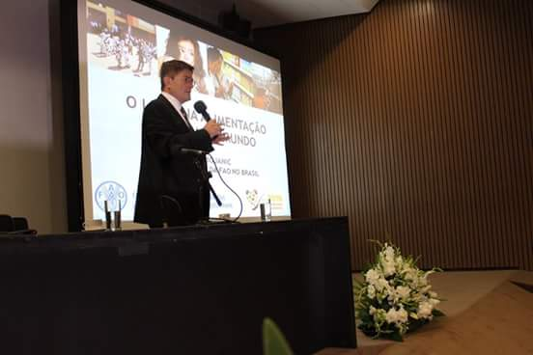
Canada | Promotion of national milk
Chile | Promotion of value of drinking milk | Chile: more info
China ( Hong Kong - SAR) | Activities for children
Colombia | Information day | 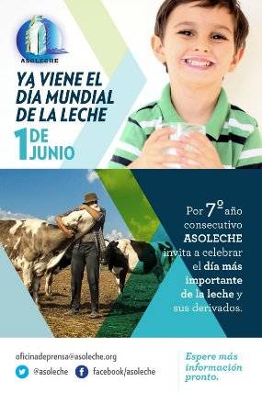
Costa Rica | Celebrations | 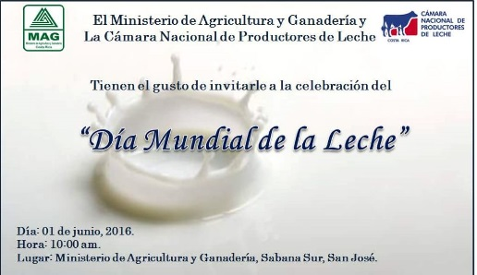
Finland | Activities in schools and election of the Milk Maid
Great Britain | Press release and picture contest
Honduras | Activities in schools and distribution of milk | 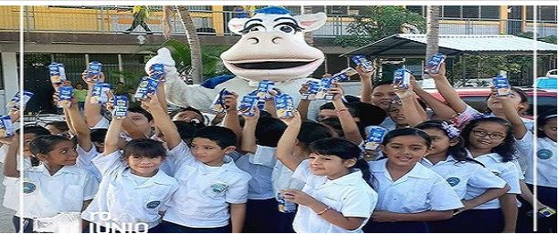
India | Milk promotion and visit to Dairy Co-operative Societies | 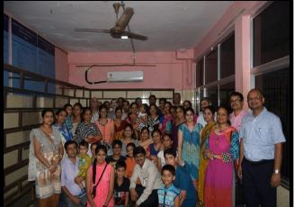
Italy | A number of events were held | 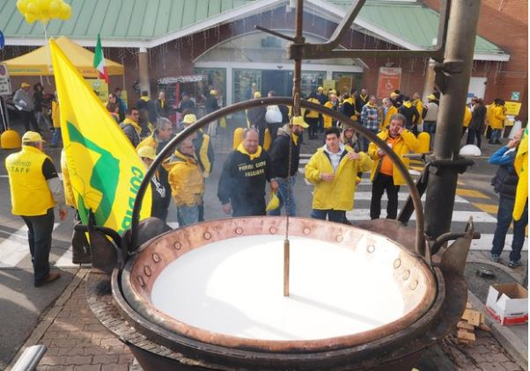  Italy: more info
Jamaica | Promotion and distribution of milk products | Jamaica: more info
Korea Rep. of | Conference and activities for children | 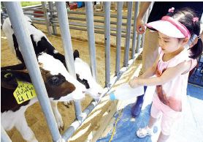
Luxembourg | Promotion of milk
Mexico | Conference on the promotion of milk consumption | 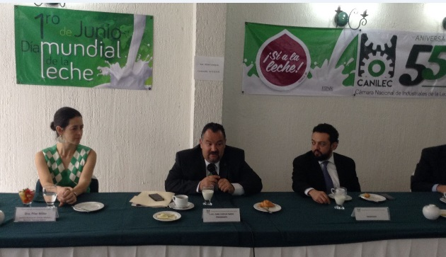
Mongolia | Celebrations and tasting of dairy products | 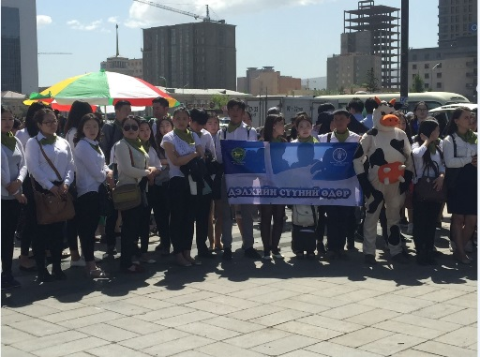
Myanmar | Activities for children and football event | 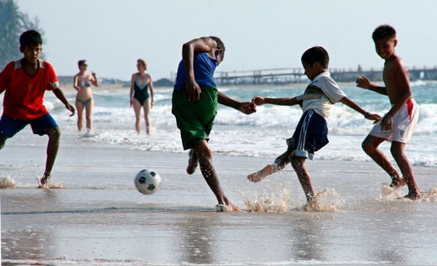
Nepal | Distribution of milk and poetry competition | 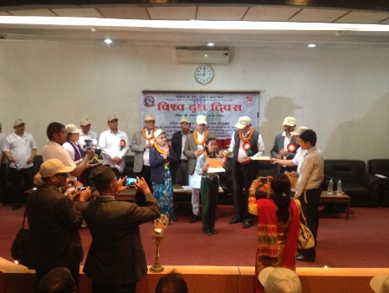
Nicaragua | Information day and entertainment | 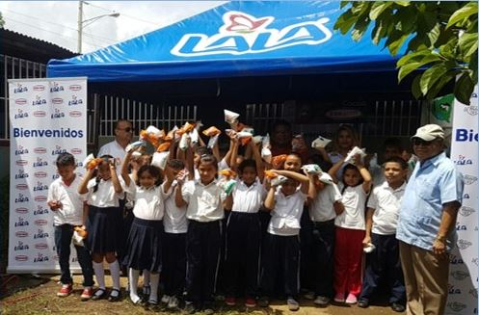
Nigeria | Milk distribution | Nigeria: more info
Pakistan | University conference and promotion of the day | 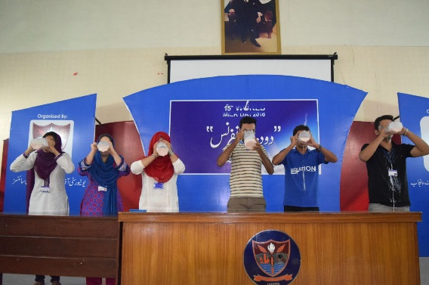
Paraguay | Seminars, National Congress and Race | Paraguay: more info
Peru | Activities for children | 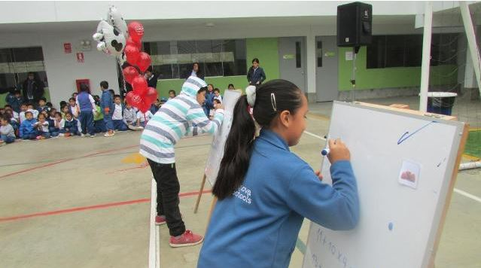
Poland | Celebrations in the Parliament | 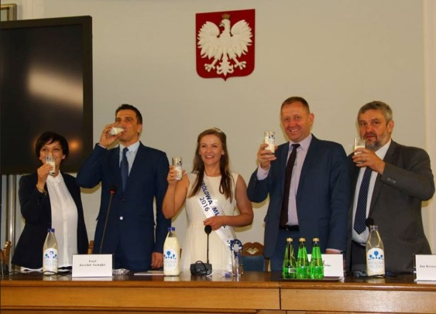
Russian Federation | Painting competition
South Africa | Activities in schools
Spain | Promotion of nutritional value of milk | 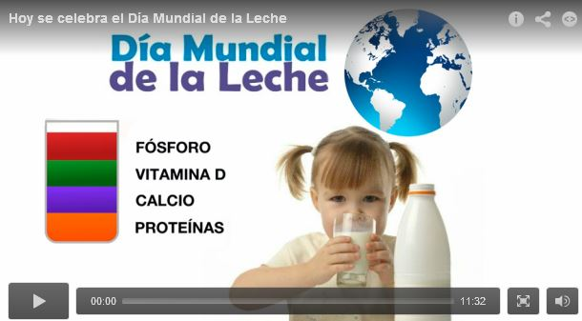  Spain: more info
Tanzania | Procession of school children | 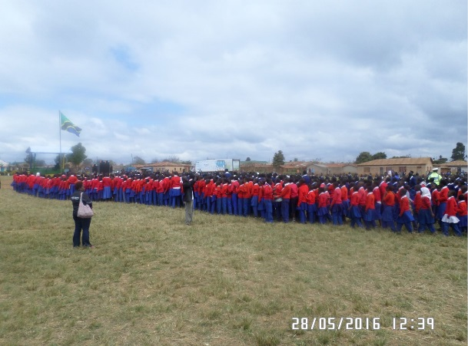
Thailand | Games, promotional activities and concerts | 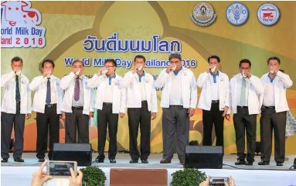
United States | Tasting of dairy products | 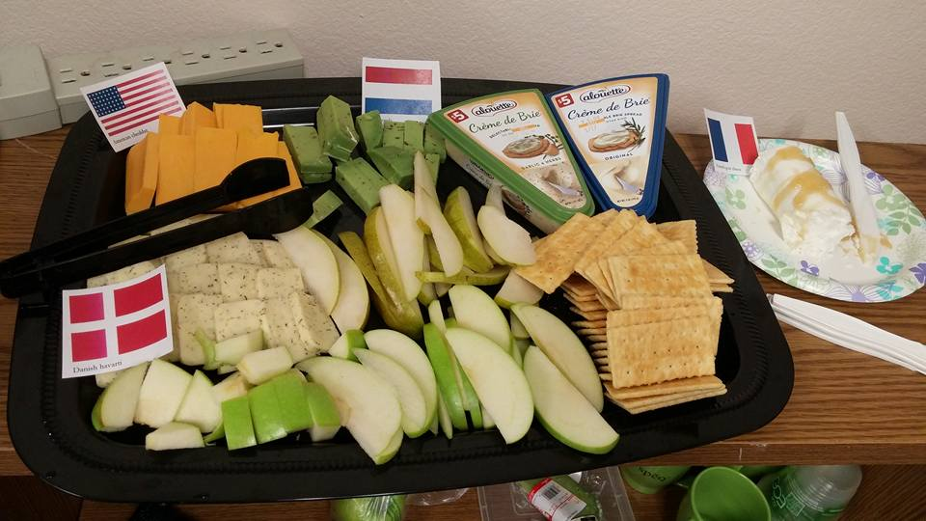
Venezuela | Information day | 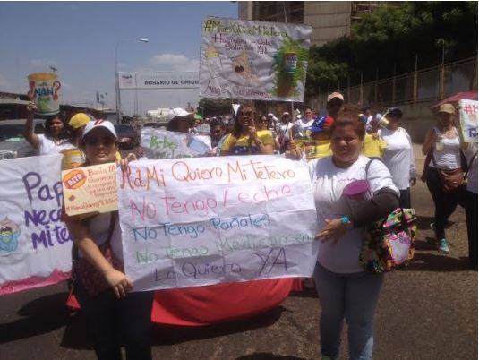

Source: Information derived mainly from the Dairy-Outlook e-mail discussion forum, plus internet.

The FAO Dairy Outlook List is an information exchange network on developments in the world's dairy industry. To subscribe send an email with "Subscribe" in the subject line to fao-dairy-outlook@fao.org

World Milk Day
Since the first World Milk Day was held in 2001, many countries spread throughout the world have participated in the celebrations and the number is growing each year.
Why hold a World Milk Day? The Day provides an opportunity to focus attention on milk and to publicise activities connected with milk and the milk industry. The fact that many countries choose to do this on the same day lends additional importance to individual national celebrations and shows that milk is a global food.
Where did it begin? FAO (the Food and Agriculture Organisation of the United Nations) was asked to propose a specific day on which all aspects of milk could be celebrated.
Why 1st June? This date was chosen because a number of countries were already celebrating a national milk day on or around this time. Late May was originally proposed, but some countries, for example China, felt they already had too many celebrations in that month. While most countries hold their celebrations on 1st June, some choose to hold them a week or so before or after this date.
Let us know how you intend to celebrate the 17th WORLD MILK DAY, June 1, 2017
Send messages to: fao-dairy-outlook@fao.org

