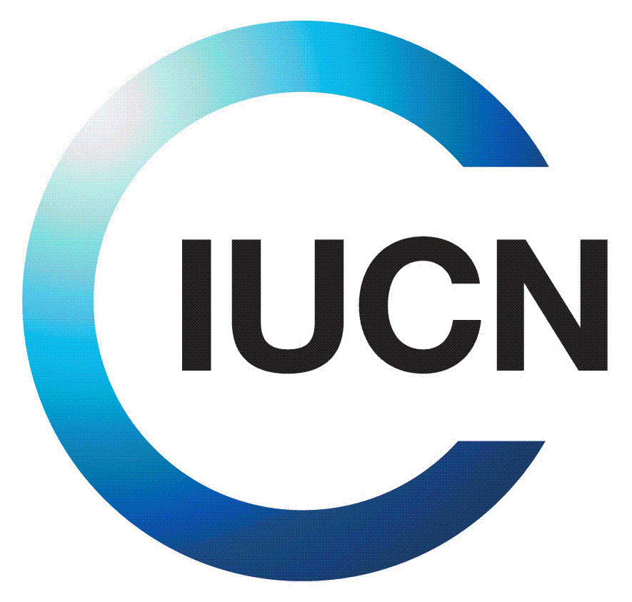

**Building a mountain partnership initiative in Eastern and Southern Africa**

**A Platform for Collaborative Action of the Mountain Partnership Members in Africa to Promote Biodiversity Conservation, Community Benefits and Sustainable Economic Development in Mountain Ecosystems**

**EASTERN AND SOUTHERN AFRICA MOUNTAIN PARTNERSHIP MEMBERS MEETING**

**KIGALI, 2O FEBRUARY 2013**

**PROGRAMME**

|  |  |  |
| --- | --- | --- |
| **Time** | **Activity** | **Speaker** |
| 08:30-09:00 | Arrival and Registration | ALL |
| 09:00-09:10 | Welcome by ARCOS and Introductions | Sam Kanyamibwa, ARCOS Executive Director |
| 09:10-09:30 | Opening Remarks by Guest of Honour | Hon Minister S. Kamanzi, Minister of Natural Resources, Rwanda |
| 09:30-10:00 | Mountain Partnership Update, and new Strategy 2013-207 from the Secretariat | Rosalaura Romeo, MP Secretariat |
| 10:00-10:30 | Discussions and questions on the Mountain Partnership Strategy | ALL |
| 10:30-11:00 | Coffee/Tea Break | |
| 11:00-11:30 | Mountain Partnership priority areas for action in Africa | ARCOS, MPS and IUCN |
| 11:30-13:00 | Discussions | Participants |
| 13:00-14:00 | Lunch Break |  |
| 14:00-16:00 | Working Groups: Defining Shared Road Map for Mountain Partnership Agenda Africa   * WG1: Implementing Mountain Partnership Strategy * WG2: Water Tower Initiative and pillar actions * Networking and MP Membership | ALL |
| 16:00-16:15 | Coffee/Tea Break | ALL |
| 16:15-17:00 | Working Groups Reporting Back | WG Rapporteurs |
| 17:00-17:30 | Conclusions, Final Remarks and Closing | ARCOS and MP Secretariat |
| **18:30** | **Cocktail (also joined by delegates attending the Great Lakes Forum)** | |
| **Thursday 21st and Friday 22nd 2012: Great Lakes Forum on Freshwater Ecosystems** | | |