|  |
| --- |
|  |
| **Value chain analysis of five key fish species:** |
| **Inland fisheries of Cambodia** |

Hap Navy and Un Sophea - Inland Fisheries Research and Development Institute (IFReDI)

Nobuyuki Yagi, T. Nakajima and T. Matsui - University of Tokyo

Graduate School of Agricultural and Life Sciences

January, 2012

# EXECUTIVE SUMMARY

Fish is one of the most important food stuffs for Cambodian people, especially for the poor. Fish does not provide only food but livelihood activities to millions of people in the country. The current study on value chain analysis of five key freshwater fish species in Cambodia was intended: to describe the situation of chain actors participating in the value chain of the five key fish species, to analyse marketing channels of the fish species, to analyse asymmetric price transmission of the species, and to propose recommendations for upgrading value chains of the five key fish species.

The study was conducted based on primary and secondary data. Pursat, Kampong Chhnang, and Kandal province and Phnom Penh city were selected as study areas with total 80 sampled fish traders (20 sampled fish traders from each study area). Moreover, interview was conducted with Key Informant person (KIP). In addition, Focus Group Discussion (FGD) was conducted with local authorities, relevant and experienced stakeholders. In this study, descriptive analysis, cross tabulation, comparative analysis, X12-ARIMA, Unit root test and empirical model were used for data analysis.

The results of the study indicate that the five key fish species have under gone through many chain actors from fishers/fish farmers, traders and exporters before reaching consumers. In addition there were also some service providers indirectly involved in the chain; these were fishing equipment producers, transporters, market managers and etc.

On average, 18.8 tonnes of Snakehead, 18.8 tonnes of Pangasius, 8.8 tonnes of Croaker, 12.7 tonnes of Reddish and 31.3 tonnes of Henicorhynchus were traded by all sampled fish traders in the four study areas. In marketing channel of the five fish species, wholesalers play an important role in delivering fish from fishers and fish farmers to markets and consumers. The quantities of fish traded annually in 2005 decreased when compared to that in 2010. However, fish price dramatically increased over the last 6 years. In asymmetry of price transmission, no asymmetry was found in Pangasius and Reddish, while negative asymmetry was found in Snakehead and Croaker, and positive asymmetry for Henicorhynchus. This implies that wholesalers of Snakehead and Croaker may have less power than retailers, while wholesalers of Henicorhynchus may have more power than retailers. In addition, in the study there found to be positive asymmetry in Pangasius and Croaker, whereas no asymmetry was found in Henicorhynchus. This reveals that retailers of Pangasius and Croaker may enjoy excess profits over consumers, while the retailers of Henicorhynchus may not.

The study has proposed six recommendations to sustain value chain of the five key fish species: 1) good management of wild fish stock and other aquatic resources; 2) augment and adopt appropriate technologies of fish raising; 3) good management of fish trade to make information of fish price more clearly and broadly accessible to all chain actors; 4) better management of the quality of fish; 5) provide more opportunities for the establishment of many financial organizations; 6) limit/restrict unnecessary and informal-fee payment.

TABLE OF CONTENTS

PART I: INTRODUCTION 5

1.1 Background 6

**1.2** **Objectives** 7

PART II: RESEARCH METHODOLOGY 8

2.1 Scope of the Study 8

2.2 Data Collection 9

2.3 Data Analysis 9

PART III: RESULTS AND DISCUSSION 11

3.1 Overview on Freshwater Fish Marketing System in Cambodia 11

3.2 The Actors in the Value Chain of the five Key Freshwater Fish Species 11

3.2.1 Lot owners/Dai owners/Commercial Fishers 12

3.2.2 Small-Scale Fishers 12

3.2.3 Fish Farmers 13

3.2.4 Fish Traders 14

3.2.5 Fish Processors 16

3.2.6 Exporters 16

3.2.7 Consumers 16

3.3 Production and Trade Volume of the Five Key Freshwater Fish Species 18

3.3.1 Snakeheads 18

3.3.2 Pangasius 18

3.3.3 Croaker 19

3.3.4 Reddish 19

3.3.5 Henicorhynchus 19

3.4 Gender Role of Chain Actors in Fishing, Fish Farming, Processing &Trading 19

3.4.1 Fishing 19

3.4.2 Fish Farming/Aquaculture 21

3.4.3 Fish Trade 21

3.4.4 Fish Processing 22

3.5 Marketing Channels of Chain Actors by Fish Species 25

3.5.1 Captured fishes 25

3.5.2 Cultured fish 28

3.6 Trend of Quantity and Price of the five Key Freshwater Fish Species 30

3.6.1 Trend of Quantity 30

3.6.2 Trend of Price 31

3.7 Empirical Analysis on Asymmetric Price Transmission of the five Key Freshwater Fish Species 32

3.7.1 Data 32

3.7.2 Unit Root Tests 34

3.7.3 Empirical Results 35

3.7.4 Discussion 38

3.8 Major Suggestions for Upgrading Value Chain of the five Key Freshwater Fish Species 39

PART IV: CONCLUSION 40

REFERENCES: 41

**LIST OF TABLES**

Table 3.1: Average quantities of fish sold by traders (tonne/year), 2010 18

Table 3.2: Gender-based perception of villagers in Cambodia on the people who play important roles in fishing activities 20

Table 3.3: Percentage of female and male involvement in the trade of five key freshwater fish species 21

Table 3.4: Percentage of women and men involvement in fish collection and obtaining profit from the fish trade 22

Table 3.5: Gender-based perception of villagers in Cambodia on people who play important roles in fish processing activities 22

Table 3.6: Gender roles in frozen freshwater fish processing (at Lang Heng Export and Import Company, Phnom Penh) 23

Table 3.7: Gender roles in freshwater fish processing activities in Phnom Penh 23

Table 3.8: Percentage of female and male involvement in Fisheries Activities 24

Table 3.9: Quantities of fish traded by species and year (Tonne/year) 30

Table 3.9: Average price of fish sold by species and year (2005-2010) (Riel/kg) 31

Table 3.10: Margins and marginal ratios 34

Table 3.12: Asymmetric price transmissions from fisher prices to wholesale prices 36

Table 3.13: Asymmetric price transmissions from wholesale prices to retail prices 37

**LIST OF FIGURES**

Figure 2.1: Map of Cambodia showing the study areas in Pursat, Kampong Chhnang, Kandal provinces, and Phnom Penh city. 8

Figure 3.1: Value chain of freshwater fish with the stakeholders in Cambodia. 17

(Source: Rab et al., 2006) 17

Figure 3.2: The value chain of captured Snakehead in the LMB of Cambodia. 25

Figure 3.3: The value chain of Reddish (Kes) in Cambodia. 26

Figure 3.4: The value chain of Henicorhynchus sp. (Riel) in Cambodia. 27

Figure 3.5: The value chain of captured Croaker (Prama) in Cambodia. 28

Figure 3.6: The value chain of cultured Snakehead in the LMB of Cambodia. 29

Figure 3.7: Mapping of the value chain of Pangasius (Pra) in Cambodia. 30

Figure 3.8: Trend of the quantities of fish traded by species and year. 31

Figure 3.9: Price series of Pangasius, Snakehead, Reddish, Croaker and Henicorhynchus 34

**LIST OF ABBREVIATION**

ADB : Asian Development Bank

CDRI : Cambodian Development and Research Institute

FAO : Food and Agriculture Organization

FGD : Focus Group Discussion

FiA : Fisheries Administration

IFReDI : Inland Fisheries Research and Development Institute

Kg : Kilogram

KIP : Key Informant Person

LMB : The Lower Mekong Basin

MRC : Mekong River Commission

NGO : Non-Governmental Organization

SPSS : Statistical Package for Social Sciences

SUMERNET : The Sustainable Mekong Research Network

USD : The United State Dollar

WF : World Fish Center

% : Percent

# PART I: INTRODUCTION

## 1.1 Background

Cambodia is mostly landlocked country located on the peninsula of Mainland Southeast Asia. It is situated between latitudes 10 to 15 degrees north and longitudes 102 to 108 east. Cambodia has an area of 181,035 km2. It is bounded by Thailand in the west and northwest, Laos in the north, and Vietnam in the east and southeast, and Gulf of Thailand in the southwest.

Cambodia is covered by forest, water bodies and rice fields. Among the water bodies, the fishing zone of freshwater covers about 1,687,000 hectares, which contribute to make the fisheries sector an important sector for the national economy (Ahmed and Touch, 1996). At the local level, fisheries has historically been the important occupation for Cambodian people as over 2 millions of them are directly and indirectly associated with inland fishery activities (Rab et al., 2006). In addition, fish constitutes about 75% of the animal protein intake for the Cambodian households and most of it comes mainly from freshwater fisheries in both fresh and processing forms (Hap, 1999). Moreover, freshwater fishery is considered to be the most productive inland fisheries of the world, contributing around 60% of the country commercial fisheries production (Ahmed et al., 1998).

Globally, aquaculture has expanded at an average annual rate of 8.90% since 1970, making it the fastest-growing food production sector. It now provides about half of all fish for human consumption. With half of all wild fish stocks now harvested to full capacity and a quarter over-exploited, it is expected that aquaculture’s share of fish production to increase further. This can benefit poor people by improving their food security and nutrition, creating jobs, stimulating economic growth and offering greater diversification of their livelihoods (WF, 2008).

In Cambodia, due to the abundance of wild fish, cultured fish in the past did not play an important role in the volume of fish supply. However, the country is now thought to be the cradle of cage and pen fish culture in Asia (FiA, 2001). Aquaculture contributes around 10% of the total inland fish catch, also plays an important role and is considered to have great potential for augmenting fish production in Cambodia (Rab et al., 2006). Furthermore, fisheries and aquaculture together is believed to have enormous potential to provide the poor people with more food, better nutrition and increased incomes.

Within the freshwater aquaculture model in Cambodia, cage culture represents the highest percentage (about 70%) of aquaculture production while pond culture covers only 30%. Cage historically originated in Cambodia and the number of cages for aquaculture has not differed very much each year since 1997. In total, approximately 4,492 cages (in 2004) were located in the Cambodian Mekong basin, encompassing Tonle Sap Lake (42%), Tonle Sap (17%), upper stretch of the Mekong River (19%), lower stretch of the Mekong River (14%) and Bassac River (7%) (So et al., 2005). However, pond culture is of recent origin and the number used rapidly increased from 3,455 in 1997 to 11,509 in 2004, representing a 43% increase. Pond culture production has increased at a rate of 26% per year since 1984 (So & Nao, 1999; FiA, 2005).

The most important and highly profitable fish species in cage culture is *Giant Snakehead* (*Channa Micropeltes*) namely Trey Chhdaur in Khmer, *Pangasius* (*Pangasianodon sp.*), namely Trey Pra in Khmer and other fish species (So et al., 2005). In Cambodia cage culture of *Giant Snakehead* started in 1990s. During 1991 to 1993, there were only a few households interested in culturing *Giant Snakehead*, but from 2001 to 2005, the number increased very fast throughout the country such as in the Tonle Sap Great Lake, along Tonle Sap River, Mekong and Bassac River (Hap et al., 2006). *Snakeheads* for human consumption in Cambodia are mainly from wild fish capture traded via the border of Cambodia and Thailand, while cultured *Snakeheads* are imported from downstream areas of Vietnam in a small amount (Loc et al., 2007). According to Sinh and Chung (2010), about 0.6% to 1% of annual total production of fresh *Snakeheads* in Vietnam, accounting from 240 to 400 tons, was exported to Cambodia.

*Pangasius* (*Pangasianodon sp.*) is one of the intensive fish pond cultured species in Cambodia (So et al., 2005). Production of *Pangasius* is predominantly from capture fisheries and has increased 2.6 times from an estimated 3,000 tons in 2004 to 8,000 tons in 2006 (FAO, 2008).

Besides *Snakeheads* and *Pangasius*, *Croaker* (*Boesemania microlepis*) namely Trey Promah in Khmer, and *Reddish* (*Micronema apogon sp.*) namely Trey Kes in Khmer are also important freshwater fish species with high commercial value in Cambodia. However, *Henicorhynchus* (*Henicorhynchus sp.*), namely in Khmer Trey Riel is one of the freshwater low-value fish species being believed to provide a staple supply of vital protein to fishers not only in Cambodia but in all riparian countries. *Henicorhynchus* is traded extensively in local markets either in fresh, salted-dried or fermented form. Moreover, it is also traded from Cambodia to Vietnam as fish meal for *Pangasius sp.* and *Channa Striata* production (Seng, 2006). *Henicorhynchus* represents the highest percentage (40%) among the 62 low-value fresh water fish species which are used as feed for fish culture (So et al., 2005). Thus, the farming of high value fish species by heavily depending on wild indigenous fishes both for seed and mainly for fish feed may lead to the depletion of wild freshwater fish stocks, especially the low value fish in the delta.

In Cambodia there are some studies about value chains analysis of *Pangasius*, *Henicorhynchus*, and *Snakeheads* done by the Inland Fisheries Research and Development Institute (IFReDI), yet there is none for that of *Reddish* and *Croaker.* Furthermore, there are some research and reviews about fisheries value chain analysis in Cambodia generally covering on all fish species, but noton specific fish species mainly *Reddish* or *Croaker*. Hence, value chain of *Reddish* and *Croaker* would be studied, based on available secondary data and field survey with the compilation of the value chain analysis of the three former fish species. The results of this study would be useful for management and any further development of the key five fish species; it will also contribute to the food security, job creation and marketing of fish products in Cambodia. Moreover, this study will also be effective for policy recommendations to all value chain agents in order to increase the value derived from fishery resources.

* 1. **Objectives**

The general objective of the study is to analyse value chain of the five fish species (*Snakeheads, Pangasius, Croaker, Reddish* and *Henicorhynchu*s) in Cambodia. The value chain analysis is important for the chain actors to increase the value derived from domestically available fishery resources, and for policy makers to identify ways of improving food security through more informed policy decisions, and to propose major solutions for a further development of the five fish species industry with the regards given to the main stakeholders in the study areas. The specific objectives of the study are:

1. To describe the situation of chain actors participating in the value chain of the five fish

species;

1. To analyse marketing channels of the five fish species;
2. To analyse asymmetric price transmission of the five fish species;
3. To propose recommendations for upgrading value chains of the fish species.

# 

# PART II: RESEARCH METHODOLOGY

## 2.1 Scope of the Study

This study was conducted in three provinces and one city, namely Pursat and Kampong Chhnang provinces along Tonle Sap Great Lake, Kandal province and Phnom Penh city along Mekong-Bassac river (Figure 2.1). These study areas were selected based on overall characteristic of the location where freshwater fish, mainly the five key freshwater fish species (*Snakeheads, Pangasius, Croaker, Reddish* and *Henicorhynchu*s) were actively and mostly traded- the picture of the species is attached as an appendix. Moreover, the study focused on traders of the fish species only, and 20 fish traders (which could be fish collectors, wholesalers, middlemen or retailers) from each study area were chosen. Thus, there were 80 sampled fish traders. In addition, heads of village and commune, local fishery officers and other related key informant persons (KIPs) were also included in this study.

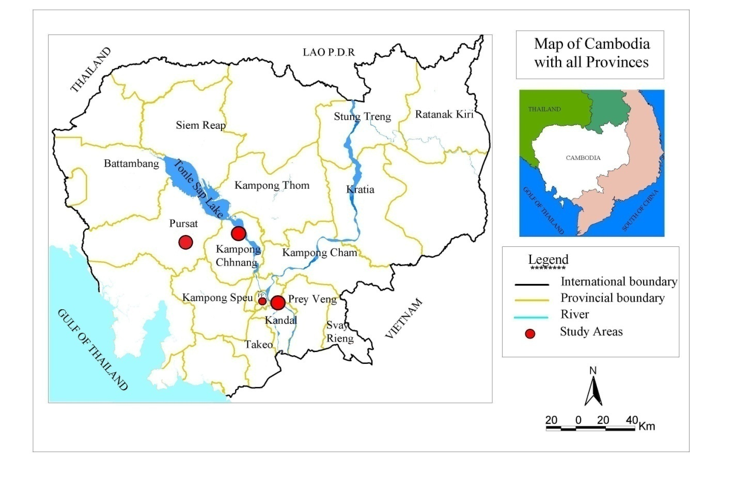

##### Figure 2.1: Map of Cambodia showing the study areas in Pursat, Kampong Chhnang, Kandal provinces, and Phnom Penh city.

## 2.2 Data Collection

Both secondary and primary data were basically used in this study. Secondary data were derived from various sources such as government reports, research publications, technical and working papers, scientific and consultancy reports of relevant institutions including Inland Fisheries Research and Development Institute (IFReDI), Fisheries Administration (FiA), Food and Agriculture Organization (FAO), Mekong River Commission (MRC), Sustainable Mekong Research Network (Sumernet), WorldFish Center (WF), and Cambodian Development and Research Institute (CDRI).

Primary data were taken from two sources: first from a database created through dai fisheries monitoring (time series data from 2005 – 2010) under Inland Fisheries Research and Development Institude (IFReDI)/Fisheries Administration (FiA) and second from field survey, which consists of both quantitative and qualitative data. The field survey was conducted with

* Key Informant Persons (KIP): Heads of villages and communes, provincial fisheries adminstration cantonment officers and other experienced stakeholders in the selected study areas were individually interviewed through a semi-structured questionnaires;
* Focus Group Discussion (FGD): Local authorities and other related stakeholders in the appointed study areas were grouped and asked to share some information relevant to fish trade using semi-structured questionnaires;
* Fish trader household (including wholsalers / fish collectors / Retailers): Only traders of the five key freshwater fish species were mainly chosen for individual interview using structured questionnaires.

## 2.3 Data Analysis

Primary data and information collected were stored in Access software program, and Excel and SPSS were used to analyse the data. In addition, the secondary data were synthesised, descriptive analysis was used to describe the secondary data and to present the characteristics of the target groups. Cross-tabulation was made to describe and to compare the data within and between group households. Comparative analysis was made to compare the mean value between the groups.

Moreover, to analyse price series data the following tests and models were used:

1. **X12-ARIMA**

Since some price series have seasonal trends, all of the series are seasonally adjuseted using this method which is commonly used in the U.S. Census, etc. The empirical analysis is conducted using these seasonally adjusted data by transforming them into natural logarithmic form.

1. **Unit Root Tests**

In this study, unit root tests were conducted to check the stationarity of price series. In this regard ADF, PP, and KPSS tests were employed.

1. **Empirical Model**

Since the price series are I (1) variables, OLS regressions of output prices on input prices may be spurious. Enders and Granger (1998) and Enders and Siklos (2001) showed how to test the co-integration relationship between prices and the asymmetry of price transmission using TAR model. In a TAR model, a co-integration test is performed by using residual series, $\left\{{\hat{μ}}_{t}\right\}$, which is obtained by regressing output prices on input prices, in the following equations:

|  |  |
| --- | --- |
| $$Δμ_{t}=I_{t}ρ_{1}μ_{t-1}+\left(1-I_{t}\right)ρ_{2}μ_{t-1}+\sum_{i=1}^{T}{γ_{i}Δμ_{t-i}}+ε_{t}$$ | (1) |

|  |  |
| --- | --- |
|  | (2) |

Where $I_{t}$ is the Heaviside indicator function, and $τ$ is the super-consistent estimator of threshold $μ_{t-1}$ calculated following Chan (1993). $ε_{t}$ is the white noise disturbance term, which satisfies the following conditions:

|  |  |
| --- | --- |
| $E\left(ε_{t}\right)=0, E\left(ε_{t}^{2}\right)=σ^{2}, E\left(ε_{t}ε_{j}\right)=0 \left(t≠j\right)$. | (3) |

The necessary and sufficient condition of $\left\{{\hat{μ}}_{t}\right\}$ to be stationary is as follows (Petrucelli and Woolford, 1984):

|  |  |
| --- | --- |
| $ρ_{1}<0, ρ_{2}<0,$ and $\left(1+ρ_{1}\right)\left(1+ρ_{2}\right)<1$, for any $τ$. | (4) |

$T$ is the lag order that minimizes the BIC (Bayesian Information Criteria).

A co-integration test is performed by testing $ρ_{1}=ρ_{2}=0$; i.e., if the null hypothesis of $ρ_{1}=ρ_{2}=0$ is rejected then input prices and output prices are said to be co-integrated. APT can be tested in the same model to compare the absolute values of $ρ_{1}$ and $ρ_{2}$. If $ρ_{1}=ρ_{2}$ is rejected and $\left|ρ_{1}\right|<|ρ_{2}|$, then it is shown that the negative discrepancies from the equilibrium error adjust more rapidly than the positive discrepancies. The implication is that the shock that decreases the margin adjusts more rapidly than the shock that increases the margin. That is, the price transmission shows downward rigidity, called positive APT. However, if $ρ_{1}=ρ_{2}$ is rejected and $\left|ρ_{1}\right|>|ρ_{2}|$, then the positive deviations adjust toward the equilibrium error more rapidly than do the negative deviations. The shock that increases the margin adjusts more rapidly than the shock that decreases the margin. This results in negative APT, which indicates upward rigidity of price transmission.

Another representation of threshold is also considered, which is called M-TAR model, using the following indicator function:

|  |  |
| --- | --- |
| $$I_{t}=\left\{\begin{aligned}1 if Δμ_{t-1}≥τ \\ 0 if Δμ_{t-1}<τ\end{aligned}\right.$$ | (5) |

The M-TAR model is the same as Equation (1) and (2) except that $μ_{t-1}$ in Equation (2) is replaced with $Δμ_{t-1}$.

The TAR and M-TAR model correspond to the two asymmetric adjustment processes, i.e., Deepness and Steepness, respectively (Sichel, 1993). In both models, however, $\left|ρ_{1}\right|<|ρ_{2}|$ indicates positive APT and when $\left|ρ_{1}\right|>|ρ_{2}|$, negative APT. Hence, the model selection may be based on information criteria such as BIC (Bayesian Information Criteria).

# PART III: RESULTS AND DISCUSSION

## 3.1 Overview on Freshwater Fish Marketing System in Cambodia

The fish marketing and distribution networks were relatively well managed and developed in inland fisheries. There were small- and medium-scale fish traders in the fisheries sector. Normally, the smaller traders collected fish from fishermen and sold it to wholesalers who in return distribute it to different places. There was high domestic demand of fish and fish products, ranging from live to processed forms such as fish paste, fermented fish, salted-dried fish, steamed fish, smoked fish and fish sauce etc. High-value species were usually sold to the traders for marketing in Phnom Penh or exporting.

The main players in the fisheries marketing system comprised fishermen, collectors, wholesalers/middlemen and retailers. The fishermen played a role as workers, and were involved either as part time or full time in small, medium or large-scale fishing. The wholesalers/distributors were the main traders and providers of the capital to most fishermen in both medium and large-scale fishing. The retailers were selling directly to the consumers. The fishermen, fishing lot owners, dai fishing owners, local collectors and local fish processors operated without any organised information system regarding prices, market demand or annual catch volumes.

Freshwater fish was distributed in various ways. In many locations around the Great Lake Tonle Sap, Mekong River and along river systems, fish was sold to customers at the “farm gate”. This practice was more common among small/family-scale or traditional producers who processed for subsistence purposes and for localised sales. In other cases, fish was transported by oxcarts, motorbikes and small trucks to urban markets. In addition, cages were towed to Phnom Penh from the Great Lake Tonle Sap and Mekong areas in order to sell fish alive (Rab et al., 2006).

## 3.2 The Actors in the Value Chain of the five Key Freshwater Fish Species

Results and findings of a research done by Rab et al. (2006) showed that the most complicated component of the fish marketing system in Cambodia was the supply chain and distribution channels (marketing channel), in which numerous transactions took place before fish products reached the final consumer or export markets. There were many middlemen (or often “middle-women”) who were essential for the fisheries trade. The trading system would not function without these entrepreneurial individuals and their enterprises. Although there were different elements of the producer component – inland, aquaculture and processing – they had similar supply and marketing channels. Fish harvested by all scales of fishers and fish farmers were immediately landed (i.e. at the landing site or harbour), and transferred to fish collectors and/or fish processors. Sometimes, harvested inland fishes were kept alive in pens or cages for sale during periods, when supply was scarce and prices were more satisfactory. Before reaching the consumer, fish and fish products would have passed through a number of transactions including fisher, fish collector, landing site owner, fish processor, collector, distributor, retailer or caterer, and etc.

### 3.2.1 Lot owners/Dai owners/Commercial Fishers

Lot owners had control over the fish product for sale to clients. Wholesalers, collectors and exporters buy fish from them at “farm gate”. Lot owners never exported fish to Thailand directly but in some cases lot owners take fish stocks for sale to Phnom Penh. Moreover, fishing lot owners marketed their fish in different ways, some worked directly with fish processors and exporters, whereas others sell to local collectors or deliver to landing sites. Larger businesses transport fishes directly to Phnom Penh’s central or regional markets. Some lot owners were reportedly financed by the larger exporters, traders or government officials, and were subsequently required to sell their catches to these financers or money provider (Rab et al., 2006).

### 3.2.2 Small-Scale Fishers

Fishermen were classified as small, medium and large scale, depending on size of catch potential and type of gear/equipment used. There were three categories of fishermen for inland fisheries. Normally, small-scale fishers were family-scale fishermen (one to three persons), who caught fish primarily for family subsistence and daily household income. The number of small-scale fishers was increasing annually as the population grew and as alternative livelihoods became scarce. Medium-scale fishers were extended families and village level partnerships (three to six persons), who caught fish for income and processing using non-industrial fishing methods (Rab et al., 2006).

According to a study on value chain analysis of *Snakeheads* in the Lower Mekong Basin of Cambodia (in Kandal, Kampong Chhnang, Kampong Thom and Siem Reap provinces, and Phnom Penh city), by Hap et al. (2011), the average number of small-scale fisher household members was 6 persons, ranged from 2 to 9 persons, and the average family labour of small-scale fisher households was 3.4 persons, ranged from 2 to 9 persons. However, the average size of family labour involving in fishing activities was high about 2.3 persons, ranged from 1 to 7 persons.

With reasons of conservation, protection and sustainable utilization of fish and other aquatic resources during fish spawning period, fishing domains acted by Fisheries Fiat-Law in early 1987 were clearly defined as followed: 1). from June 1st – September 30th, for the region north of the Chaktomouk parallel; 2). from July 1st – October 31st, for the region south of the Chaktomouk parallel (FiA, 2001).

There were peak and low period of fish caught in open fishing season. Based on the study of Hap et al. (2011), peak period of wild fish was from October to February and low period was from March to May. The average number of day per month and of month per year for fishing was the same during open and closed season since fishing was the main occupation of small-scale fishers.

The study also revealed that major operating cost on fishing activities varied in accordance with season - open and close fishing seasons. Generally, in open season, average total operating cost on fishing activities per day per small-scale fisher household was USD 23.3 and USD 9 in close season. In other words, small-scale fishers had higher expense on fishing activities in open season because they spent more time for fishing activities compared to that in closed season. If fisher used only family labours, the input cost would be decreased. This was due to the fact that there was high cost of hired labours in the study areas as well as in the country.

Overall, the total caught of captured fish by small-scale fisher households was sold to local fish traders (known as fish collectors/middlemen/wholesalers/retailers), local processors, traders from other provinces, and own sale to consumers at local areas and markets. Moreover, there was only small amount of the fish, mostly left from selling was kept for household consumption (Hap et al., 2011).

There were some difficulties encountered to fishers. One of which was the shortage of fishing grounds for small-scale fishing activities. In some cases, it was very competitive to have places for fishing. Second, it was the decrease of fish catch and wild fish stock in rivers, resulting from illegal (mosquito net, electro-fishing and explosive) and over fishing. Third, it was high cost of inputs, mainly on fuel, food, fishing gears and informal-fee payments. Another thing, it was lack of capital (Hap et al., 2011).

### 3.2.3 Fish Farmers

Fish farmer is one of the supplying sources of fish to consumers and markets. There were three main types of fish farming systems in Cambodia: cage, pen and pond farming systems. Cage culture system seemed to have originated in the Great Lake. 77% of the cages were located in the Tonle Sap, Mekong and Bassac rivers, and only 23% were within the lakes. However, pen culture was a technique practice in some part of the Great Lake, the rivers and lakes around the capital. Moreover, pond culture of fish was the least developed technique in Cambodia. Its contribution was some 15 - 20% of total cultured fish volume in 1993 - 1998 (FiA, 1999). Cage and pen fish cultures involved from 70 - 80% of Cambodian aquaculture production during 1992 – 1998, while pond culture dominated only 20 – 30% (FiA, 1999).

Of the five key freshwater fish species (*Snakeheads, Pangasius, Croaker, Reddish* and *Henicorhynchu*s), only 2 fish species - *Snakeheads* and *Pangasius* - have been cultured by fish farmers. *Snakeheads* were mostly found to be cultured in Kandal and Siem Reap provinces (Hap et al., 2011), while *Pangasius* was often found to be farmed around Phnom Penh city and Kandal province (So and Nao, 1999). The two fish species were cultured either in pens, cages or ponds.

According to Fisheries Administration (2001), the major cultured species from cage and pen systems were *Pangasius* (73%), followed by *Snakeheads* (21%) and other fish species. However, So et al. (2005) revealed that the most important fish species in Cambodia’s cage culture system was the strictly carnivorous G*iant Snakehead*; the second most important fish species was *Pangasius*; and the third ones were *Common* *Snakeheads* and other fish species. Moreover, although raised in pond culture systems, mainly in intensive pond culture, *Pangasius* represented the highest percentage compared to other fish species and contributed less than 10% of the total aquaculture production (FiA, 2001).

Normally, an average size of fish farmer household was about 5.17 persons, ranged from 2 to 10 persons. On average, the number of family labours involved in fish farming per household was 3.20 persons, ranged from 1 to 8 persons. Of the total fish farmer households, around 5% of them hired labourers averaged to 1.75 persons i.e. ranged from 1 to 2 persons (Hap et al., 2011).

Overall, nearly all of the total quantity of the cultured fish was sold to local fish traders (collectors/wholesalers/middlemen/retailers), to traders from other provinces, and direct sale in markets. Moreover, only few of the cultured fish was kept for household consumption (Hap et al., 2011).

Generally, one of many difficulties faced by fish farmers was that feed used for fish farming was mostly trash/low value fish, so most of the farmers were difficult to find or afford to buy due to its scare availability and high price. Another problem was that although there was some man-made feed (pellet feed) for fish, its price was also high and could be hardly affordable for fish farmers. Moreover, appropriate technologies in raising fish seemed to be limited to fish farmers. As a result, rate of fish death from uncontrollably infected diseases was high. Furthermore, lack of capital to operate the whole crop cycle was still a problem for many fish farmers (Hap et al., 2011).

### 3.2.4 Fish Traders

Fish traders generally included collectors, middlemen, wholesalers, semi-wholesalers and retailers. Overall, the average numbers of fish trader household members were 4.24 persons (male: 2.04 persons, and female: 2.20 persons), ranged from 1 to 9 persons. Moreover, the average number of the household members engaged in fish trade was only 2.06 persons (male: 0.75 person and female: 1.31 persons), ranged from 1 to 6 persons. Furthermore, the majority of fish trader households do not hire labourers (86.15%). This revealed that most of fish traders used only their family labours in the trade (Hap et al., 2011).

Normally, fish was traded either in the landing sites, markets or homes. Sometimes fish was also traded nomadically. Most of traders sell their products in the markets but not year round. The main sources of the freshwater fish supply were fishers, fish farmers, middlemen/wholesalers and importers. Furthermore, buyers of the fish included middlemen/wholesalers, retailers, processors, exporters, consumers, supermarkets and restaurants (Hap et al., 2011).

Fish traders could be collectors, middlemen, wholesalers, semi-wholesalers and retailers; they were different in term of their characteristics in the trade, as shown below:

#### 3.2.4.1 Collectors

Fish collectors buy fish, directly or through their network, from fishers or fishing lot/dai owners in the fishing villages. They had one or several boats with several iceboxes for fish storage during the fish collection period. Collectors are specialised operators who buy fish from fishermen and bring them to the landing sites throughout the year. They set prices with fishers depending on fish quality, supply situation and daily fish market demand. Mostly, fish collectors had capital for immediate cash payment to fishermen; however, they often provided credit to small-scale fishers in the form of cash and in kind (e.g. fishing gear). Moreover, some collectors also receive loans from wholesalers, middlemen and exporters. Fish collectors sell their fish collected to middlemen, wholesalers, retailers or exporters at fish-landing site (Rab et al., 2006).

#### 3.2.4.2 Wholesalers

Wholesalers tended to represent an important part of the marketing chain, in which often major quantities of fish was channelled through them. In the case of Cambodia, they were best compared with fish distributors who had a permanent fish stall at a fish-landing site, a floating village or at a distribution centre. They might buy fish from fishers, lot owners, collectors or middlemen and re-sold it to exporters, retailers or restaurant owners. This was very much location-specific, and the scale of the business might depend on whether a wholesaler was based in a provincial town or in the Phnom Penh area (Rab et al., 2006).

#### 3.2.4.3 Semi-wholesalers

Defined as semi-wholesalers were those fish traders who had a permanent stall inside/outside a market, whereby fish was brought by middlemen or wholesalers and sold to them in the market. Semi-wholesalers acted sometime as retailers, but they usually had an additional function in distributing fish to small retailers who sell fish in the local markets directly to consumers and processors. Most semi-wholesalers were fish traders at provincial level, but some of them also operated in Phnom Penh, or might transport fish from the capital to sell to retailers in fish-deficient provinces (Rab et al., 2006).

#### 3.2.4.4 Retailers

Fish retailers are those who sell fish in markets directly to consumers or restaurant owners – in many cases they had a permanent stall inside or outside the market. Generally, in each market (from provincial to local level) there were many fish retailers selling fish every day. Fish retailers who sell fish in the market were mostly women, but they often had their spouses or relatives/partners who assist them in buying fish from the landing site or the distribution centre. Some fish retailers who worked alone (i.e. those who did not have a spouse or partner to help them) buy fish from semi-wholesalers in the same market or place where they sell fish directly to consumers. In addition, there were also retailers who are itinerant traders who do not have a permanent stall but sell from a basket or another container by moving from place to place. Often they were also called fish vendors or hawkers (Rab et al., 2006).

There were some difficulties to which fish traders confronted in the business. First, the amounts of fish, especially wild fish were not enough for them to supply the markets. Sometimes due to the scarcity of fish most of fish traders had to do price auction. As a result, fish would be unavoidably sold at higher price and this made fish traders to get little profit. Second, there was no fixed fish price. Fish price always varies from one trader to another, so it was hard to set a specific price. Furthermore, quality degradation, weight loss and death rate were always the important cases that apply to fish, especially during fish loading and Unloading to different markets. This could not be fully controlled by fish traders since their knowledge on fish conservation is still limited. Moreover, fish traders seemed to spend more money on business operation mainly on transportation. Furthermore, capital was still a problem in the business transaction (Hap et al., 2011).

### 3.2.5 Fish Processors

Fish processors were generally either fishers, fish raisers or business men (Rab et al., 2006). Overall, the average numbers of fish processor household members in labour age were 4.7 persons (male: 2.3 persons and female: 2.5 persons), ranging from 2 to 12 persons. Specifically, the average number of household members in labour age and involved in fish processing was only 3.3 persons (male: 1.9 person and female: 1.8 person). Furthermore, over half of processor households do not hire labourers. Instead, they use their own family labour in the processing work (Hap et al., 2011).

The processors buy fish from fishers, fishing lot owners, fish farmers, traders/middlemen/fish collectors/wholesalers, other processors, retailers and importers(from Vietnam). The processors make products such as fish paste, salted-dried fish, fermented fish, smoked fish etc. Processed products were usually sold to domestic market (middlemen/wholesalers, retailers mainly in Phnom Penh, consumers, supermarkets and restaurants) and some products were also exported to the international market with specific products and species. Only few of it was kept for household consumption (Rab et al., 2006; Hap et al., 2011).

Fish processors face some difficulties: first, the steadily increasing price of fresh/live fish which leads to the hardship of affording fresh/live fish for processing. Second, the difficulty of processing quality product due to limited processing knowledge and technique. Third, after fish were preserved (especially into salted-dried fish) processors found it hard to preserve its quality due to their limited knowledge of maintaining quality after processing a product. Also, they faced difficulties selling out the products. Fourth, the mean and way in which the products were packed and loaded to markets was still problems for some fish processors (Hap et al., 2011).

### 3.2.6 Exporters

Exporters play an important role in the marketing channel by exporting fisheries products to neighbouring and other countries. Generally, they purchase fish directly from fishing lot owners or traders/middlemen, stored it with ice in the containers, and export it either by land or air as live fish (Rab et al., 2006).

### 3.2.7 Consumers

Consumers were the final buyers of fish for personal or household consumption. They could buy different kinds of fish in the form of fresh or processed fish. The average household consumption of freshwater and processed fish was 1.3 and 1.5 kg/week respectively. The average size of households was five persons, similar to the study conducted by Hap et al. (2011) which stated the household size as 5.81. This number gave an annual per capita consumption of approximately 29.1 kg/person/year, similar to the estimation of 32.3 kg/person/yr by Hortle (2007). The most common consumed species were *Channa* *spp.*, *Henicorhynchus/Labiobarbus* *spp.*, and *Cirrhinus molitorella*. The most common processed fish products include smoked, salted-dried and fermented (Loc et al., 2009).

The main difficulty for consumers was the availability of enough fish, especially wild fish, which satisfies the market demand. Fish was scarce and consumers prefer wild fish over cultured fish, in addition it was reported that most of the fish especially wild fish are traded to big markets in the city where traders expect to get higher price. As a result consumers living in the rural and sub-urban areas are left with less fish to consume. Moreover, the scarcity of fish resulted to an increase to fish price which brings challenges to the low/limited income consumers. In addition to high fish price, fish bought from markets was sometimes not properly weighed and this puts more pressure on fish consumption.

Semi-wholesalers

Collectors/middlemen

Retailers

Consumers

Wholesalers

Fishermen/ Fishing lot/dai owners/ cage/pond owners

Fish processors/ Factories

Exporters

* Workers
* Fishing equipment producers
* Sellers of fishing equipments
* Boat makers
* Loan/credit owners
* Ice suppliers
* Transporters
* Cleaners
* Boat drivers
* Fish processors
* Salt suppliers
* Fishery officers
* Policemen
* Local authorities
* Telephone sellers
* Basket producers
* Basket sellers
* Motor-taxi drivers
* Electricity suppliers
* Water suppliers
* Landing place owners
* Market managers

Figure 3.1: Value chain of freshwater fish with the stakeholders in Cambodia.

(Source: Rab et al., 2006)

## 3.3 Production and Trade Volume of the Five Key Freshwater Fish Species

### 3.3.1 Snakeheads

There were two main sources to be considered when revealing to annual total production of *Snakeheads*: fishers and fish farmers. A study on the value chain analysis of *Snakeheads* in the lower Mekong Basin of Cambodia by Hap et al. (2011) showed that the average quantity of wild *Snakeheads* caught by fisher household was approximately 7,110 kg/year, and the average quantity of cultured *Snakeheads* raised by fish farmer household was about 1,800 kg/cycle or year (only 1 cycle per year). Moreover, the quantity of fresh *snakeheads* traded by traders was on average 16,567 kg/year. A study by Sinh and Chung (2010) reported that about 0.6%-1% of total production of *Snakeheads* in Vietnam was imported by Cambodia in fresh form. This percentage accounted for 240 to 400 tonnes.

The result of this study which was conducted in Pursat, Kampong Chhnang and Kandal provinces, and Phnom Penh city shows that the average quantity of *Snakeheads* traded by all sampled traders (80 fish traders) was 18.8 tonne/year in 2010. This quantity varied from 0.2 tonne to 224.6 tonnes –see Table 3.1.

#### Table 3.1: Average quantities of fish sold by traders (tonne/year), 2010

|  |  |  |  |
| --- | --- | --- | --- |
| Fish Species | Average | Min | Max |
| Pangasius (Pra) | 18.8 | 1.1 | 171.0 |
| Snakehead (Chhdaur/Ros) | 18.8 | 0.2 | 224.6 |
| Reddish (Kes) | 12.7 | 0.1 | 60.0 |
| Croaker (Pramah) | 8.8 | 0.0 | 45.0 |
| Henicorhynchus (Riel) | 31.3 | 0.6 | 140.0 |
| **All species** | 46.6 | 0.3 | 4,16.5 |

### 3.3.2 Pangasius

In Cambodia, *Pangasius Hypopthalmus* production was predominantly from capture fisheries. Survey data indicated the high variability of catches using a range of fishing gears. The Mekong River Commission (MRC) estimated that Dai Fisheries on the Tonle Sap River accounted for 223 tonnes, or 1.6% of the total catch (Van Zalinge et al., 2002). In addition, data from fishing lots showed catches of 1,367 tonnes per year from floating and seine nets, with *Pangasius* contributing up to 6.6% of the total catch. However, this capture fishery production was being supplemented with the growing aquaculture industry. The production of P*angasius* in Cambodia has increased 2.6 times from an estimated 3,000 tonnes in 2004 to 8,000 tonnes in 2006 (FAO, 2008).

Moreover, the trade of 4,300 kg of *Pangsius* was recorded representing 0.6% of the total aquaculture production, or 2% of the Dai fishery catch. All of this production was for domestic markets (Loc et al., 2009).

This study reveals that average quantity of *Pangasius* traded by all sampled fish traders per year (in 2010) was the same as *Snakeheads* which was 18.8 tonnes. This quantity varied from 1.1 tonnes to 171 tonnes – refer Table 3.1.

### 3.3.3 Croaker

Neither reports nor papers which clearly dipict total production of *Croaker* in the country have beenfound. According to Rab et al. (2006), 450 kg of *Croaker* (0.3% of total export) was exported by all the sampled traders in open season of 2004.

However, in this study, average quantity of *Croaker* traded by all sampled fish traders per year (in 2010) was 8.8 tonnes (Table 3.1).

### 3.3.4 Reddish

Like *Croaker*, total production/catch of *Reddish* is not unfolded in any document. Based on Rab et al. (2006) 4,570 kg of Reddish (3.05% of total export) was exported by all the sampled traders (in Pursat, Kampong Chhnang, Siem Reap and Kandal province, and Phnom Penh city) in open season of 2004.

In this study, the average quantity of *Reddish* traded by all sampled fish traders per year (in 2010) was 12.7 tonnes see Table 3.1.

### 3.3.5 Henicorhynchus

The average fish catch of each dai in the season of 2006-2007 was around 300 tonnes, ranging from 59 to 603 tonnes. Hence, the combination of fish caught from all dais (61 dais), the total catch was estimated around 18,000 tonnes. In this, over 95% of the total dai fish catch was small-sized fish, of which *Henicorhynchus* was the most dominant species, contributing 52% i.e. about 9,360 tonnes from all dais fisheries (So et al., 2007). Moreover, a study conducted by Loc et al. (2009) revealed that 29,064 tonnes of *Henicorhynchus/labiobarbus* spp.was recorded, representing 55% of the dai fishery.

As indicated in Table 3.1, average quantity of *Henicorhynchus* traded by all sampled fish traders per year (in 2010) was 31.3 tonnes, ranging from 0.6 tonne to 140 tonnes.

In General, the average quantity of the five key freshwater fish species traded by all sampled fish traders per year (in 2010) was 46.6 tonnes which varied from 0.3 tonne to 416.5 tonnes – see Table 3.1.

## 3.4 Gender Role of Chain Actors in Fishing, Fish Farming, Processing and Trading

### 3.4.1 Fishing

In Cambodia, from the total population of 11.4 million 2.1% were professional fisherman and around 80% were engaged in both fishing and agricultural production (Nao and Mong, 1997).

FiA and MRC (2005) revealed that in the village along Tonle Sap River in Kampong Chhnang (Nak Ta Han village) and Pursat provinces (O Ta Prok village) all interviewed men and women were engaged in fishing. There was a perception of women not going out for fishing and men were considered the only once engaged in the fishing activity. In contrast, a considerable number of women were involved in catching fish (on a small scale) for home consumption.

It was also indicated that a women go fishing for household consumption when her husband was unable to fish or if she is a widow and there was no male member in the household. Furthermore, villagers recognise the important role women play in fisheries and fishery-related activities. Women and men were involved in all activities, except in building and repairing boats where only men were engaged. In the case of cooking fish baits, it is primarily done by women but if there are no women to cook the bait then men are also involved see Table 3.2.

#### Table 3.2: Gender-based perception of villagers in Cambodia on the people who play important roles in fishing activities ranging from 3(very important) to 0(not important)

|  |  |  |  |
| --- | --- | --- | --- |
| Fishing Activities | Men | Women | Children  (>10 years) |
| Fishing | 3 | 2 | 1 |
| Fish selling | 2 | 3 | 1 |
| Fish culture | 3 | 2 | 0 |
| Fish processing | 2 | 3 | 2 |
| Collecting fish bait | 3 | 1 | 0 |
| Cooking fish bait | 1 | 3 | 0 |
| Preparing fishing operation and equipments | 3 | 2 | 0 |
| Fishing net/trap/gear making | 3 | 2 | 1 |
| Collecting gill net and hook long line | 3 | 3 | 2 |
| Repairing boat | 3 | 0 | 0 |
| Making palm boat | 3 | 0 | 0 |
| Firewood collection | 3 | 2 | 2 |
| Collecting edible aquatic plants/vegetable | 3 | 2 | 2 |
| Collecting snail | 3 | 2 | 2 |
| Buying fish gears and bait | 3 | 3 | 0 |
| Buying boat | 3 | 2 | 0 |

Note: 3=Very important; 2= Important; 1= somewhat important/supportive; 0=Not important

(Source: FiA and MRC, 2005)

Based on a study about gender and the post-harvest fisheries sector in Pursat, Kompot and Kandal provinces, and Phnom Penh city by Ham (2006), women and men were involved in complementary activities in capture fisheries. Men went fishing in more distant waters, while women used small boats near to the shoreline. Moreover, ADB (2007) showed that while the role of women in capture fishing as a whole is less important to that of men, there are specific fishing related activities where women play a more significant part, including maintaining fishing equipments such as nets, and supplying fishing gears. Furthermore, on the Great Lake, women were actively engaged in capture fisheries in both artisanal and commercial fisheries. In general, men were associated with the more visible, commercially-oriented, large-scale or medium-scale activities, whereas women tended to play a bigger role in the small-scale, subsistence and non-commercial sectors, especially in collecting invertebrates. Traditionally, fishing practice has been classified into large, medium and small scales. Specifically, fishing activities on the Great Lake where the commercial fishing lot systems dominated, women’s involvement in large-scale fish harvesting activities was excluded by certain cultural beliefs.

### 3.4.2 Fish Farming/Aquaculture

Along with men, women played a great role in aquaculture. The social and market situation changed the gender division of labour in aquaculture. In Cambodia, it was often seen that men went out to buy and collect fingerlings. However, the location of the pond was a critical factor in determining the division of labour in feeding fish in pond culture. In villages where the ponds/cages tended to be far away from the house, women were less likely to feed fish. When women were the feeders of fish, they know which feed was good for which fish. Although most women harvested and decided on the daily household consumption of fish, major fish harvest was under the control of men. The harvest of a large batch of fish from a pond/cage using cast nets was definitely considered a man’s responsibility. The money earned from aquaculture was normally kept by women. Moreover, women knew the value of different species much more than men since they sell various fish species in the market. Women also know names of small fish better than men since the small fish is normally consumed in the household and men do not bother about such fishes (Kusakabe, 2006).

### 3.4.3 Fish Trade

In fishing related activities, the contribution of women is quite evident and they are active traders of captured fish. Fish was the largest export item in Tonle Sap. Small-scale fish trade was dominated by women, while there were more men among larger traders (Kusakabe et al., 2005). A study in the villages of Nak Ta Han in Kampong Chhnang province and O Ta Prok in Pursat province depicted that 97% of fish sellers were women (FiA and MRC, 2005).

Table 3.3 shows the percentage of women and men involvement in the trade of the five key freshwater fish species (in Pursat, Kampong Chhnang and Kandal provinces, and Phnom Penh city). In the fish trade activity women dominate in most of the activities such as: fish buying and selling management (69.4%), decision on fish selling and buying (74%), buying activities (64%), and selling activities (78.9%). However, transportation activities were mostly done by men (50.9%).

#### Table 3.3: Percentage of female and male involvement in the trade of five key freshwater fish species

|  |  |  |
| --- | --- | --- |
| Description | Female | Male |
| Fish buying and selling management | 69.4 | 30.6 |
| Decision in fish selling and buying | 74.0 | 26.0 |
| Buying activities | 64.0 | 36.0 |
| Selling activities | 78.9 | 21.1 |
| Transportation activities | 49.1 | 50.9 |

Table 3.4 shows percentage of women and men involvement in fish collection and the profit gained from the fish trade. In most cases, both women and men buy and sell fish, and they benefit from the fish trade activities. Moreover, women have higher percentage of involvement (43%) compared to men (6%).

#### Table 3.4: Percentage of women and men involvement in fish collection and obtaining profit from the fish trade

|  |  |  |  |  |  |  |
| --- | --- | --- | --- | --- | --- | --- |
| Description | Female | | Male | | Both | |
| No. | (%) | No. | (%) | No. | (%) |
| Fish buyer (for sale) | 15.0 | 42.9 | 2.0 | 5.7 | 18.0 | 51.4 |
| Interest receiver | 3.0 | 8.6 | 1.0 | 2.9 | 31.0 | 88.6 |

### 3.4.4 Fish Processing

Fish processing and marketing was an area where women were much more involved than men. Women were heavily engaged in the utilization of aquatic resources through the processing and marketing of fish, which enabled the transfer of aquatic resources to faraway places and their consumption over a period of time. Women were the sellers, buyer, traders, middle-women and entrepreneurs of fish processing and marketing. They often controlled the household income generated from selling fresh and processed fish (Kusakabe, 2006).

Villagers in the two villages in Kampong Chhnang and Pursat provinces also recognised the important role of women in fish processing activities. Both women and men were important in all activities, except ingredient and beheading fish in which only women were engaged (Table 3.5) (FiA and MRC, 2005).

#### Table 3.5: Gender-based perception of villagers in Cambodia on people who play important roles in fish processing activities

|  |  |  |  |
| --- | --- | --- | --- |
| Activities | Gender and Children Roles | | |
| Men | Women | Children |
| Fish Peeling | 2 | 3 | 2 |
| Ingredient | 0 | 3 | 0 |
| Fish Head Cutting | 1 | 3 | 1 |
| Fish Cleaning | 3 | 2 | 1 |
| Processed Fish Selling | 2 | 3 | 1 |

**Note**: 3=Very important; 2= Important; 1= somewhat important/supportive; 0=Not important

(Source: FiA and MRC, 2005)

The study by Ham (2006) also revealed gender roles in fish processing in Phnom Penh city and Pursat province. Table 3.6 shows gender roles in frozen freshwater fish processing at Lean Heng Export and Import Company in Phnom Penh. According to the table, there were two types of workers – permanent and seasonal workers (Permanent workers were the ones who had often worked in the company for many years and received a monthly salary. However, seasonal workers referred to those who worked on a day-by-day basis and did not generally stay at the company. These seasonal workers got daily payment and their work was not year round but mostly concentrated during open fishing season from October to April). The numbers of women, both permanent and seasonal workers, were more than men. Moreover, men and women are involved in different activities: women were responsible for light work like heading and scaling fish whereas men were responsible for heavy works such as carrying and preparing frozen fish products.

#### Table 3.6: Gender roles in frozen freshwater fish processing (at Lang Heng Export and Import Company, Phnom Penh)

|  |  |  |  |
| --- | --- | --- | --- |
| Gender | Activities | Permanent workers | Seasonal workers |
| Women | - Heading fish  - Scaling fish  - Cleaning fish  - Boning fish  - Wrapping fish  - Putting product into ice containers | 18 persons | 40-50 persons |
| Men | - Weighing fish  - Carrying products  - Freezing products  - Preparing ice  - Wrapping fish | 4 persons | 3 persons |

(Source: Derived from Ham, 2006)

Women played very important roles in directly managing and controlling workers and profits. As indicated in Table 3.7, in large- and small-scale salted and dried fish processing majority of the workers were women. For instance, the number of women permanent workers in large-scale salted and dried fish (*Snakeheads*) processing, small-scale salted and dried fish (*Snakeheads*) processing, and large-scale salted and dried fish (*Pangasius*) processing were 16 out of 19 persons, 3 out of 4 persons, and 12 out of 15 persons respectively. Both genders are involved in different activities as indicated in table 3.7(Ham, 2006).

#### Table 3.7: Gender roles in freshwater fish processing activities in Phnom Penh

|  |  |  |  |
| --- | --- | --- | --- |
| Name and  Location | Activities | Permanent  workers | Seasonal  workers |
| *Large-scale salted and dried fish (Snakeheads) processors (Toul Kork, Phnom Penh)* | | | |
| Women | - Scaling fish  - Cleaning fish  - Boning fish  - Sun-dried fish  - Salting fish  - Collecting dried fish products | 16 persons | 5-10 persons |
| Men | - Collecting dried fish products  - Weighing fish  - Salting and transporting fish  - Transporting salted fish to dry  - Cleaning and boning fish | 3 persons | 3 persons |
| *Small-scale salted and dried fish(Snakeheads) processors (Tol Tompong Market, Phnom Penh)* | | | |
| Women | - Scaling fish  - Cleaning fish  - Boning fish  - Sun-dried fish  - Salting fish  - Collecting dried fish products  - Cleaning and boning fish | 3 persons | - |
| Men | - Collecting sun-dried fish products  - Weighing fish  - Salting and transporting fish  - Transporting salted fish to dry | 1 persons | - |
| *Large-scale salted and dried fish (Pangasius) processors (Yeur No. 9, Russey Keo, Phnom Penh)* | | | |
| Women | - Scaling fish  - Cleaning fish  - Boning fish  - Sun-dried fish  - Salting fish | 12 persons | 10-15 persons |
| Men | - Collecting sun dried fish products  - Weighing fish  - Salting and transporting fish  - Transporting salted fish to dry | 3 persons | 23 persons |

(Source: Derived from Ham, 2006)

Besides this, in Pursat province fish processing was a female-dominated activity. Women played a vital role in the processing work, particularly at the level of small-scale or family fish processing. In this type of processing, women, men and children worked together, but women had greater responsibilities than others in salting, sun-drying and marketing fish. It was reported that there were three fish species mainly processed: *Giant Snakehead* (salted-dried Giant Snakehead), *Common Snakehead* (salted-dried common snakehead), and *Croaker* (salted-dried croaker) (Ham, 2006).

According to Khim et al. (2002) concerning gender roles in fisheries activities, the percentage of female (adult and child) involvement in fisheries activities was higher (52.2%) than that of male (adult and child) (47.8%). In the case of fish capture, the majority of fishers involved in fish capture were male (80%). In aquaculture, female were mostly engaged in feeding (60%) and daily care (55%), whereas male were involved in pond preparation (75%), fertilizing (55%) and harvesting (55%). Besides this, stocking fish was equally done by female (50%) and male (50%). Moreover, fish marketing including buying and selling fish were primarily done by female (85%) (Table 3.8).

#### Table 3.8: Percentage of female and male involvement in Fisheries Activities

|  |  |  |  |  |  |  |  |
| --- | --- | --- | --- | --- | --- | --- | --- |
| Fisheries Activities | Female  (Adult) | Female (Child) | **Total (Female)** | Male (Adult) | Male (Child) | **Total (Male)** | Grand Total  (Female and Male) |
| 1. Fish Capture | 15 | 5 | 20 | 75 | 5 | 80 | 100 |
| 2. Aquaculture |  |  |  |  |  |  |  |
| - Pond Preparation | 20 | 5 | 25 | 70 | 5 | 75 | 100 |
| - Fish Stocking | 45 | 5 | 50 | 45 | 5 | 50 | 100 |
| - Feeding | 50 | 10 | 60 | 30 | 10 | 40 | 100 |
| - Fertilizing | 35 | 10 | 45 | 40 | 15 | 55 | 100 |
| - Daily Care | 55 | 0 | 55 | 45 | 0 | 45 | 100 |
| - Harvesting | 30 | 15 | 45 | 35 | 20 | 55 | 100 |
| 3. Fish Marketing |  |  |  |  |  |  |  |
| - Buying | 80 | 5 | 85 | 10 | 5 | 15 | 100 |
| - Selling | 80 | 5 | 85 | 10 | 5 | 15 | 100 |
| Total: | 45.6 | 6.7 | 52.2 | 40.0 | 7.8 | 47.8 | 100.0 |

(**Source:** Derived from: Khim et al., 2002)

## 3.5 Marketing Channels of Chain Actors by Fish Species

### 3.5.1 Captured fishes

**3.5.1.1 Snakehead**

The value chain of captured *Snakehead* in Cambodia was quite simple because the majority of the fish were sold only for domestic market. Figure 3.2 shows the value chain of captured *Snakehead* in Cambodia from producers (fishers) to consumers. Normally, wholesalers/collectors/traders played very important role in directly delivering 68.1% of *Snakehead* from fishers to other chain actors in the value chain, including retailers, processors, restaurants and markets in Phnom Penh city. In addition, some amount of *Snakehead* was directly bought by retailers (25%) and kept for household consumption (6.9%). Only 8.6% of the captured *Snakehead* was supplied to processors via wholesalers/collectors/traders. The processed products of *Snakehead* were salted-dried fish, salted fish cheek, fermented fish and fish paste. After processing, it was mostly and directly sold to consumers (5.2%). Moreover, a small portion was also sold to restaurants, retailers, and Phnom Penh city.

**Inputs**

**-** Fuel/Oil

- Food expenditure

- Other expenses (cigarette, wines, sweet)

68.1%

8.6%

Restaurants

**Major inputs**

**Wholesales**

**Production**

**Processing**

**Retailing**

**Consumption**

Whole sellers/

Collector/Trader

25%

Household consumption

6.9%

32%

Phnom Penh City

Processors

1.7%

22.1 %

0.85%

100%

**Fisher**

51.8%

100%

5.4%

5.4%

5.2%

0.85%

1.7%

6.1%

6.1%

##### Figure 3.2: The value chain of captured *Snakehead* in the LMB of Cambodia.

(Source: Hap et al., 2011)

**3.5.1.2 Reddish**

Figure 3.3 shows the *Reddish* value chain in Cambodia from fishers to consumers. Generally, fishers directly sell the largest quantity of *Reddish(*37.4%) to wholesalers/collectors/traders. Fishers also sell directly to retailers (23.6%) and consumers (20.5%). Fishers and wholesalers/collectors/traders were the only important supplying sources of *Reddish* to processors who handled 24.4% of the fish in the chain. After reaching the retailers and processors, fresh and processed *Reddish* is then sold to consumers in the local or city markets. Generally, around 7% of *Reddish* was exported to Thailand in both fresh and processed forms. The processed products of *Reddish* were salted-dried fish and smoked fish only, and most of it heads to Phnom Penh city.

37.7 %

2.9%

3.4%

Processors

100%

100%

**Inputs**

**-** Fuel/Oil

- Food expenditure

- Other expenses (cigarette, wines, sweet)

6.2%

**Major inputs**

**Wholesales**

**Production**

**Processing**

**Retailing**

**Consumption**

Wholesalers/Collector/Trader

23.6 %

15.8%

Phnom Penh City

12.3%

8.2%

**Fishers**

36.3%

2.4%

7.2%

10.2%

13.1%

Thailand

3.7%

End consumer

20.5 %

18.2% %

##### 

##### Figure 3.3: The value chain of Reddish (Kes) in Cambodia.

**3.5.1.3 Henicorhynchus**

In Cambodia, the study conducted by Loc et al. (2009) indicated that *Henicorhynchus/ Labiobarbus* spp. were only sold to the domestic markets. Fishers sell almost half of the catch directly to retail markets (48.8%) and the rest is sold through various combinations of collectors, traders, wholesalers and processors. Similar to the *Pangasius* chain, fish collectors played an important role, buying one quarter of fish from fishers and selling it to wholesalers and processors. Processors handled around 35% of fish in the chain, these were often small-scale, household level units which produced salted-dried fish or fermented fish sauce from the surplus catch (Figure 3.4).

There was no export trade recorded in Cambodia, however it was well established that large amounts of these species were sold to Vietnam, Thailand and Laos both fresh and processed (Yim and McKenney, 2003a; Bush, 2004; Keang, 2004). There was no reliable data on the exported quantities of *Henicorhynchus/Labiobarbus* spp. However, there was anecdotal evidence that demand for the fish increased in large cities of Vietnam such as Ho Chi Minh, leading to large importing demand of the fish species from Cambodia.

There were two companies in Vietnam which begun selling canned Ca Linh (Vietnamese word) to international markets. The Antesco company sold canned Ca Linh with sugarcane and exported 10% of its 15 tonnes/yr production, and the Ba Giao Khoe 55555 Salted Fish Company exported 60% of its 150 tonnes/yr production of salted and dried fish. Ba Giao Khoe directly imported from Cambodia while the Antesco Company bought their fish from a wholesaler who probably imported it from Cambodia. The companies hire boats which travelled directly to the Dai fishery on Tonle Sap during the main fishing season (Loc et al., 2009).

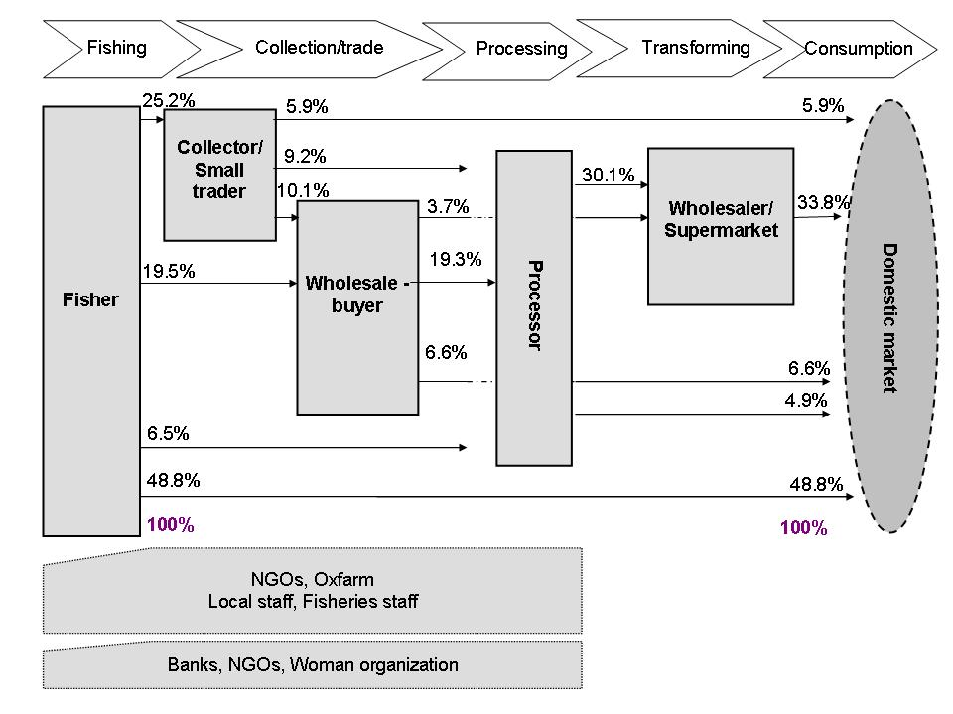

Figure 3.4: The value chain of *Henicorhynchus* sp.(Riel) in Cambodia.

(Source: Loc et al., 2009)

**3.5.1.4 Croakers**

Figure 3.5 shows the value chain of captured *Croaker* in Cambodia from fishers to consumers. More than half of the *Croakers* were sold directly by fishers to wholesalers/collectors/traders (57.3%) before it was distributed to other stakeholders in the chain. The remaining was sold to retailers (21.1%) and consumers (8.9%). Processors absorbed around 26% of the fish in the chain. The processed product was salted-dried *Croakers*, most of which was sold to retailers and to Phnom Penh city. In the case of fish export, around 6% of fresh and processed *Croakers* was exported to Thailand.

End consumer

12.7%

4.2 %

100%

100%

Processors

**Inputs**

**-** Fuel/Oil

- Food

expenditure

- Other

expenses

(cigarette,

wines,

sweet)

57.3%

13.0 %

**Major inputs**

**Wholesales**

**Production**

**Processing**

**Retailing**

**Consumption**

Wholesalers/

Collector/Trader

21.1%

25.5 % 25.53

Phnom Penh City

14.6 %

8.9 %

**Fisher**

43.6%

10.8 %

13.7%

11.6%

Thailand

1.9 %

4.2 %

8.9%

### 

##### Figure 3.5: The value chain of captured Croaker (Prama) in Cambodia.

### 3.5.2 Cultured fish

**3.5.2.1 Snakeheads**

The value chain of cultured *Snakehead* in Cambodia was quite similar to that of wild *Snakehead* because the majority of the fish was sold only for domestic consumption. Figure 3.6 shows the value chain of cultured *Snakehead* in Cambodia from producers (fish farmers) to consumers. Wholesalers/collectors/traders still played a vital role in the marketing channel of cultured *Snakehead*. Over 90% of the fish was sold by fish farmers to wholesalers/collectors/ traders while less than 10% was directly sold to retailers and kept for household consumption. Retailers absorbed most of the fish from wholesalers/collectors/ traders, accounting for around 44%. The rest of the fish was sold from wholesalers/collectors/ traders via the various combination of Phnom Penh city (28.7%), processors (11.6%) and restaurants (7.2%). The processed products of cultured *Snakehead* encompassed salted-dried fish, salted fish cheek, fermented fish and fish paste. Most of these products were supplied to consumers, retailers, Phnom Penh city and restaurant.

**Inputs**

**-** Broods/ Fingerlings

- Fish feed

- Medicine

- Food

- Other expenses

91.6%

11.6%

Restaurants

**Major inputs**

**Wholesales**

**Production**

**Processing**

**Retailing**

**Consumption**

Wholesalers/

Collector/Trader

6%

Household consumption

2.4%

44.1%

Phnom Penh City

Processors

1.4%

28.7%

3.1%

100%

**Farmer**

47.6%

100%

7.2%

7.2%

3.1%

1.4 %

5.6%

5.6%

4%

##### 

##### Figure 3.6: The value chain of cultured Snakehead in the LMB of Cambodia.

(Source: Hap et al., 2011)

**3.5.2.2 Pangasius**

*Pangasius* value chain in Cambodia was made up of a series of collectors/traders, wholesalers, processors and retailers. Figure 3.7 shows the value chain of *Pangasius* in Cambodia from producers (fish farmers) to consumers. Collectors/traders still played an important role in value chain of *Pangasius*. The highest quantity of *Pangasius* (43.8%) was distributed by collectors/traders from fish farmers to various chain actors, including wholesalers and processors. Furthermore, around 38% of *Pangasius* was sold directly from fish farmers to wholesalers before it was distributed to other chain actors in the markets. Processors handled an estimated 55.9% of the fish in the chain. Processors were small, household scale operations or medium scale private businesses, none of which meet international standards. Only a relatively small amount of the fish, an estimated 14.5% was sold directly by farmers to domestic markets (Loc et al., 2009).

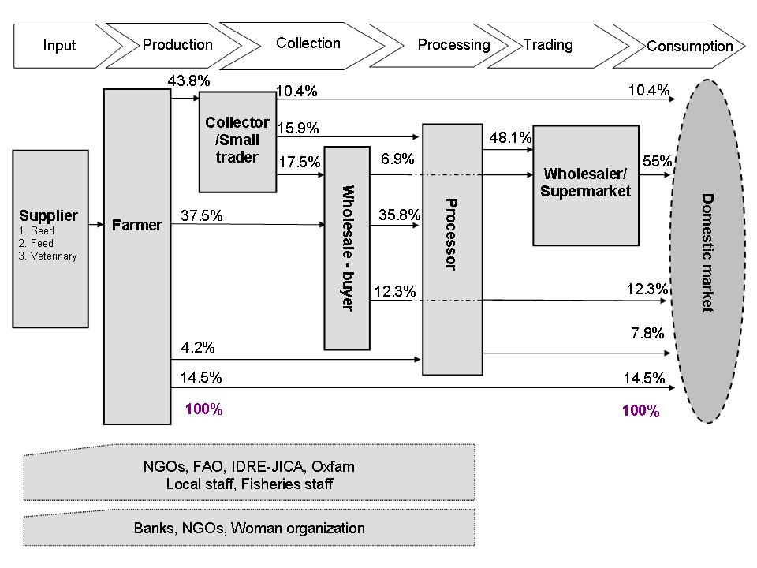

Figure 3.7: Mapping of the value chain of *Pangasius* (Pra) in Cambodia.

(Source: Loc et al., 2009)

## 3.6 Trend of Quantity and Price of the five Key Freshwater Fish Species

### 3.6.1 Trend of Quantity

Table 3.9 and Figure 3.8 respectively show quantities and trend of quantities of the five key freshwater fish species annually traded in the selected study areas from 2005 to 2010. According to the data, *Henicorhynchus* was highly traded while *Croaker* was least traded from the five key species regardless of year in which they are traded. Therefore, in comparison with other fish species, it can be implied that *Henicorhynchus* was the most preferably consumed, whereas *Croaker* was the least, which may be due to price and availability the specific species in the areas. However, even though the five fish species were preferable, the average total quantity traded dramatically declined over the past 6 years, from 90.4 tonnes in 2005 to 46.6 tonnes in 2010, mainly resulting from the decrease of wild fish stock in the rivers/lake and limitation of raising techniques of the fish in the country.

#### Table 3.9: Quantities of fish traded by species and year (Tonne/year)

|  |  |  |  |  |  |  |  |  |  |  |  |  |  |  |  |  |  |  |
| --- | --- | --- | --- | --- | --- | --- | --- | --- | --- | --- | --- | --- | --- | --- | --- | --- | --- | --- |
| Fish Species | **Year** | | | | | | | | | | | | | | | | | |
| 2005 | | | 2006 | | | 2007 | | | 2008 | | | 2009 | | | 2010 | | |
| Avg | Min | Max | Avg | Min | Max | Avg | Min | Max | Avg | Min | Max | Avg | Min | Max | Avg | Min | Max |
| Pangasius | 51.8 | 0.5 | 208.6 | 55.4 | 0.1 | 417.6 | 36.6 | 0.1 | 324.0 | 24.0 | 0.5 | 138.6 | 20.3 | 0.0 | 137.7 | 18.8 | 1.1 | 171.0 |
| Snakehead | 44.2 | 0.3 | 443.8 | 48.7 | 0.3 | 312.2 | 38.2 | 0.2 | 312.2 | 22.3 | 0.2 | 237.7 | 22.4 | 0.1 | 213.1 | 18.8 | 0.2 | 224.6 |
| Reddish | 28.3 | 0.0 | 90.0 | 33.1 | 0.0 | 162.0 | 23.8 | 0.1 | 126.0 | 15.6 | 0.1 | 100.0 | 14.4 | 0.1 | 100.0 | 12.7 | 0.1 | 60.0 |
| Croaker | 14.1 | 0.0 | 116.2 | 12.1 | 0.0 | 63.0 | 12.9 | 0.0 | 60.0 | 8.2 | 0.1 | 54.0 | 8.3 | 0.1 | 51.0 | 8.8 | 0.0 | 45.0 |
| Henicorhynchus | 55.5 | 0.6 | 399.0 | 48.8 | 0.6 | 291.2 | 52.7 | 0.6 | 291.2 | 37.5 | 0.6 | 153.4 | 34.1 | 0.2 | 140.0 | 31.3 | 0.6 | 140.0 |
| **All five species** | 90.4 | 3.1 | 1,187.8 | 96.5 | 1.9 | 944.1 | 82.1 | 2.1 | 749.7 | 54.7 | 0.5 | 461.3 | 52.7 | 0.4 | 415.0 | 46.6 | 0.3 | 4,16.5 |

##### Figure 3.8: Trend of the quantities of fish traded by species and year.

### 3.6.2 Trend of Price

Table 3.9 depicts the average price and trend of price of the five selected freshwater fish species in the selected study areas from 2005 to 2010. In general, within the five fish species, *Reddish* was one of the species obtaining the highest commercial value, respectively followed by *Snakeheads*, *Croakers* and *Pangasius*, while *Henicorhynchus* obtained the lowest commercial value. Moreover, according to table 3.9, price of the five fish species was in sharp increase over the last 6 years. This was partially caused by the decline of wild fish stock in the river which resulted from illegal fishing and increasing of pressure of fish extraction; population growth; and lack of proper fish raising techniques to meet fish demand.

#### Table 3.9: Average price of fish sold by species and year (2005-2010) (Riel/kg)

|  |  |  |  |  |  |  |
| --- | --- | --- | --- | --- | --- | --- |
| Fish Species | **Year** | | | | | |
| 2005 | 2006 | 2007 | 2008 | 2009 | 2010 |
| Pangasius | 5,122.7 | 5,868.1 | 5,652.8 | 7,125.0 | 7,824.4 | 7,575.0 |
| Snakehead | 6,874.8 | 9,267.4 | 11,895.8 | 12,308.3 | 12,224.0 | 14,294.0 |
| Reddish | 11,684.3 | 13,830.0 | 15,333.3 | 16,574.7 | 21,588.1 | 27,442.5 |
| Croaker | 5,863.2 | 7,786.9 | 8,673.6 | 10,180.6 | 11,229.2 | 12,416.7 |
| Henicorhynchus | 1,584.0 | 1,611.3 | 1,904.2 | 2,183.3 | 2,320.8 | 2,650.0 |

## 3.7 Empirical Analysis on Asymmetric Price Transmission of the five Key Freshwater Fish Species

### 3.7.1 Data

As aforementioned, the fish species employed in this study are: *Pangasius*, *Snakehead*, *Reddish*, *Croaker*, and *Henicorhynchus*. The first four species are categorised as big fishes, while the last species is categorised as small fishes. For each species, price series along the supply chains are used i.e. fisher prices, wholesale prices, and retail prices. These price data are obtained through interviews. The prices are monthly series from January 2005 to December 2010, and the sample size is 72 (months). The original price series for each species are shown in Figure 3.8.

According to Figure 3.8, it is easily confirmed that wholesale prices are higher than fisher prices, and retail prices are higher than wholesale prices. However, the margins differ among species and stage of the chains. The average margins and margin ratios are shown in Table 3.10.

For the fishes other than *Henicorhynchus*, margins and margin ratios between wholesale prices and retail prices are much higher than those between fisher prices and wholesale prices. In the case of *Henicorhynchus*, the margins and margin ratios are almost the same in both marketing stages. This may indicate that the profits for retailers who sell *Pangasius*, *Snakehead*, *Reddish*, and *Croaker* are higher than those for wholesalers and those who sell *Henicorhynchus*, if the cost of delivering such fishes is the same as that of *Henicorhynchus*. Unfortunately, because the data for transportation costs are not available, this notion is inconclusive.

Figure 3.8 also indicates that some price series have seasonal trends. Therefore, all of the series are seasonally adjusted using X12-ARIMA, which is a common method used in the U.S. Census, etc. The empirical analysis is conducted using these seasonally adjusted data by transforming them into natural logarithmic form as done by previous studies.

##### Figure 3.9: Price series of Pangasius, Snakehead, Reddish, Croaker and Henicorhynchus

#### Table 3.10: Margins and marginal ratios

|  |  |  |  |  |  |  |  |  |  |  |
| --- | --- | --- | --- | --- | --- | --- | --- | --- | --- | --- |
|  | Pangasius | | Snakehead | | Reddish | | Croaker | | Henicorhynchus | |
|  | F-W | W-R | F-W | W-R | F-W | W-R | F-W | W-R | F-W | W-R |
| Margin | 468 | 1,632 | 557 | 2,521 | 956 | 3,084 | 840 | 1,631 | 450 | 464 |
| Ratio | 0.096 | 0.248 | 0.065 | 0.219 | 0.067 | 0.191 | 0.120 | 0.179 | 0.285 | 0.212 |

**Notes:**

1) F-W represents the margin (ratio) between fisher prices and wholesale prices.

2) W-R represents the margin (ratio) between wholesale prices and retail prices.

3) Margin is the difference between two prices.

4) Margin ratio is calculated by dividing the margin by downstream prices.

5) The values are averages from January 2005 to December 2010.

### 3.7.2 Unit Root Tests

According to the ADF tests, the null hypothesis that the series has a unit root was not rejected in the level series of all species and stages, but was rejected in the first-difference series of all species and stages at 1% significance level. PP test results shows that the same null hypothesis was not rejected in the level series of all but the fisher price of *Henicorhynchus*. The hypothesis was significantly rejected in the first-difference series of all species and stages. Meanwhile, the KPSS test results indicates that the null of stationary was rejected in the level series of all species and stages at 1% significance level, but was not rejected in the first-difference series except for the retail prices of Snakehead and Reddish. In general, these unit root tests( table 3.11) represent that the price series are first-difference stationary, or I (1) variables.

Table 3.11: Unit root test results

|  |  |  |  |  |  |  |
| --- | --- | --- | --- | --- | --- | --- |
| Variables | ADF | | PP | | KPSS | |
| $$\ln{p_{P}^{F}}$$ | -1.27 |  | -1.37 |  | 1.05 | *** |
| $$Δ\ln{p_{P}^{F}}$$ | -8.87 | *** | -14.28 | *** | 0.18 |  |
| $$\ln{p_{P}^{W}}$$ | -1.32 |  | -1.34 |  | 1.01 | *** |
| $$Δ\ln{p_{P}^{W}}$$ | -9.38 | *** | -9.50 | *** | 0.15 |  |
| $$\ln{p_{P}^{R}}$$ | -1.68 |  | -1.59 |  | 0.99 | *** |
| $$Δ\ln{p_{P}^{R}}$$ | -9.70 | *** | -10.10 | *** | 0.05 |  |
| $$\ln{p_{S}^{F}}$$ | -1.53 |  | -0.98 |  | 1.04 | *** |
| $$Δ\ln{p_{S}^{F}}$$ | -13.05 | *** | -14.77 | *** | 0.14 |  |
| $$\ln{p_{S}^{W}}$$ | -0.82 |  | -0.81 |  | 1.05 | *** |
| $$Δ\ln{p_{S}^{W}}$$ | -9.20 | *** | -9.24 | *** | 0.07 |  |
| $$\ln{p_{S}^{R}}$$ | -1.82 |  | -2.33 |  | 0.97 | *** |
| $$Δ\ln{p_{S}^{R}}$$ | -10.25 | *** | -10.37 | *** | 0.35 | * |
| $$\ln{p_{R}^{F}}$$ | 0.87 |  | 1.10 |  | 1.09 | *** |
| $$Δ\ln{p_{R}^{F}}$$ | -9.13 | *** | -9.13 | *** | 0.26 |  |
| $$\ln{p_{R}^{W}}$$ | 0.90 |  | 0.92 |  | 1.10 | *** |
| $$Δ\ln{p_{R}^{W}}$$ | -11.48 | *** | -11.57 | *** | 0.20 |  |
| $$\ln{p_{R}^{R}}$$ | 0.76 |  | 1.64 |  | 1.08 | *** |
| $$Δ\ln{p_{R}^{R}}$$ | -8.76 | *** | -9.16 | *** | 0.38 | * |
| $$\ln{p_{C}^{F}}$$ | -1.62 |  | -1.72 |  | 1.11 | *** |
| $$Δ\ln{p_{C}^{F}}$$ | -11.68 | *** | -13.62 | *** | 0.22 |  |
| $$\ln{p_{C}^{W}}$$ | -0.77 |  | -0.53 |  | 1.11 | *** |
| $$Δ\ln{p_{C}^{W}}$$ | -9.37 | *** | -10.68 | *** | 0.07 |  |
| $$\ln{p_{C}^{R}}$$ | -1.15 |  | -1.28 |  | 1.10 | *** |
| $$Δ\ln{p_{C}^{R}}$$ | -9.97 | *** | -10.30 | *** | 0.14 |  |
| $$\ln{p_{H}^{F}}$$ | -1.79 |  | -3.25 | ** | 0.93 | *** |
| $$Δ\ln{p_{H}^{F}}$$ | -10.69 | *** | -13.89 | *** | 0.09 |  |
| $$\ln{p_{H}^{W}}$$ | -2.52 |  | -2.27 |  | 1.09 | *** |
| $$Δ\ln{p_{H}^{W}}$$ | -9.13 | *** | -12.17 | *** | 0.15 |  |
| $$\ln{p_{H}^{R}}$$ | -0.15 |  | -1.16 |  | 1.12 | *** |
| $$Δ\ln{p_{H}^{R}}$$ | -10.83 | *** | -20.69 | *** | 0.06 |  |

**Notes:**

1) t statistics of ADF tests were obtained by regressions with optimal lag length which minimizes BIC. The null of unit root were tested according to MacKinnon (1996).

2) Phillips-Perron test statistics were obtained by regressions with optimal Newey-West bandwidth using Bartlett kernel. The null of unit root were tested according to MacKinnon (1996).

3) In KPSS tests, Lagrange multiplier test statistics are obtained with Newey-West bandwidth using Bartlett kernel, and the asymptotic critical values are based on Kwiatkowski et al. (1992).

4) In each test, constant was included in the regression.

5) *, **, and *** represent significance at 10%, 5%, and 1% levels, respectively.

### 3.7.3 Empirical Results

The estimation results of asymmetric price transmission from fisher prices to wholesale prices are shown in Table 3.12. All of the results satisfied conditions (3) and (4), and price series were confirmed to be co-integrated. Model selection results based on BIC indicate that M-TAR model fits better than TAR model in all fish species. According to the asymmetry tests, no asymmetry was found in *Pangasius* and *Reddish*, while negative asymmetry was found in *Snakehead* and *Croaker*, and positive asymmetry for *Henicorhynchus*. Positive asymmetry in this stage means that the rise in fisher prices is transmitted to wholesale prices more quickly than is fall in fisher prices. This implies that wholesalers (collectors or middlemen[1]) have more power to determine prices than retailers. On the other hand, negative asymmetry means that the fall in fisher prices is transmitted faster than the rise in fisher prices, which implies that retailers have more power to determine prices than wholesalers (collectors or middlemen). Therefore, wholesalers (collectors or middlemen) of Snakehead and Croaker may have less power than retailers, while wholesalers (collectors or middlemen) of *Henicorhynchus* may have more power than retailers.

Meanwhile, the estimation results of asymmetric price transmission from wholesale prices to retail prices are shown in Table 3.13. All of the results satisfied the conditions (3) and (4), but not all of price series were confirmed to be co-integrated. The wholesale prices and retail prices of *Snakehead* and *Reddish* were not co-integrated according to the co-integration tests, which mean that asymmetry tests could not be conducted. For other species, price series were co-integrated and M-TAR model was selected based on BIC. There found to be positive asymmetry in *Pangasius* and *Croaker*, while no asymmetry was found in *Henicorhynchus*. Positive asymmetry in this stage means that the rise in wholesale prices is transmitted more quickly to retail prices than the fall in wholesale prices. This implies that retailers have power to determine prices over consumers. Hence, the retailers of *Pangasius* and *Croaker* may enjoy excess profits over consumers, while the retailers of *Henicorhynchus* may not.

#### Table 3.12: Asymmetric price transmissions from fisher prices to wholesale prices

|  |  |  |  |  |  |  |  |  |  |  |  |  |  |
| --- | --- | --- | --- | --- | --- | --- | --- | --- | --- | --- | --- | --- | --- |
| Fish Name | Model | $$ρ_{1}$$ | | $$ρ_{2}$$ | | lags | $$Φ$$ | | Asym. | | BIC | $$τ$$ | Choice |
| Pangasius | TAR | -0.487 | *** | -0.704 | *** | 0 | 13.84 | *** | 0.88 |  | -537.26 | -0.041 |  |
| 0.13 |  | 0.19 |  |  |  | 0.351 |  |
| M-TAR | -0.368 | ** | -0.677 | *** | 0 | 14.64 | *** | 2.03 |  | -538.41 | 0.035 | ○ |
| 0.17 |  | 0.14 |  |  |  | 0.159 |  |
| Snakehead | TAR | -0.935 | *** | -0.424 | * | 0 | 26.37 | *** | 3.62 | * | -577.17 | 0.009 |  |
| 0.13 |  | 0.23 |  |  |  | 0.061 | – |
| M-TAR | -0.976 | *** | -0.502 | ** | 0 | 26.55 | *** | 3.84 | * | -577.38 | 0.025 | ○ |
| 0.14 |  | 0.19 |  |  |  | 0.054 | – |
| Reddish | TAR | -0.564 | *** | -0.781 | *** | 0 | 18.46 | *** | 0.93 |  | -606.33 | 0.020 |  |
| 0.16 |  | 0.16 |  |  |  | 0.339 |  |
| M-TAR | -0.552 | *** | -0.899 | *** | 0 | 19.43 | *** | 2.21 |  | -607.62 | -0.038 | ○ |
| 0.14 |  | 0.19 |  |  |  | 0.142 |  |
| Croaker | TAR | -1.188 | *** | -0.344 | ** | 2 | 31.13 | *** | 22.41 | *** | -526.75 | 0.051 |  |
| 0.15 |  | 0.13 |  |  |  | 0.000 | – |
| M-TAR | -1.148 | *** | -0.150 |  | 1 | 28.73 | *** | 31.55 | *** | -535.73 | 0.036 | ○ |
| 0.15 |  | 0.12 |  |  |  | 0.000 | – |
| Henico-  rhynchus | TAR | -0.454 | *** | -0.800 | *** | 0 | 14.80 | *** | 2.26 |  | -455.58 | 0.054 |  |
| 0.14 |  | 0.18 |  |  |  | 0.137 |  |
| M-TAR | -0.398 | *** | -0.942 | *** | 0 | 17.09 | *** | 5.58 | ** | -458.81 | -0.007 | ○ |
| 0.13 |  | 0.19 |  |  |  | 0.021 | + |

**Notes:**

1) and are the adjustment coefficients in TAR model.

2) “lags” is the lag length in TAR model, where the conditions that $ρ_{1}<0$, $ρ_{2}<0$, and $\left(1+ρ_{1}\right)\left(1+ρ_{2}\right)<1$ are satisfied, and the disturbance term in TAR model is white noise, then BIC is minimized.

3) is the F statisticobtained by testing the null hypothesis that. Rejection regions are based on Enders and Siklos (2001).

4) “Asym.” is the F statistics obtained by testing the null hypothesis that. + means positive APT and – means negative APT.

5) is the super-consistent estimate of the threshold in TAR model, which is estimated by Chan’s (1993) method.

6) Values in ( ) are standard errors. Values in [ ] are p values.

7) The circle in the “Choice” column means that the estimation result is valid in the sense that it satisfies the conditions of and white noise, that the variables are cointegrated, and that BIC is the smallest.

8) *, **, and *** represent significance at 10%, 5%, and 1% levels, respectively.

#### Table 3.13: Asymmetric price transmissions from wholesale prices to retail prices

|  |  |  |  |  |  |  |  |  |  |  |  |  |  |
| --- | --- | --- | --- | --- | --- | --- | --- | --- | --- | --- | --- | --- | --- |
| Fish Name | Model | $$ρ_{1}$$ | | $$ρ_{2}$$ | | lags | $$Φ$$ | | Asym. | | BIC | $$τ$$ | Choice |
| Pangasius | TAR | -0.084 |  | -0.335 | *** | 0 | 5.79 |  | 2.90 | * | -477.89 | -0.093 |  |
| 0.11 |  | 0.10 |  |  |  | 0.093 | + |
| M-TAR | -0.001 |  | -0.333 | *** | 0 | 6.84 | * | 4.77 | ** | -479.72 | 0.006 | ○ |
| 0.12 |  | 0.09 |  |  |  | 0.032 | + |
| Snakehead | TAR | -0.237 | ** | -0.320 | *** | 5 | 5.23 |  | 0.34 |  | -490.28 | 0.061 |  |
| 0.11 |  | 0.12 |  |  |  | 0.561 |  |
| M-TAR | -0.329 | *** | -0.167 |  | 5 | 5.72 |  | 1.17 |  | -491.20 | -0.031 |  |
| 0.10 |  | 0.13 |  |  |  | 0.284 |  |
| Reddish | TAR | -0.133 |  | -0.318 | ** | 2 | 2.33 |  | 1.00 |  | -540.56 | -0.059 |  |
| 0.13 |  | 0.16 |  |  |  | 0.321 |  |
| M-TAR | -0.062 |  | -0.355 | ** | 2 | 3.23 |  | 2.70 |  | -542.31 | 0.002 |  |
| 0.14 |  | 0.14 |  |  |  | 0.105 |  |
| Croaker | TAR | -0.124 |  | -0.611 | *** | 0 | 12.97 | *** | 7.34 | *** | -540.59 | 0.062 |  |
| 0.13 |  | 0.12 |  |  |  | 0.009 | + |
| M-TAR | -0.287 | *** | -1.051 | *** | 0 | 13.56 | *** | 8.29 | *** | -541.46 | -0.033 | ○ |
| 0.10 |  | 0.25 |  |  |  | 0.005 | + |
| Henico-  rhynchus | TAR | -0.299 | ** | -0.521 | *** | 0 | 9.06 | ** | 1.33 |  | -428.64 | -0.077 |  |
| 0.12 |  | 0.15 |  |  |  | 0.253 |  |
| M-TAR | -0.518 | *** | -0.280 | ** | 0 | 9.22 | ** | 1.59 |  | -428.90 | 0.015 | ○ |
| 0.14 |  | 0.13 |  |  |  | 0.211 |  |

**Notes:**

1) and are the adjustment coefficients in TAR model.

2) “lags” is the lag length in TAR model, where the conditions that $ρ_{1}<0$, $ρ_{2}<0$, and $\left(1+ρ_{1}\right)\left(1+ρ_{2}\right)<1$ are satisfied, and the distubunce term in TAR model is white noise, then BIC is minimized.

3) is the F statisticobtained by testing the null hypothesis that. Rejection regions are based on Enders and Siklos (2001).

4) “Asym.” is the F statistics obtained by testing the null hypothesis that. + means positive APT and – means negative APT.

5) is the super-consistent estimate of the threshold in TAR model, which is estimated by

Chan’s (1993) method.

6) Values in ( ) are standard errors. Values in [ ] are p values.

7) The circle in the “Choice” column means that the estimation result is valid in the sense that it satisfies the conditions of and white noise, that the variables are cointegrated, and that BIC is the smallest.

8) *, **, and *** represent significance at 10%, 5%, and 1% levels, respectively.

### 3.7.4 Discussion

In the price transmission from fisher prices to wholesale prices, positive APT was observed for *Henicorhynchus*, while negative APT and no APT were observed for other fishes. This implies that wholesalers (collectors or middlemen) of *Henicorhynchus* have more power to determine wholesale prices than retailers. This is possible if wholesalers (collectors or middlemen) of *Henicorhynchus* are larger than retailers and/or the number of wholesalers (collectors or middlemen) of *Henicorhynchus* is smaller than retailers. This may be true because *Henicorhynchus* is sold only in locally small markets while other fishes are sold in larger markets or supermarkets. Another possible explanation of this is that, because *Henicorhynchus* is cheap, consumer demand may be high, and a variety of consumers can buy it. It means that there are a lot of retailers who sell this fish, which may make price negotiation advantageous to wholesalers (collectors or middlemen) than atomic retailers. This may also be true because, in Cambodia, *Henicorhynchus* is a vital commodity, used for fish paste, fermented, fish source, and smoked fish, and consumed by almost all people in the country.

Among the fishes other than *Henicorhynchus*, negative APT was observed for *Snakehead* and *Croaker* in the price transmission from fisher to wholesale prices. This implies that wholesalers (collectors or middlemen) of these fishes have less power to determine wholesale prices than retailers do. This is possible if wholesalers (collectors or middlemen) of these fishes are smaller than retailers and/or the number of wholesalers (collectors or middlemen) of these fishes is larger than retailers. Furthermore, as no APT was observed for *Pangasius* and *Reddish*, wholesalers (collectors or middlemen) of *Pangasius* and *Reddish* have more power to determine prices over retailers than those of *Snakehead* and *Croaker*. This may be possible if wholesalers (collectors or middlemen) of *Pangasius* and *Reddish* are larger than those of *Snakehead* and *Croaker* and/or the number of wholesalers (collectors or middlemen) of *Pangasius* and *Reddish* is smaller than those of *Snakehead* and *Croaker*. It is said that there are such buyers that buy *Pangasius* specifically, while there are no such buyers for *Snakehead* and *Croaker*[2]. This may lead to the exercise of price negotiation power by wholesalers (collectors or middlemen) of *Pangasius*.

In the price transmission from wholesale prices to retail prices, positive APT was observed for *Pangasius* and *Croaker*, and no APT was observed for *Henicorhynchus*, while APT tests could not be conducted for *Snakehead* and *Reddish* because the price series are found to be non-co-integrated. The results for *Pangasius* and *Croaker* indicate that the retailers have more power to determine the retail prices than the consumers. This is possible if the retailers are large enough and/or the number of retailers is small enough compared to the size and/or number of the consumers. If the size of consumers is the same among all fishes, the number of retailers are smaller for *Pangasius* and *Croaker* than that of *Henicorhynchus*.

## 3.8 Major Suggestions for Upgrading Value Chain of the five Key Freshwater Fish Species

Some of the major suggestions for upgrading the value chain of the five key freshwater fish species in Cambodia toward sustainable development are proposed as follows:

1. To manage wild fish stock and other aquatic resources well. Specifically to put high pressure and to prohibit all illegal fishing, over fishing, or any activity that harm the resources in order make it sustainable. However, this cannot be effective without the involvement of local people, local authorities and government, NGOs and functional organisations.
2. To augment and adopt appropriate technologies of raising *Snakeheads* and *Pangasius* (including producing fish broods and feed), using pellet feed at affordable price for fish farmers in replacement of trash/low value fish, to reduce rate of fish death and improve quality of fish as much as possible, and to avoid the depletion of trash/low value fish, which has been considered as the main food for people, especially for the poor. By promoting *Snakeheads* and *Pangasius* farming: first, cultured fish could be used to sufficiently complement or replace wild fish which is decreasing and second, it can decrease the price of fish to fit household income and the poor can have access to fish.
3. To have good management of fish trade in order to make information of fish price more clearly and broadly accessible to all chain actors and to prevent price fluctuation. It is vital to ensure that each chain actor can possibly obtain the same benefit in order to have sustainable value chain and trade of the five key fresh water fish species.

1. To better manage the quality of fish by introducing proper conservative technologies mainly when transporting fresh fish in order to decrease the fish death and weight loss during business transaction. Moreover, to provide appropriate processing technique to sustain the business of the key freshwater fish species processing and to increase the opportunities for domestic and export markets for both fresh and processed forms.
2. To provide more opportunities for the establishment of financial organisations which tend to offer more loan with low interest rate.
3. To limit or restrict unnecessary and informal-fee payment which usually occur to all chain actors during business transaction.

# PART IV: CONCLUSION

In conclusion, amongst all chain actors involved in the value chain and marketing channel of the five key freshwater fish species, wholesalers play the most important role since they extract most of the fish from fishers and fish farmers, and distribute/deliver fish to the markets. Apart from fishers/fish farmers, traders and exporters there are also other actors indirectly involved in the marketing channel.

The total quantity of the five fish species decreased in 2010 compared to 2005. However, the traded quantity of *Henicorhynchus* was higher with cheaper price when compared to the other fish species. In the trade of the fish species wholesalers of *Henicorhynchus* have more power to determine wholesale price than retailers since *Henicorhynchus* is cheap, there might be high demand and it will be affordable to many consumers.

In the case of other species: wholesalers of *Snakehead* and *Croaker* have less power to determine wholesale price than retailer. Whereas, wholesalers of *Pangasius* and *Reddish* have more power to determine price over retailers than do those of *Snakehead* and *Croaker*. Moreover, the retailers of *Pangasius* and *Croaker* have more power to determine the retail price than consumers.

# REFERENCES:

ADB (2007). Promoting Gender Equality and Women Empowerment. GAD Activity: Enhancing the Role of Women in Inland Fisheries in Cambodia. Final Report. TA CAM 6143. Asian Development Bank (ADB). Phnom Penh, Cambodia. 124p.

Ahmed, M., Hap, N., Ly V., and M. Tiongco (1998). Socioeconomic assessment of freshwater capture fisheries of Cambodia. Report on household survey. Mekong River Commission (MRC). Phnom Penh. Cambodia. 185 p.

Ahmed, M. and Touch, S. T. (1996). Management of Freshwater Capture Fisheries of Cambodia – Issues and Approach. Phnom Penh, Cambodia.

Bush, S. R. (2006). Livelihoods, markets and governance: market access and value adding for small-scale fishers in the Lower Mekong Basin. Phnom Penh, Cambodia, Oxfam America.

Loc, V. T. T., Bush, S., Sinh, L. X., Hap, N., and Khiem, N. T. (2009). Value Chains for Sustainable Mekong Fisheries: the Case of Pangasius hypopthalmus and Henicorhunchus/Labiobarbus spp. in Vietnam and Cambodia. Final Scientific Report. Project Number 6289. The Sustainable Mekong Research Network (SUMERNET).

Bush, S. R. (2004). Scales and Sales: changing social and spatial fish trading networks in the Siiphandone fishery, Lao PDR. Singapore Journal of Tropical Geography, 25(1): 32-50.

Chan, K.S. (1993). “Consistency and Limiting Distribution of the Least Squares Estimator of a Threshold Auto regressive Model,” The Annuals of Statistics, Vol. 21(1): 520-533.

Enders, W. and C.W.J. Granger (1998) “Unit-Root Tests and Asymmetric Adjustment with an Example Using the Term Structure of Interest Rates,” Journal of Business & Economic Statistics, Vol.16(3): 304-311.

Enders, W. and P.L. Siklos (2001). “Cointegration and Threshold Adjustment,” Journal of Business &Economic Statistics, Vol.19(2): 166-176.

FAO (2008). FAOSTAT.Rome, Food and Agriculture Organization of the United Nations. Retrieved from <http://faostat.foa.org/faostat/> on 10/08/08.

FiA (1999). Fisheries Data Collection 1980-1998. Fisheries Department (DoF), Phnom Penh, Cambodia.

FiA (2001). Inland Fisheries Review. Agriculture Productivity Improvement Project (APIP). ITF Credit No. 0110-KH and IFAD Loan No. 423-KH. The Fisheries Component. Technical Paper N. 2. Fisheries Administration (FiA). Phnom Penh, Cambodia.

FiA (2005).Fisheries Administration Data Collection and Statistics. Phnom Penh, Cambodia.

FiA (2001). Inland Fisheries Review. Agriculture Productivity Improvement Project (APIP). ITF Credit No. 0110-KH and IFAD Loan No. 423-KH. The Fisheries Component. Technical Paper N. 2. Fisheries Administration (FiA). Phnom Penh, Cambodia.

FiA and MRC (2005). Gender and Women Participation in Fisheries Sector. Phnom Penh,

Cambodia. As cited in Kusakabe, K. (2006*).* Gender and Fisheries in the Lower Mekong Basin. Compilation Report. Regional Network for Promoting Gender/Women in Fisheries in Lower Mekong Basin.

Ham, K. (2006). Gender and the Post-Harvest Fisheries Sector. The Output from the DFID-Funded Post-Harvest Fisheries Livelihood Project. Working Paper 7. Fisheries Administration, Phnom Penh, Cambodia. 44p

Hap, N. (1999). Production Technology and Technical Efficiency of Freshwater Capture Fisheries in Phnom Penh, Kampong Cham, and Battambang Provinces, Cambodia. The University of the Philippines at Los Banos, Laguna. Master Thesis. 97p.

Hap, N., Kandarith K., and Battarai, M. (2006). Assessment of Production Cost of Inland Fisheries in Cambodia. Fisheries Administration (FiA). Phnom Penh, Cambodia.

Hap, N., Un, S., and Tray, B. (2011). Value Chain Analysis of Snakehead Fish in The Lower Mekong Basin of Cambodia. Cambodia – Country Report. AquaFish CRSP Project. USAID Grant No. EPP-A00-06-00012-00. Fisheries Administration (FiA). Phnom Penh, Cambodia.

Hortle, K. (2007). Consumption and the yield of fish and other aquatic animals from the Lower Mekong Basin. Vientiane, MRC Technical Paper No.16.

Keang, S. (2004). Fish exports and the Livelihoods of the Poor. Phnom Penh, Cambodia Post Harvest Fisheries Livelihoods Project, Community Fisheries Development Office, Department of Fisheries.

Khim, K., Poeu, O. and Nonoguchi, A. (2002) *Gender Roles in Fisheries Activities, Cambodia*. Supported by JICA and Fisheries Administration (FiA). Ministry of Agriculture, Forestry and Fisheries. Phnom Penh, Cambodia.

Kusakabe, K. (2006). Gender and Fisheries in the Lower Mekong Basin. Compilation Report. Regional Network for Promoting Gender/Women in Fisheries in Lower Mekong Basin.

Kusakabe, K., U. Suntornratana, Prak, S., and N. Sriputinibondh (2005). Women Negotiating Borders: Marketing Routes and Cross-border Trade of Inland Fish Between Thailand and Cambodia. Research report with support from National Center of Competence in Research North-South, Joint Area of Case Studies, Partnership Actions for Mitigating Syndromes of Global Change (PAMS).

Kwiatkowski D., P.C.B. Phillips, P. Schmidt, and Y. Shin (1992). “Testing the Null Hypothesis of Stationarity Against the Alternative of a Unit Root: How Sure Are We That Economic Time Series Have a Unit Root?,” Journal of Econometrics, Vol.54(1-3): 159-178.

Loc, V. T. T., Sinh, L. X. and Bush, S. (2007). Trans-boundary Challenges for Fisheries Policy in the Mekong Delta, Vietnam: Implications for Economic Growth and Food Security. Vietnam.

Loc, V. T. T., Bush, S., Sinh, L. X., Hap, N., and Khiem, N. T. (2009). Value Chains for Sustainable Mekong Fisheries: the Case of Pangasius Hypopthalmus and Henicorhynchus/ Labiobarbus spp. in Vietnam and Cambodia. Project Number 6289. Final Scientific Report. The Sustainable Mekong Research Network (SUMERNET).

MacKinnon, J.G. (1996). “Numerical Distribution Functions for Unit Root and Cointegration Tests,” Journal of Applied Econometrics, Vol.11(6): 601-618.

Nao, T., and Mong, L. (1997). Socio-economic Importance of Cambodian Fisheries Sector. Fisheries Administration. Phnom Penh, Cambodia. 7p.

Rab, M. A., Hap, N., Ahmed, M., Keang, S. and Viner, K. (2006). Socioeconomics and values of resources in Great Lake-Tonle Sap and Mekong-Bassac area: Results from a sample survey in Kampong Chhnang, Siem Reap and Kandal provinces. Phnom Penh, Cambodia.

Rab, M. A., Hap, N., Seng, L., Ahmed, M., and Viner, K. (2006). Marketing Infrastructure, Distribution Channels and Trade Pattern of Inland Fisheries Resources in Cambodia: An Exploratory Study. WorldFish Center, Buta Maung Penang, Malaysia. 42p.

Seng, K. (2006). Fish Export and the Livelihood of the Poor. Working Paper 11. Ministry of Agriculture, Forestry and Fisheries, Fisheries Administration (FiA). Phnom Penh, Cambodia.

Sinh, L. X. and Chung, D. M. (2010). Current Situation of and Challenges for Snakehead (channa micropeltes and channa striatus) Farming in the Mekong Delta, Vietnam. Scientific and Technology Journal of Agriculture and Rural Development, No.10/2010, pp.56-63.

So, N., and Nao, T. (1999). Aquaculture Sector Review (19984-1999) and Outline of National Aquaculture Development Plan (2000-2020). Fisheries Administration (FiA). Ministry of Agriculture, Forestry and Fisheries (MAFF). Phnom Penh, Cambodia. 72 p.

So, N., Eng, T., Souen, N., and Hortle, K. G. (2005). Use of Freshwater Low-value Fish for Aquaculture Development in the Cambodia's Mekong Basin. Consultancy Report for Mekong River Commission Assessment of Mekong Capture Fisheries Project, Phnom Penh, Cambodia. 34p.

So, N., Leng, S. V., and Kura, Y. (2007). Study of the Catch and Market Chain of Low Value Fish along Tonle Sap River, Cambodia – Implications for Management of Their Fisheries. A Preliminary Study. Consultancy Report WorldFish Center’s Greater Mekong Region. Fisheries Administration, Phnom Penh, Cambodia. 37p.

Van Zalinge, N., Sopha, L., Ngor, P. B., Kong, H. and Jorgensen, V. (2002). Status of the Mekong Pangasianodon hypophthalmus resources, with special reference to the stock shared between Cambodia and Vietnam. MRC Technical Paper No.1, Mekong River Commission. Phnom Penh, Cambodia.

WF (2008). Using Fisheries and Aquaculture to Reduce Poverty and Hunger. Publication. The WorldFish Center. Phnom Penh, Cambodia.

Yim, C. and McKenney, B. (2003a). Fish Exports from the Great Lake to Thailand: An Analysis of Trade Constraints, Governance, and the Climate for Growth. CDRI Working Paper 27. Phnom Penh, Cambodia.

**Appendix**

**Pictures of the Five Key Freshwater Fish Species and Trading Activities**

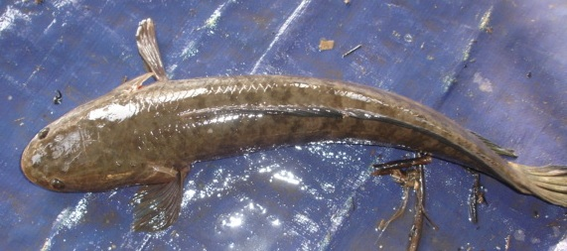

Scientific Name : **Channa Striata**

English Name : **Common Snakehead**

Khmer Name : **Trey Ros**

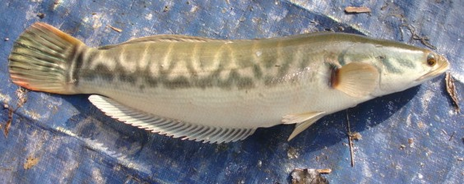

Scientific Name : **Channa Micropeltes**

English Name : **Giant Snakehead**

Khmer Name : **Trey Chhdaur**



Scientific Name : **Pangasius Bocourti**

English Name : **Basa Catfish**

Khmer Name : **Trey Pra Kchaov**

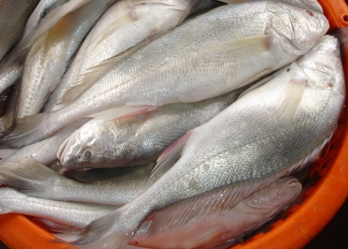

Scientific Name : **Boesemania microlepis**

English Name : **Croaker**

Khmer Name : **Trey Promah**

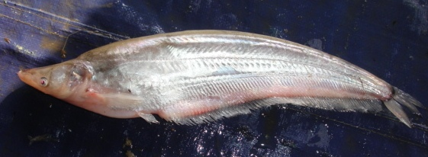



Scientific Name : **Micronema apogon sp.**

English Name : **Reddish**

Khmer Name : **Trey Kes**



Scientific Name : **Henicorhynchus/Cirrhinus Lobatus**

English Name : **Lesser Silver Mud Carp**

Khmer Name : **Trey Riel Ongkarm**



Scientific Name : **Henicorhynchus/Cirrhinus Siamensis**

English Name : **Siamensis Mud Carp**

Khmer Name : **Trey Riel Tob**

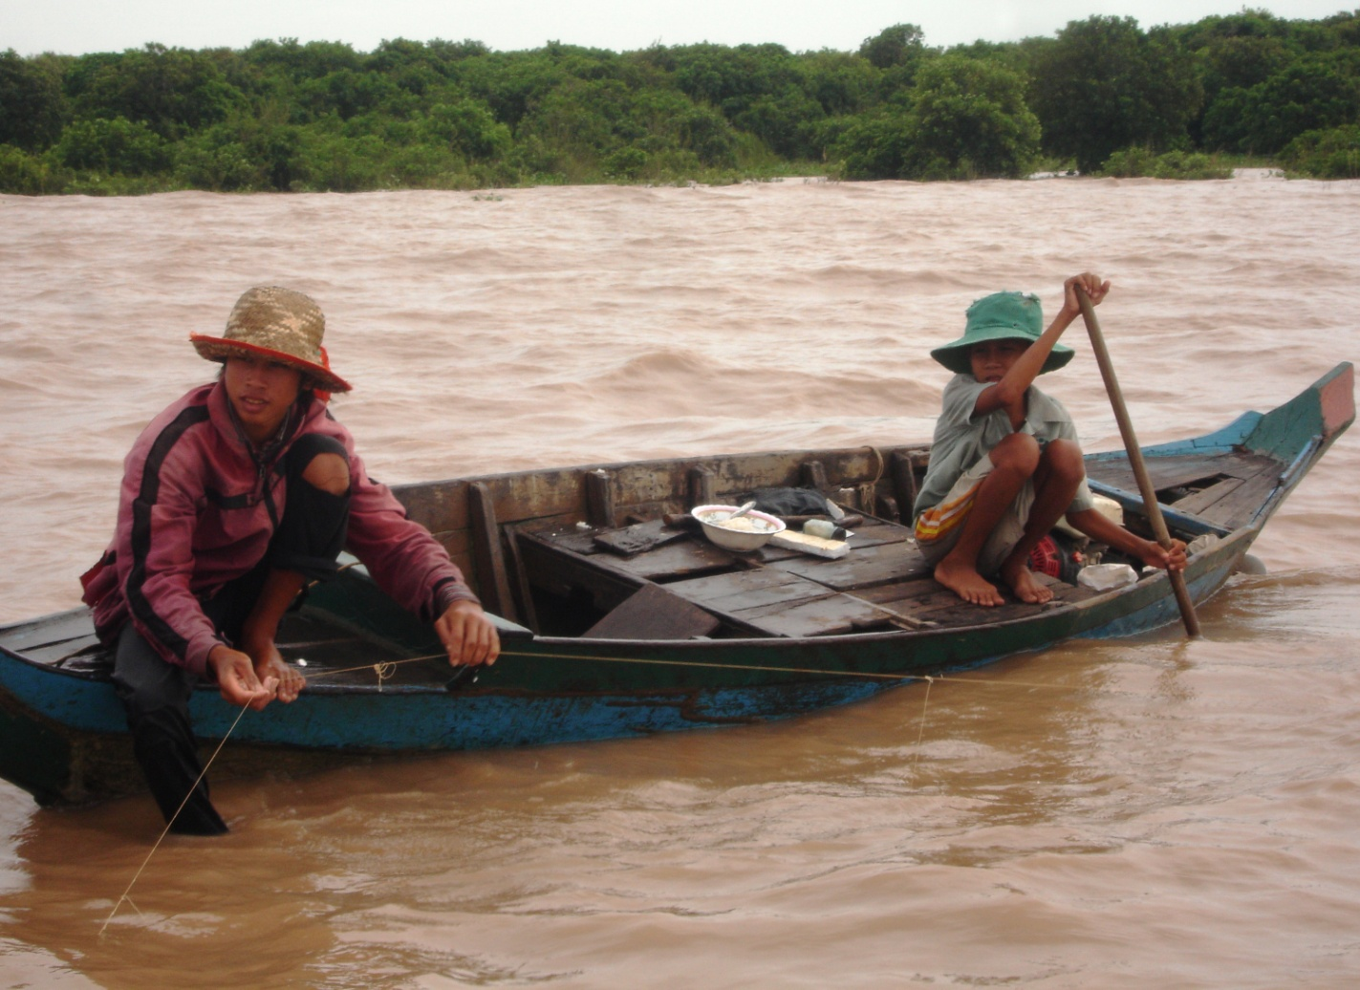

Fishing activities of fishermen in the study area

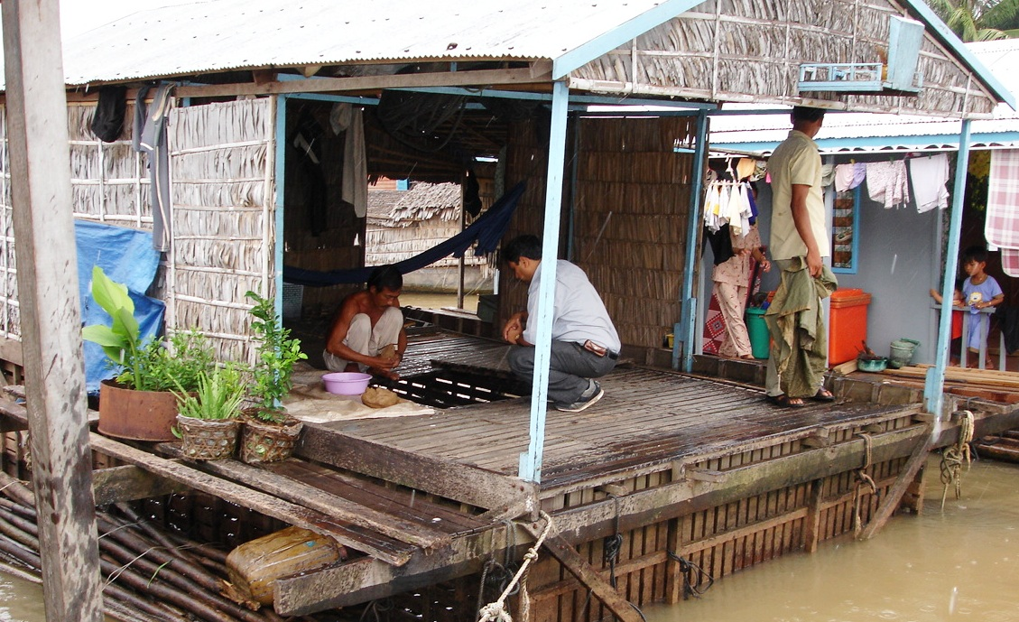

Fish cage culture (Snakehead) in the study area

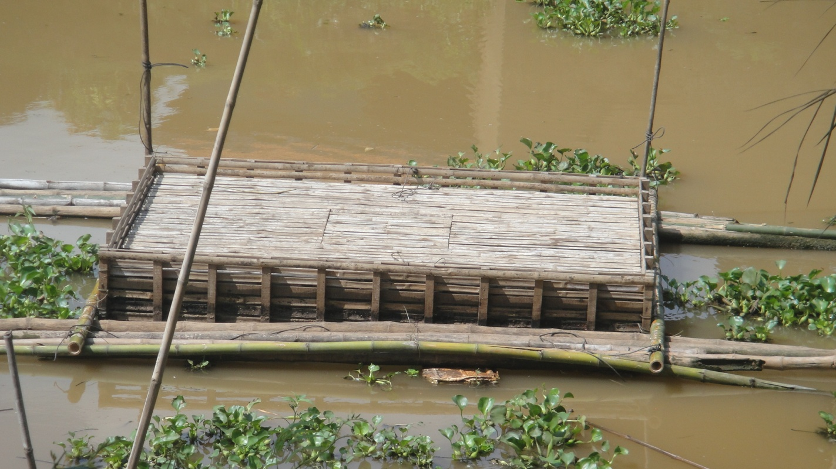

Fish cage culture (Snakehead) in the study area

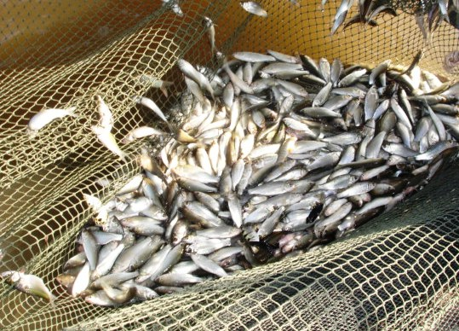

Henicorhynchus caught by fishermen

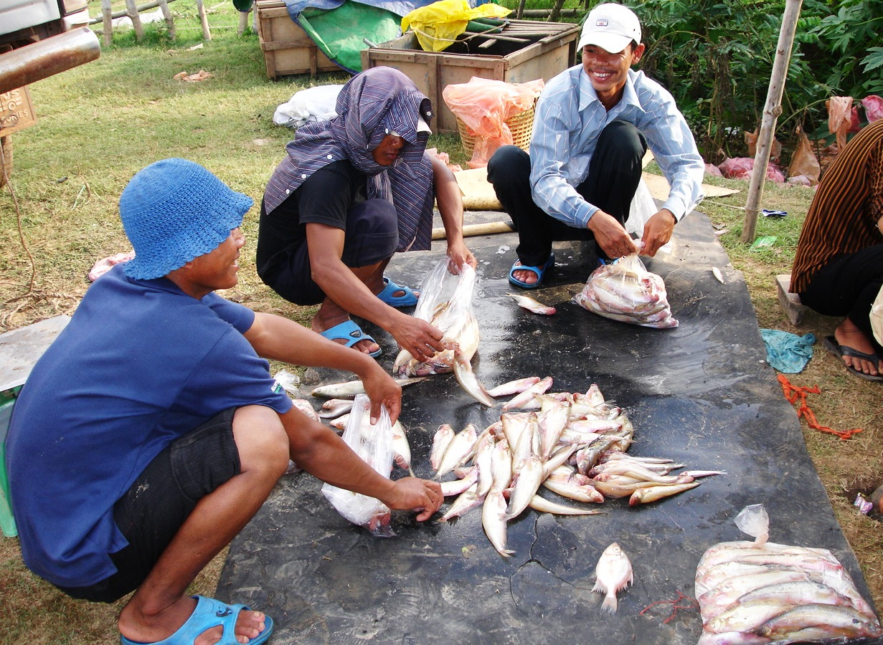

Preparation of fish (Reddish) before exported to Thailand

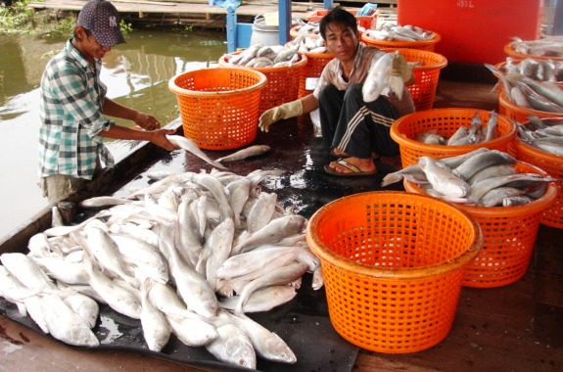

Shorting by size of fish (Croaker) before exported to Thailand

**Selling activities of 5 key freshwater fish species in markets**

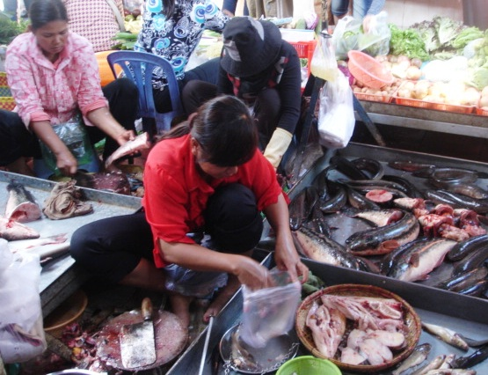

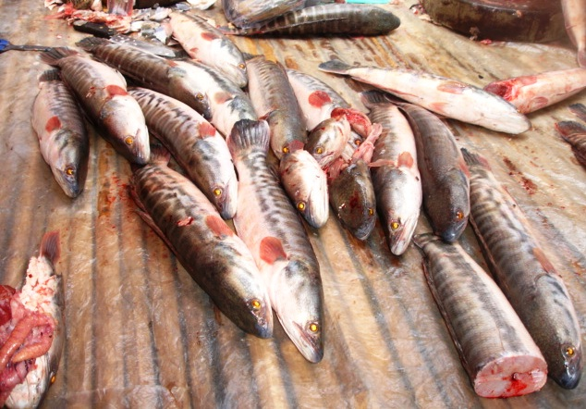

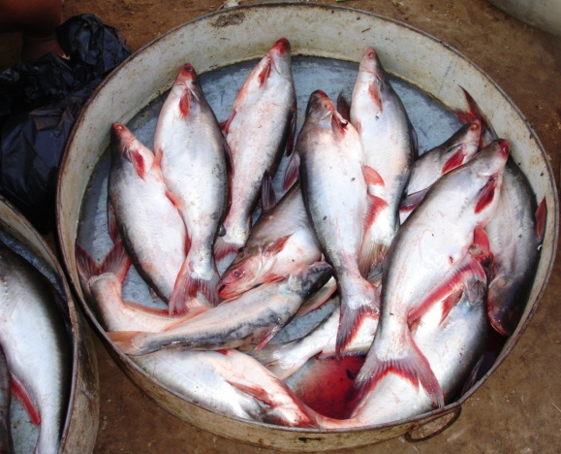

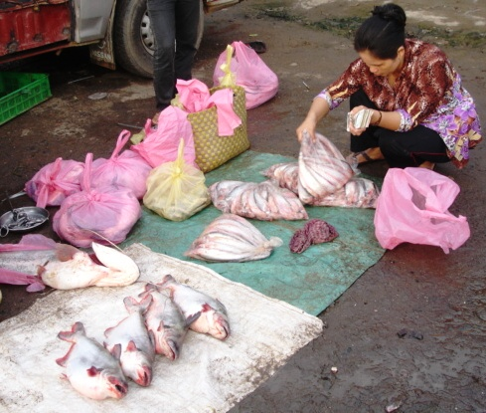

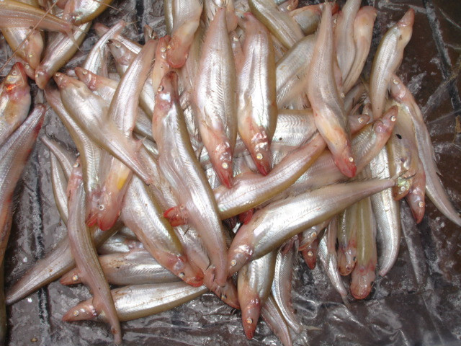

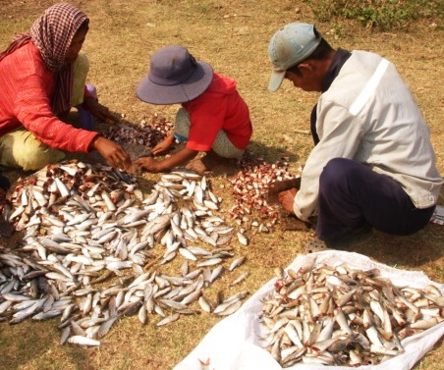

1. According to the data, the fisher prices are the ones at which fishers sell, not the one at which wholesalers buy. Hence, we cannot identify exactly who of them actually have power over retailers.
2. This remark is based on the interview to a researcher of Department of Global Agricultural Sciences, The University of Tokyo.