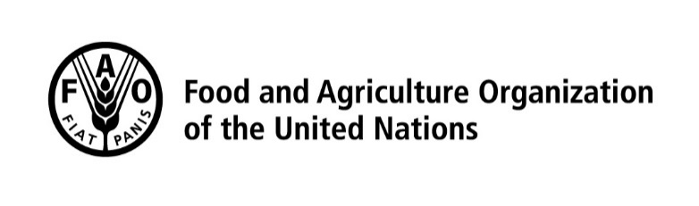
Sustainable Development Goals:
Indicator 2.5.1.a Number of plant genetic resources for food and agriculture secured in either medium or long term conservation facilities

List of descriptors for reporting on SDG indicator 2.5.1.a

Mandatory descriptors are underlined. Data reporting for indicators of the Sustainable Development Goals (SDG) is on an annual basis. An Excel table to be filled in and sent to WIEWS@fao.org is included at the end of this document. For further information on the indicator and the type of ex situ collections of plant genetic resources to be reported please refer to the Metadata sheet of the SDG indicator 2.5.1.a or contact WIEWS@fao.org.

Descriptors:
• Holding institute code/name (mandatory) - WIEWS code or name of the genebank holding the collection.
• Accession number (mandatory) - Unique identifier for the accession within the genebank, which is assigned when a sample is entered into the genebank collection (e.g. ‘PI 113869’).
• Name of taxon (mandatory) - Scientific name of the accession, including genus, species and sub-ranking, if any (e.g. Triticum aestivum L.; Vigna unguiculata subsp. aduensis Pasquet; Aegilops comosa var. subventricosa Boiss.; etc.). Genus, species and sub-ranking can be optionally reported as three separate descriptors. The authority should be indicated for the lowest taxonomic category reported.
• Name of crop - English common name of the crop, if available and/or applicable.
• Acquisition date (YYYY/MM) (highly recommended) - Date on which the accession entered the genebank, where YYYY is the year, MM is the month.
• Country of origin - 3-letter ISO 3166-1 code of the country in which the sample was originally collected (e.g. landrace, crop wild relative, farmers’ variety), bred or selected (breeding lines, GMOs, segregating populations, hybrids, modern cultivars, etc.).
• Biological status of accession (highly recommended) - Available options are as follows:
100) Wild
200) Weedy
300) Traditional cultivar/landrace
400) Breeding/research material
500) Advanced or improved cultivar (conventional breeding methods)
600) GMO (by genetic engineering)
• Genebank(s) holding safety duplications - WIEWS code or name of the genebank(s) where a safety duplicate of the accession is maintained. Multiple values are separated by a semicolon without space.
• Latitude of collecting site (decimal degrees format) - If available and/or applicable.
• Longitude of collecting site (decimal degrees format) - If available and/or applicable.
• Collecting/acquisition source - Available options are as follows:
10) Wild habitat
20) Farm or cultivated habitat
30) Market or shop
40) Institute, Experimental station, Research organization, Genebank
50) Seed company
60) Weedy, disturbed or ruderal habitat
• Type of germplasm storage (mandatory) - Multiple choices are allowed, separated by a semicolon (e.g. 20;30) when the accession is maintained under different types of storage. For details on storage type please refer to Genebank Standards for Plant Genetic Resources for Food and Agriculture (FAO 2014). Available options are as follows:
12) Seed medium term
13) Seed long term
20) Field collection
30) In vitro collection
40) Cryopreserved collection
50) DNA collection
• Status under the Multilateral System - Status of the accession under the Multilateral System of Access and Benefit Sharing of the International Treaty for Plant Genetic Resources for Food and Agriculture (Treaty). It only applies to countries that are party to the Treaty. Available options are as follows:
Not included
Included

© FAO, 2021
Published on December 2021

